**Course Description**

Once you've started learning tools for data manipulation and visualization like dplyr and ggplot2, this course gives you a chance to use them in action on a real dataset.

You'll explore the historical voting of the United Nations General Assembly, including analyzing differences in voting between countries, across time, and among international issues.

In the process you'll gain more practice with the dplyr and ggplot2 packages, learn about the broom package for tidying model output, and experience the kind of start-to-finish exploratory analysis common in data science.

**Data cleaning and summarizing with dplyr**The best way to learn data wrangling skills is to apply them to a specific case study. Here you'll learn how to clean and filter the United Nations voting dataset using the dplyr package, and how to summarize it into smaller, interpretable units.

**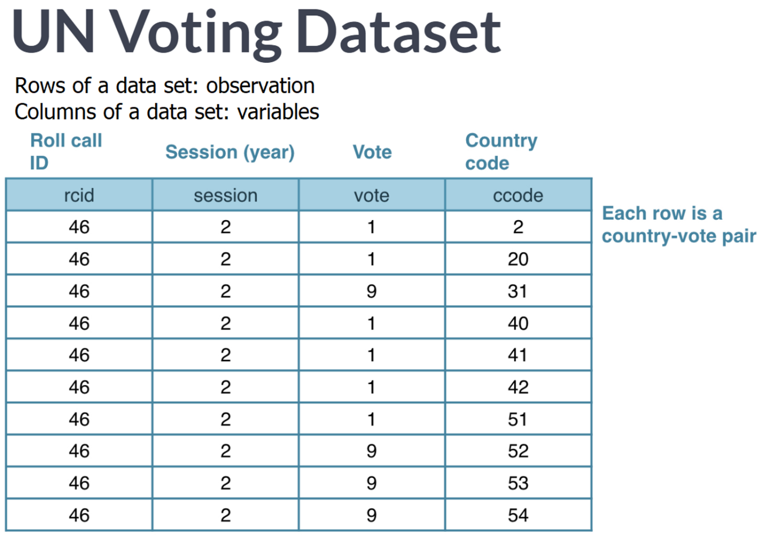**

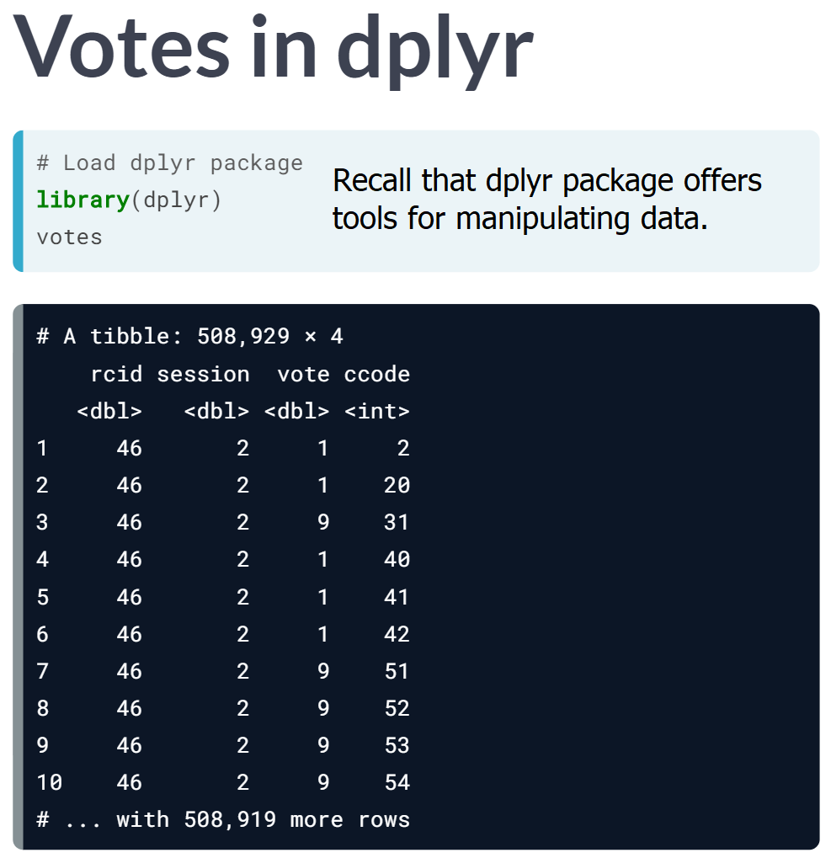

As with almost any dataset we will run into, we will need to clean this data before we can start analyzing it.



Also recall that dplyr verbs are functions that perform a single, simple actions on the dataset.

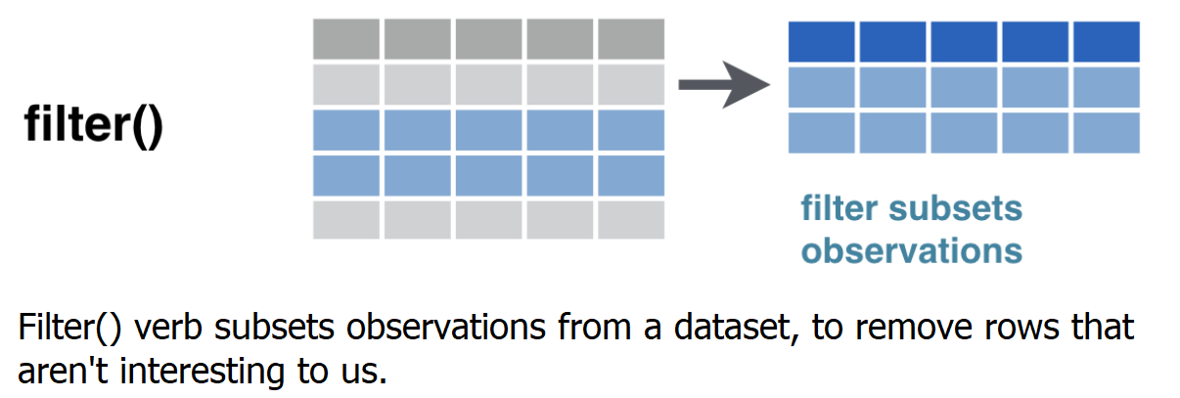

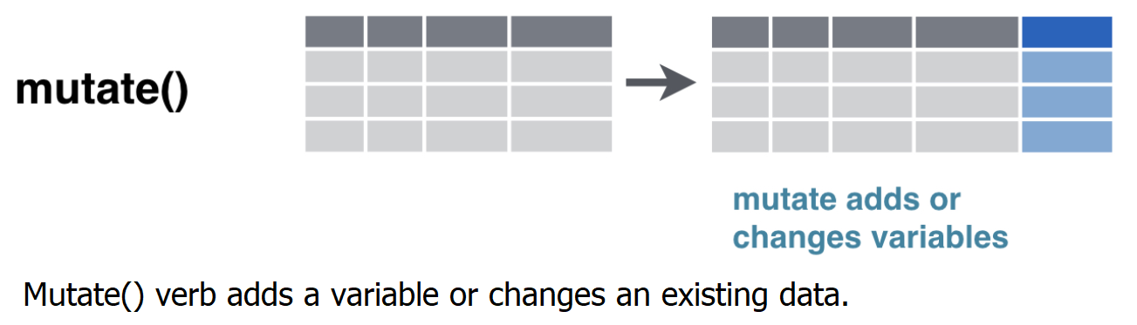

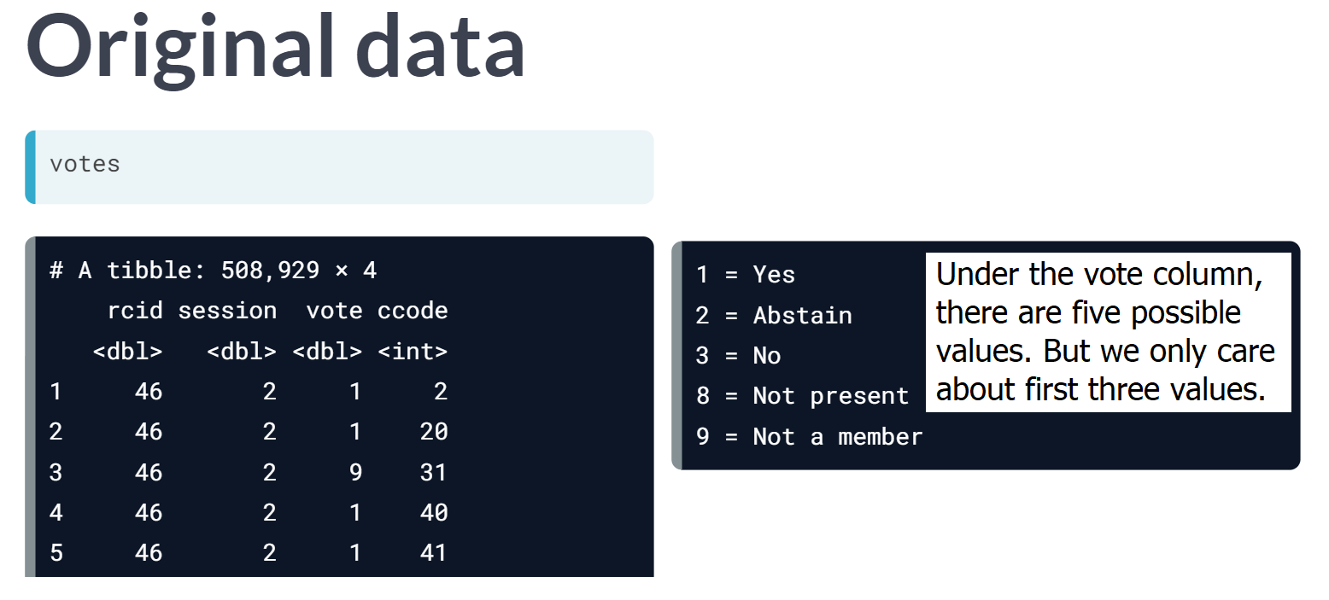

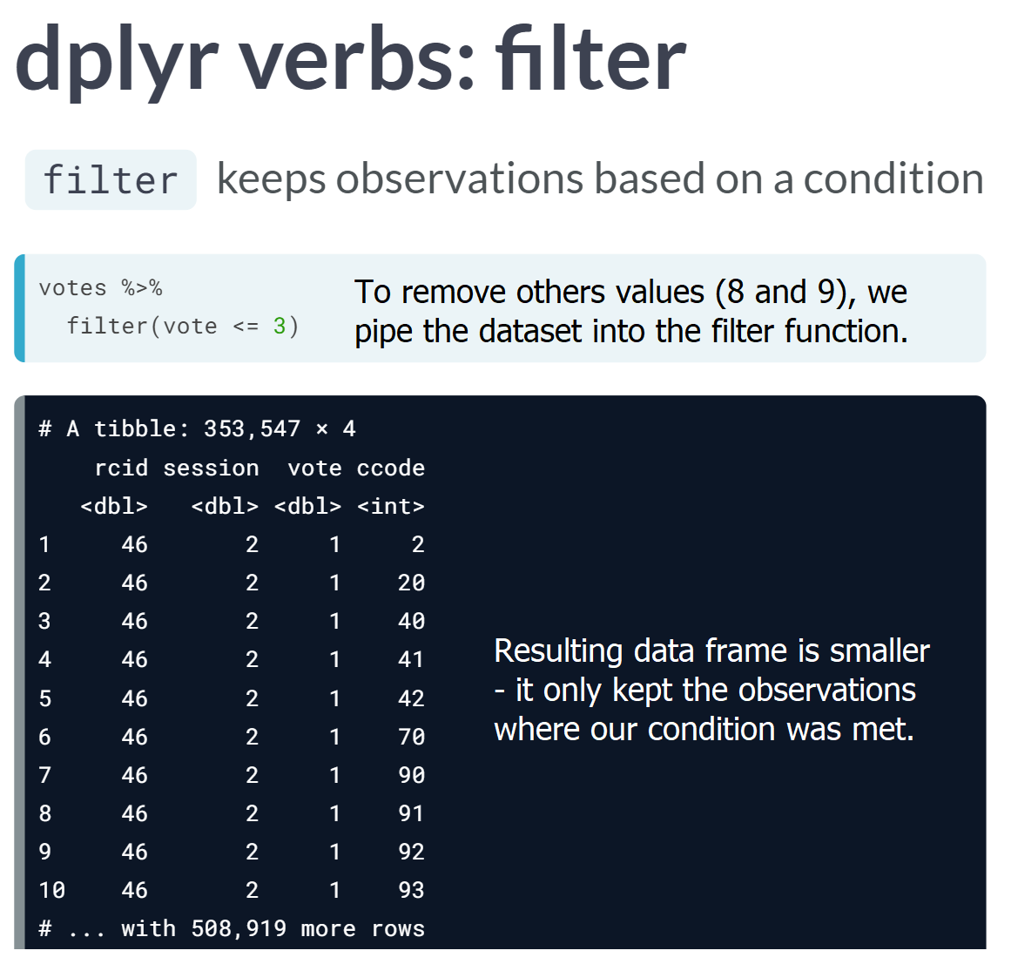

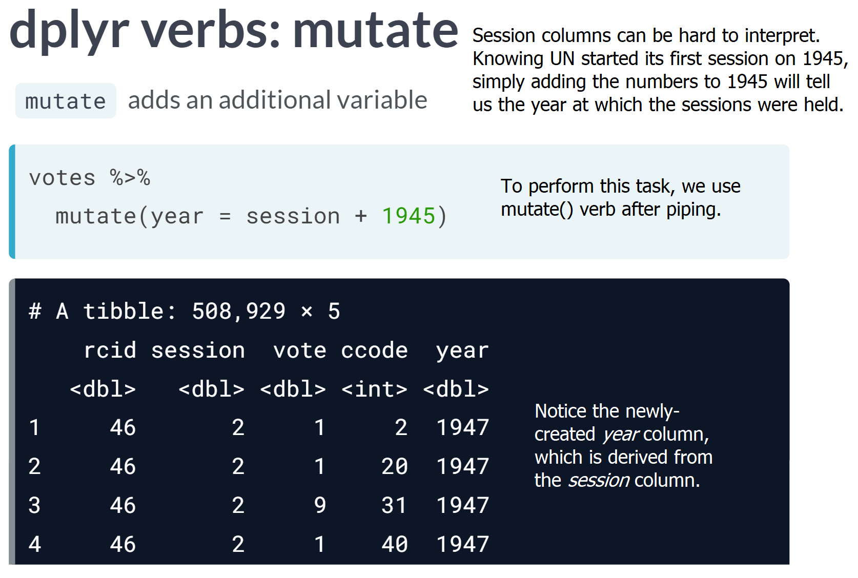

# Filtering rows

The vote column in the dataset has a number that represents that country's vote:

* **1** = Yes
* **2** = Abstain
* **3** = No
* **8** = Not present
* **9** = Not a member

One step of data cleaning is removing observations (rows) that you're not interested in. In this case, you want to remove "Not present" and "Not a member".

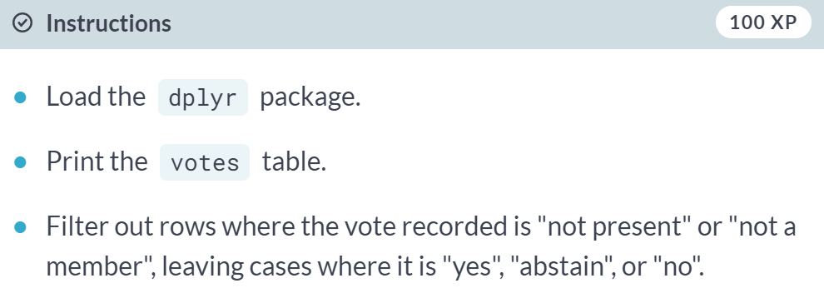  
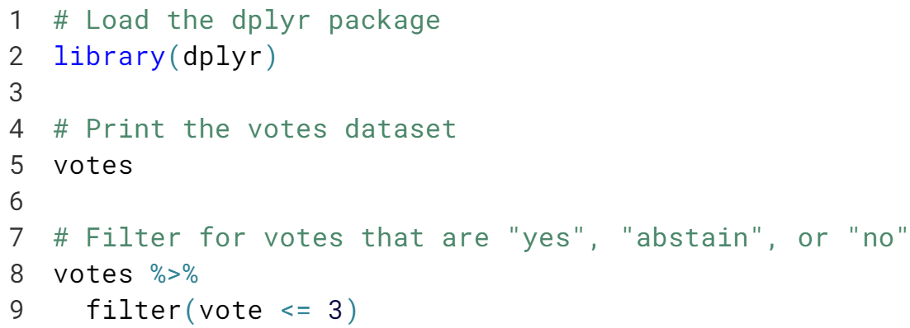

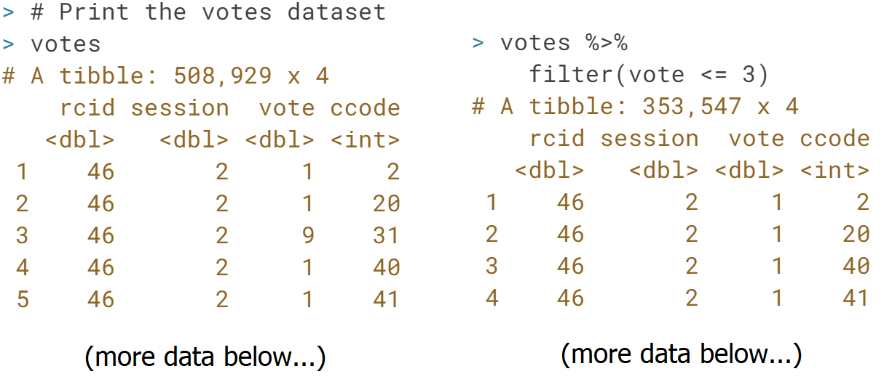

# Adding a year column

The next step of data cleaning is manipulating your variables (columns) to make them more informative.

In this case, you have a session column that is hard to interpret intuitively. But since the UN started voting in 1946, and holds one session per year, you can get the year of a UN resolution by adding 1945 to the session number.

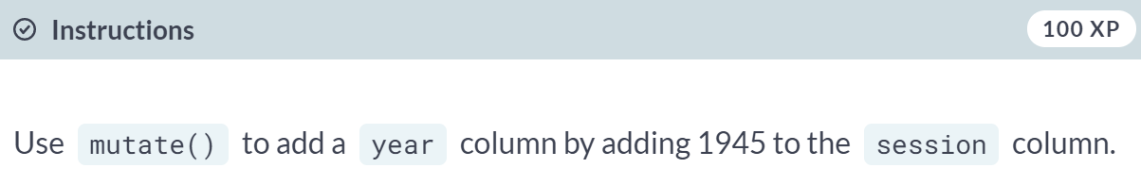

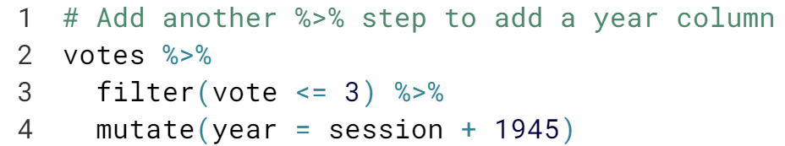

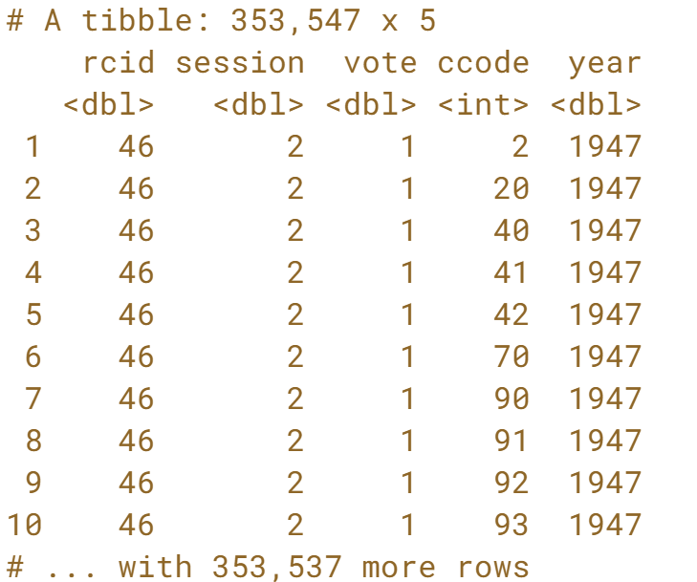

# Adding a country column

The country codes in the ccode column are what's called [**Correlates of War codes**](http://cow.dss.ucdavis.edu/data-sets/cow-country-codes). This isn't ideal for an analysis, since you'd like to work with recognizable country names.

You can use the countrycode package to translate. For example:

library(countrycode)

# Translate the country code 2

> countrycode(2, "cown", "country.name")

[1] "United States"

# Translate multiple country codes

> countrycode(c(2, 20, 40), "cown", "country.name")

[1] "United States" "Canada" "Cuba"

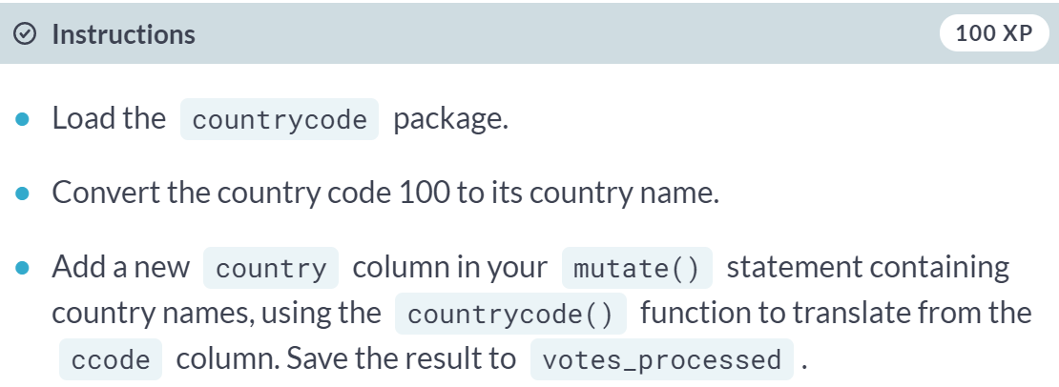

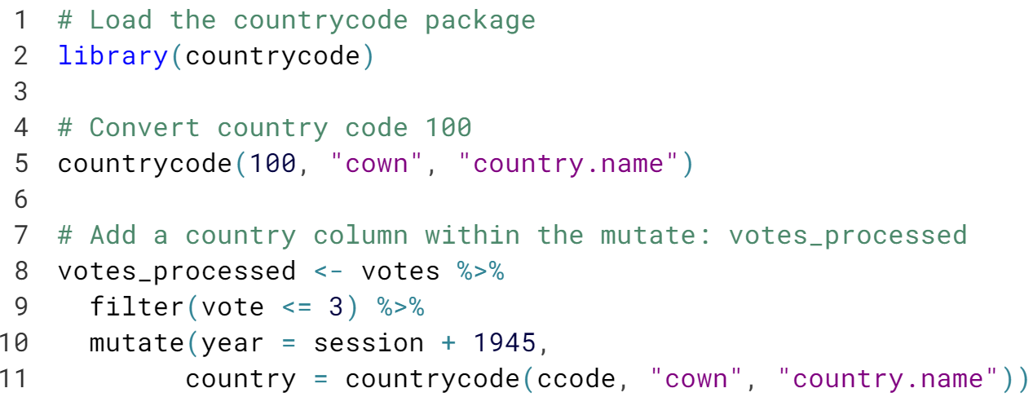







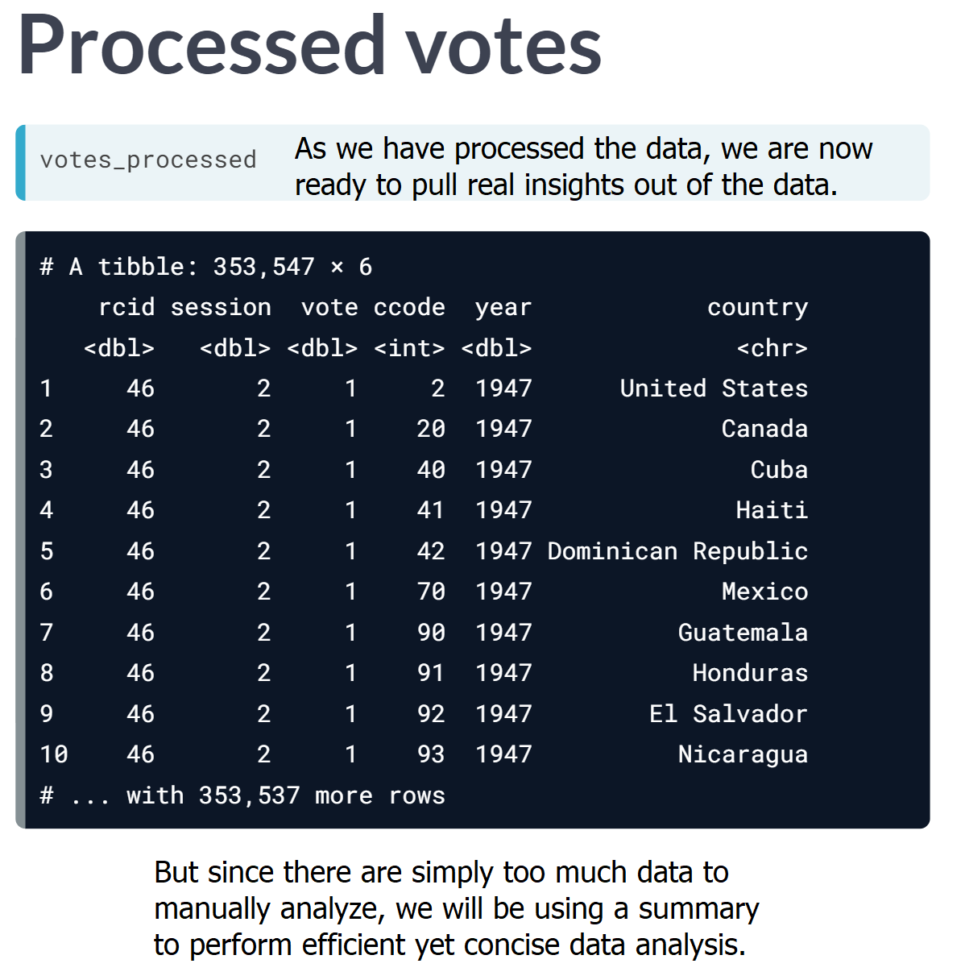  
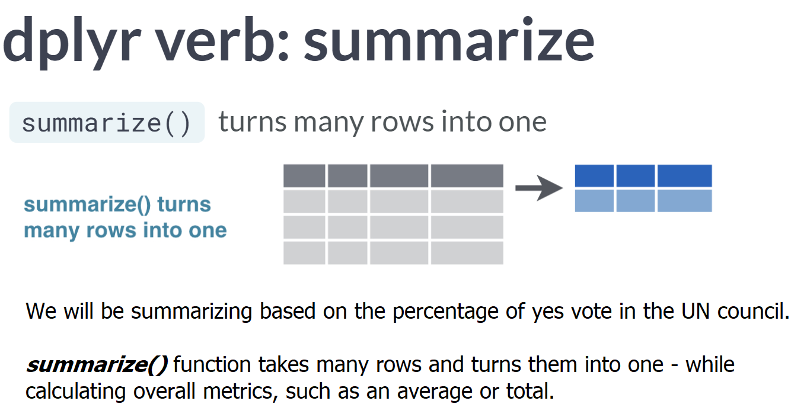

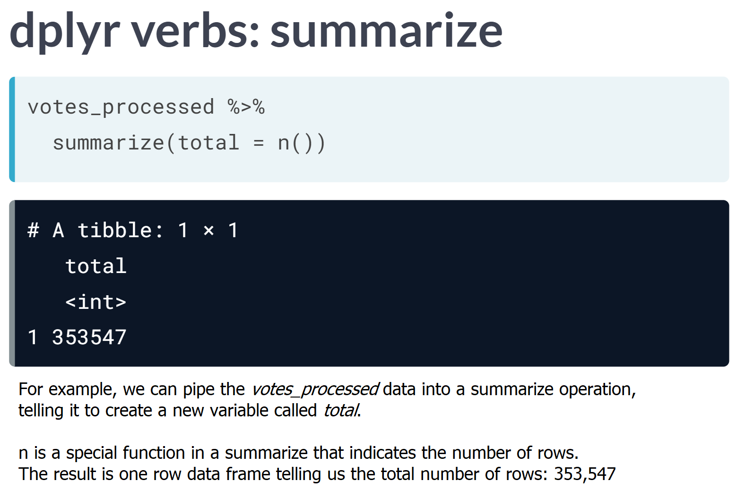

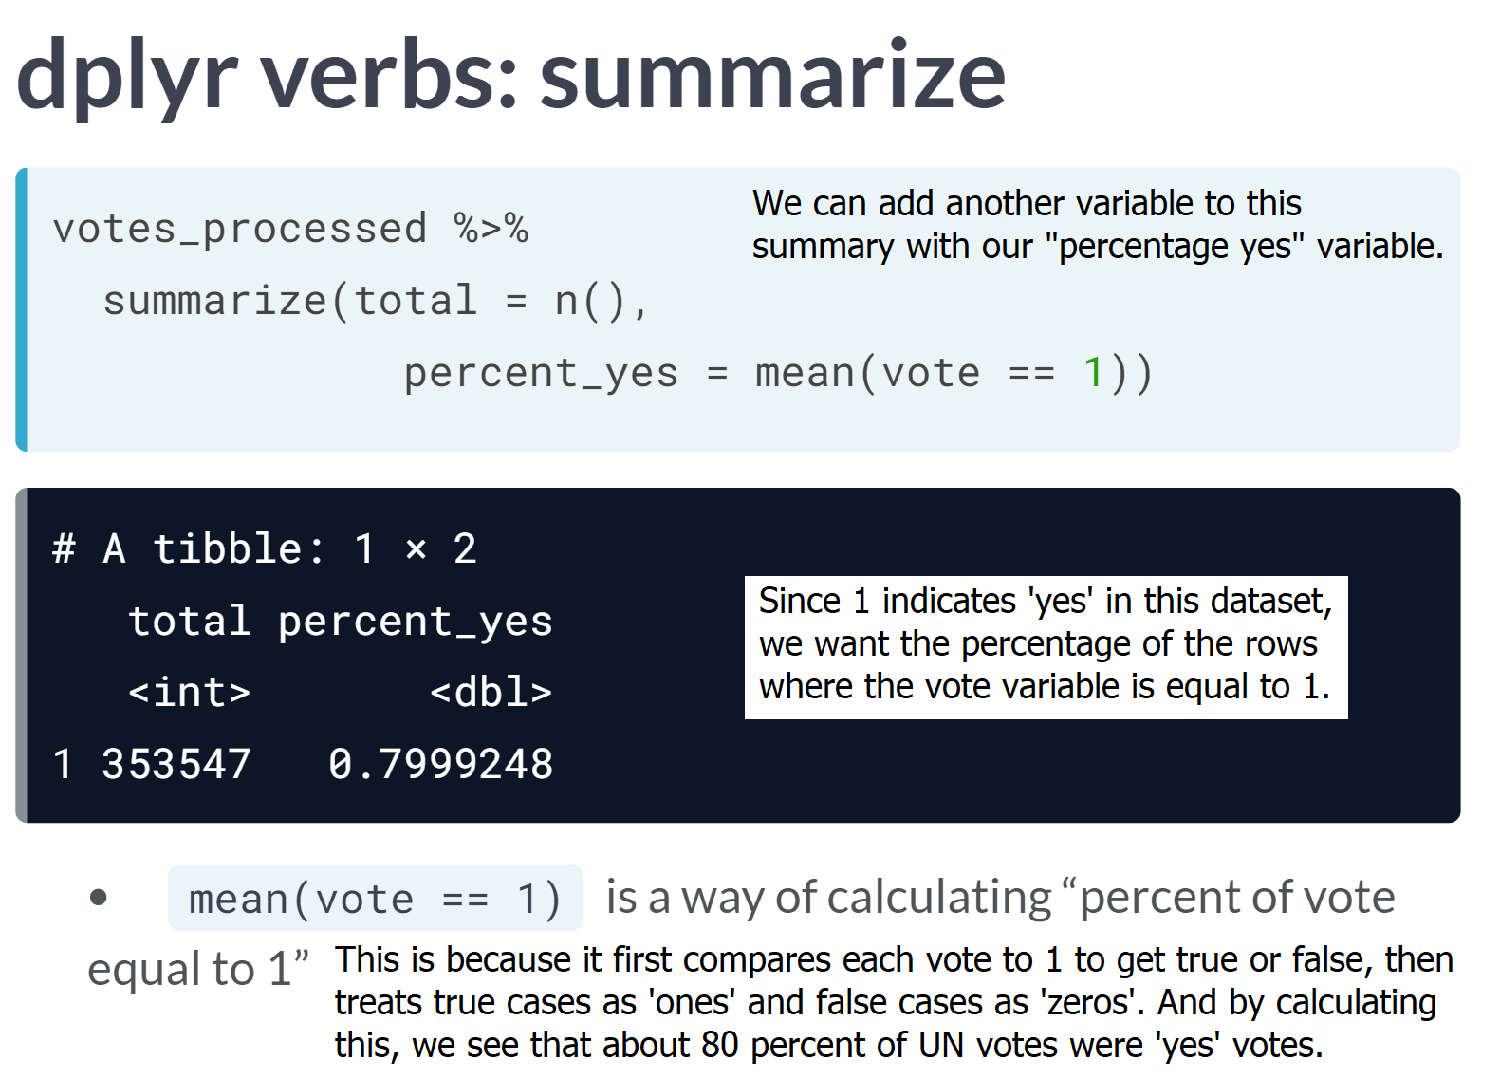

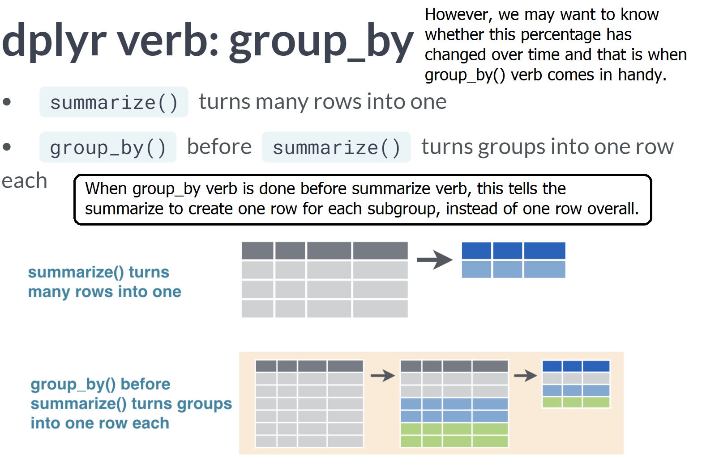

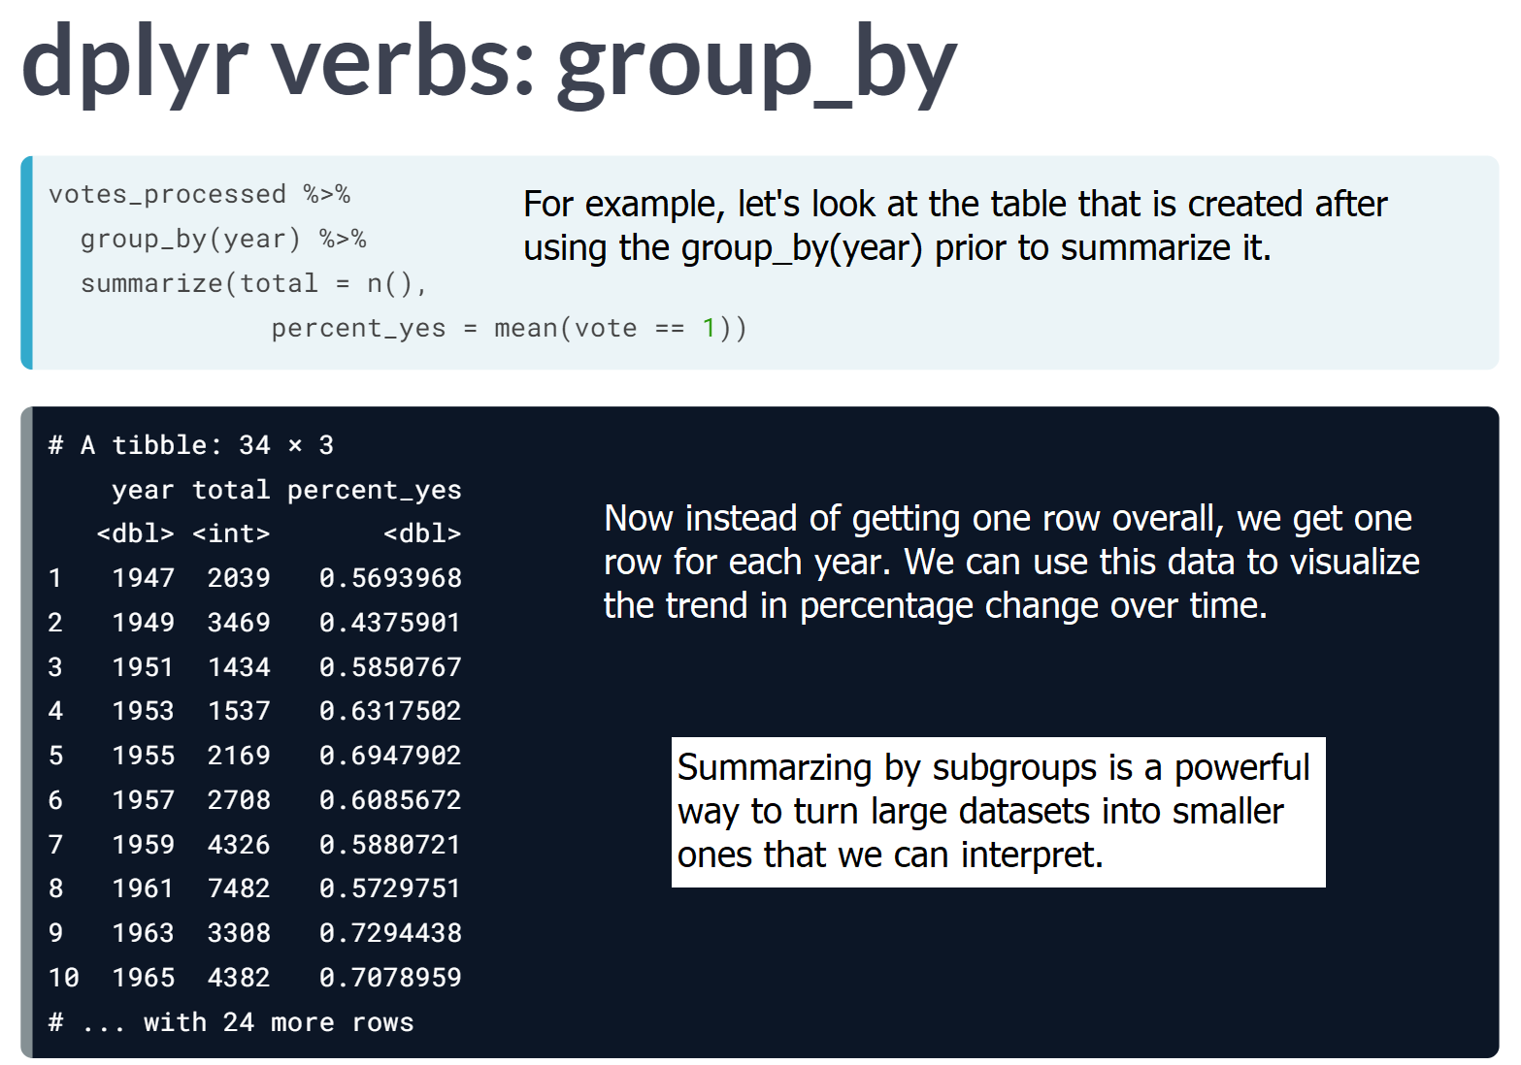

# Summarizing the full dataset

In this analysis, you're going to focus on "% of votes that are yes" as a metric for the "agreeableness" of countries.

You'll start by finding this summary for the entire dataset: the fraction of all votes in their history that were "yes". Note that within your call to summarize(), you can use n() to find the total number of votes and mean(vote == 1) to find the fraction of "yes" votes.

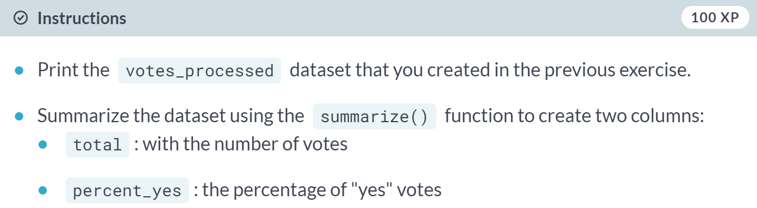

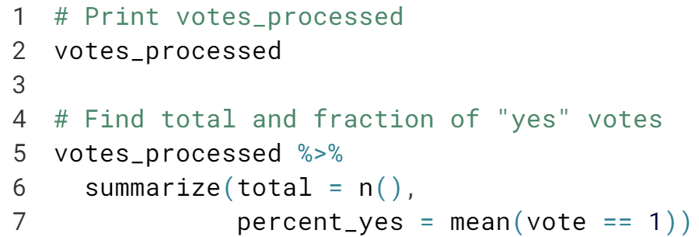

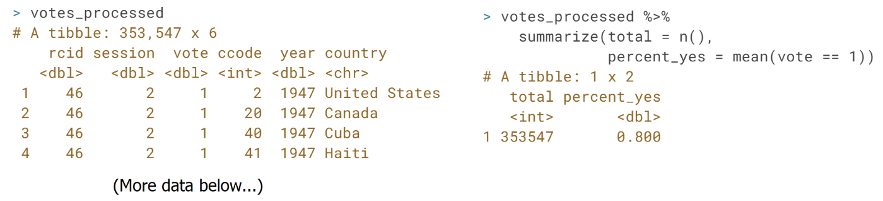

# Summarizing by year

The summarize() function is especially useful because it can be used within groups.

For example, you might like to know how much the average "agreeableness" of countries changed from year to year. To examine this, you can use group\_by() to perform your summary not for the entire dataset, but within each year.



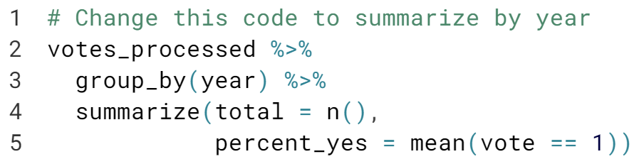  
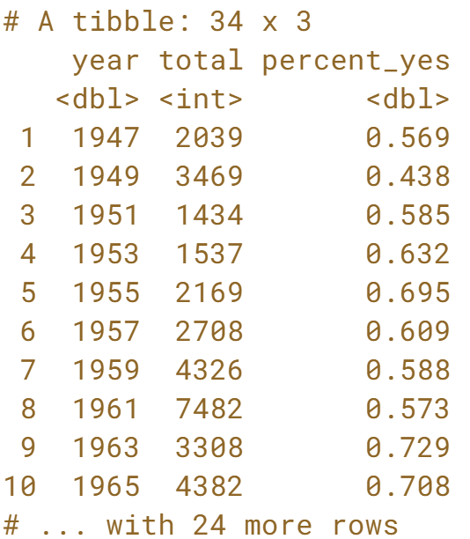  
Nice one! The ***group\_by()*** function must go before your call to ***summarize()*** when you're trying to perform your summary within groups.

# Summarizing by country

In the last exercise, you performed a summary of the votes within each year. You could instead summarize() within each country, which would let you compare voting patterns between countries.

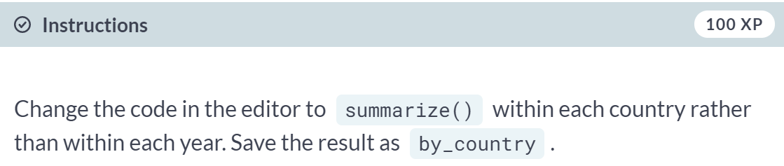  
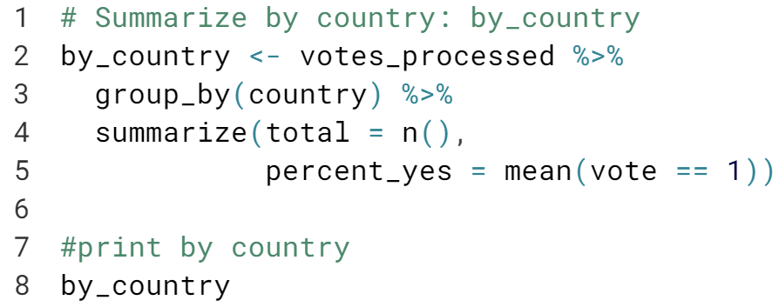

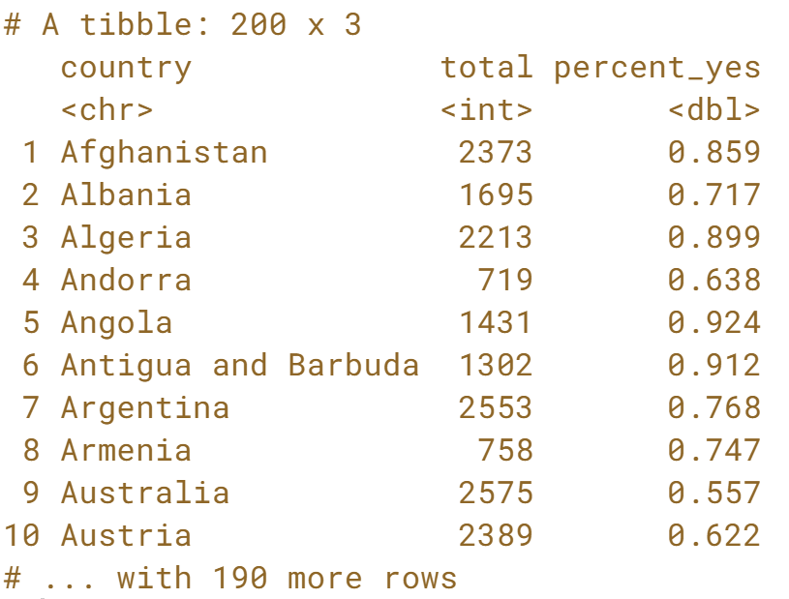

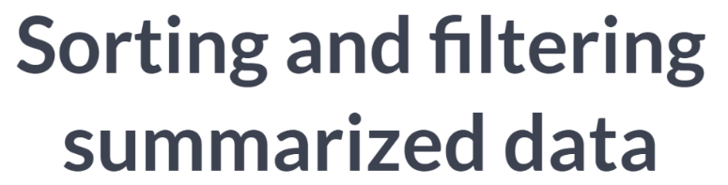

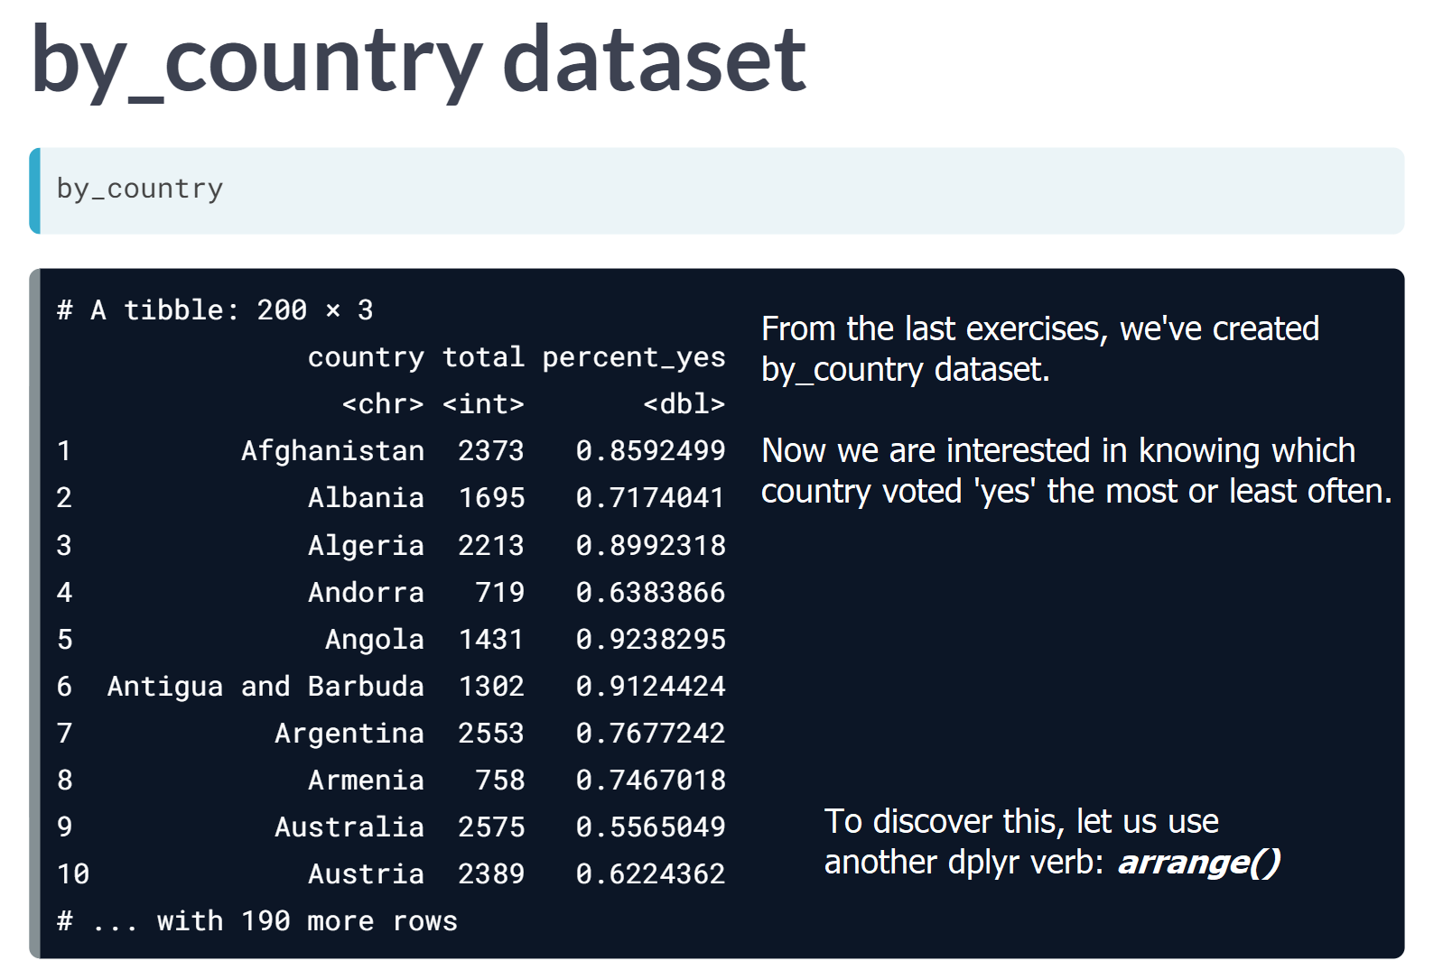

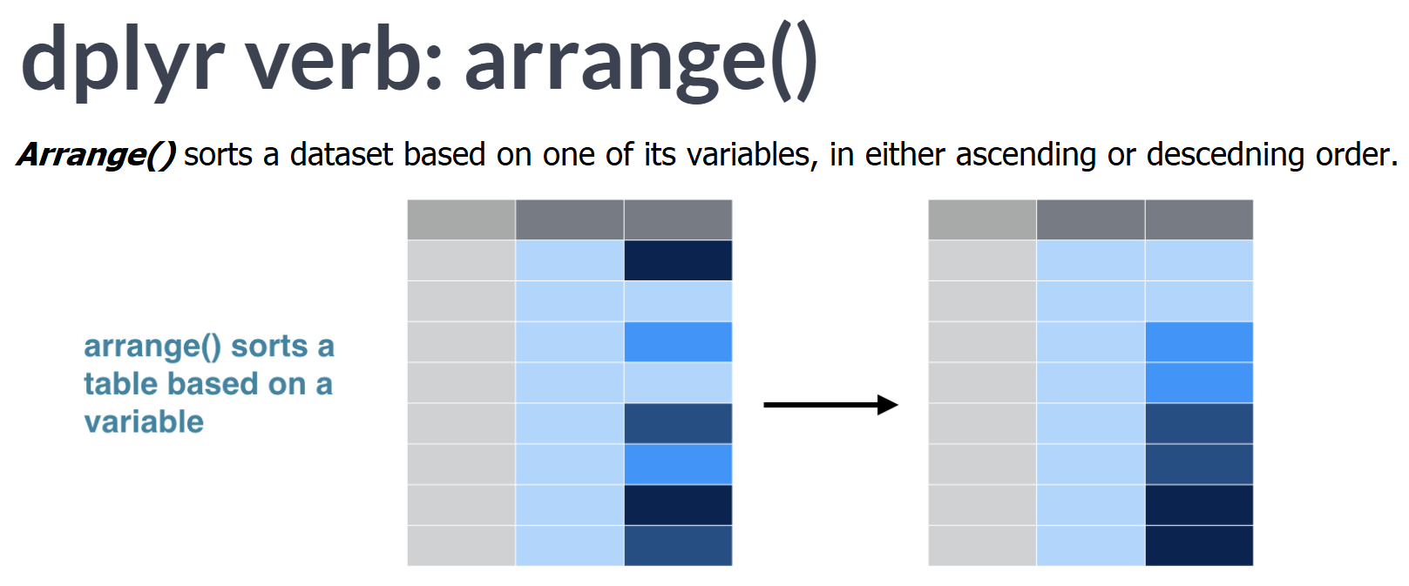

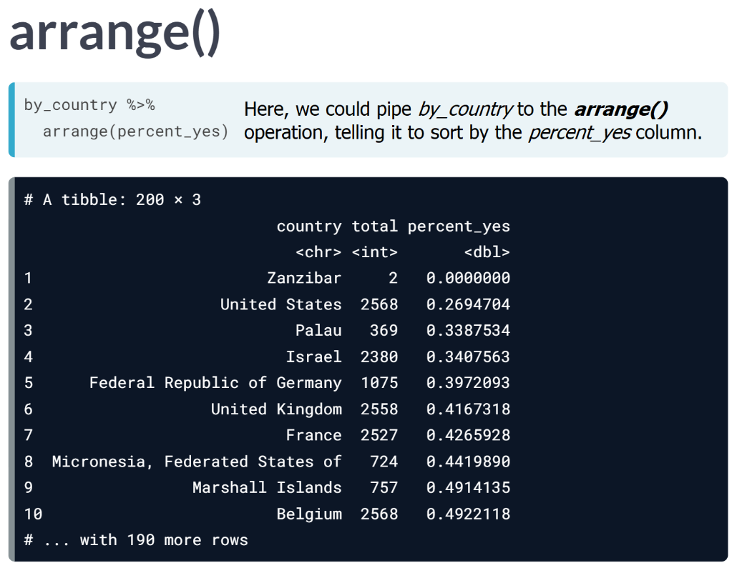

Notice that Zanzibar is the country with least percentage of ‘*yes*’ in their vote, but also note that they only have voted for twice, indicating this percentage value is meaningless as the sample size of the Zanzibar is insufficient.

This is one of the most common ways that summarized data can trip you up. To fix this, in these coming exercises we will filter the dataset to remove countries with a low total, just like we earlier used ***filter()*** to remove vote rows we didn't care about.  
  
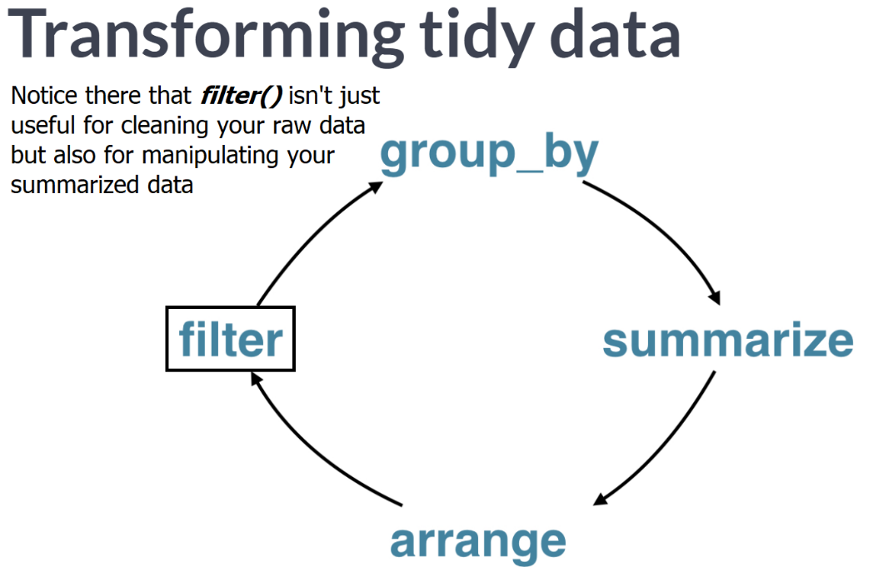  
It's therefore important to get comfortable using each of these dplyr verbs at all the stages of an analysis.

# Sorting by percentage of "yes" votes

Now that you've summarized the dataset by country, you can start examining it and answering interesting questions.

For example, you might be especially interested in the countries that voted "yes" least often, or the ones that voted "yes" most often.

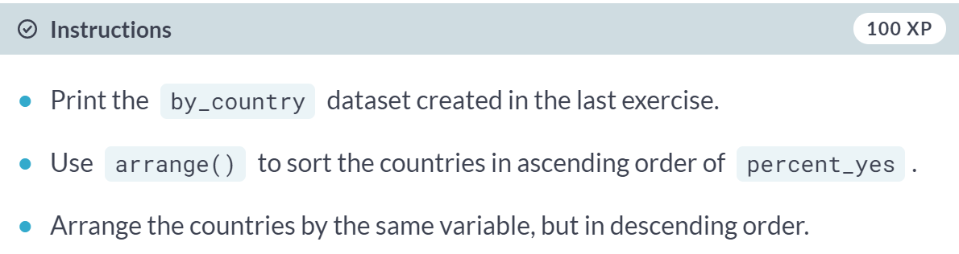

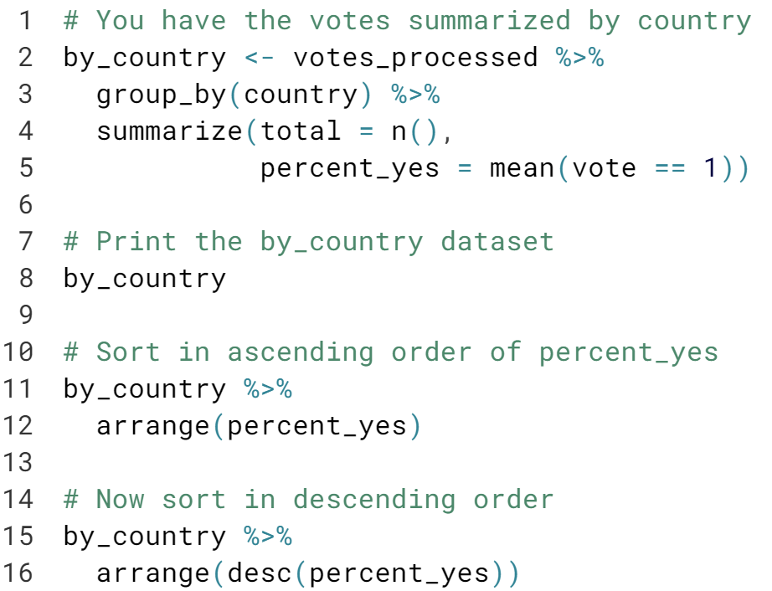

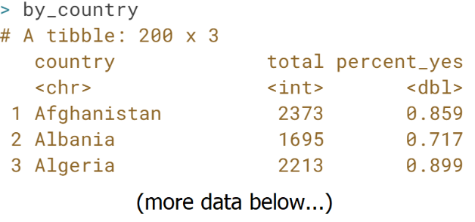  
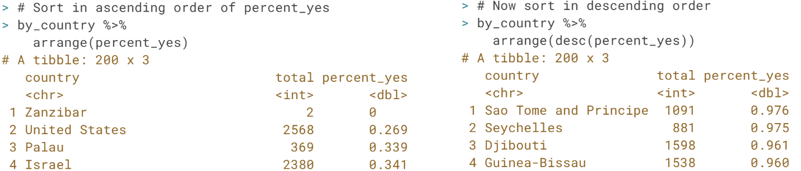

# Filtering summarized output

In the last exercise, you may have noticed that the country that voted least frequently, Zanzibar, had only 2 votes in the entire dataset. You certainly can't make any substantial conclusions based on that data!

Typically, in a progressive analysis, when you find that a few of your observations have very little data while others have plenty, you set some threshold to filter them out.

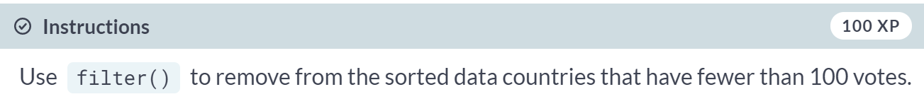

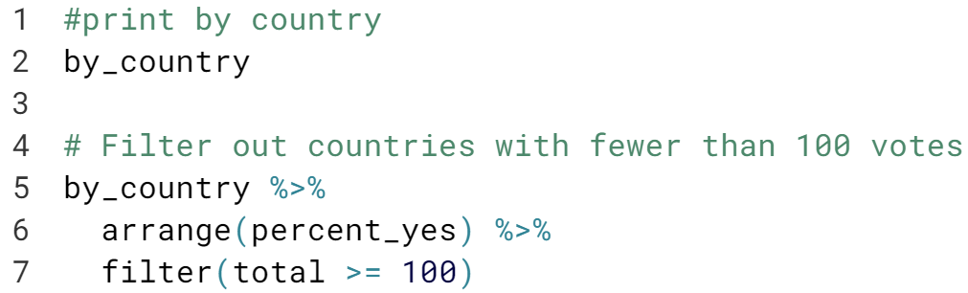

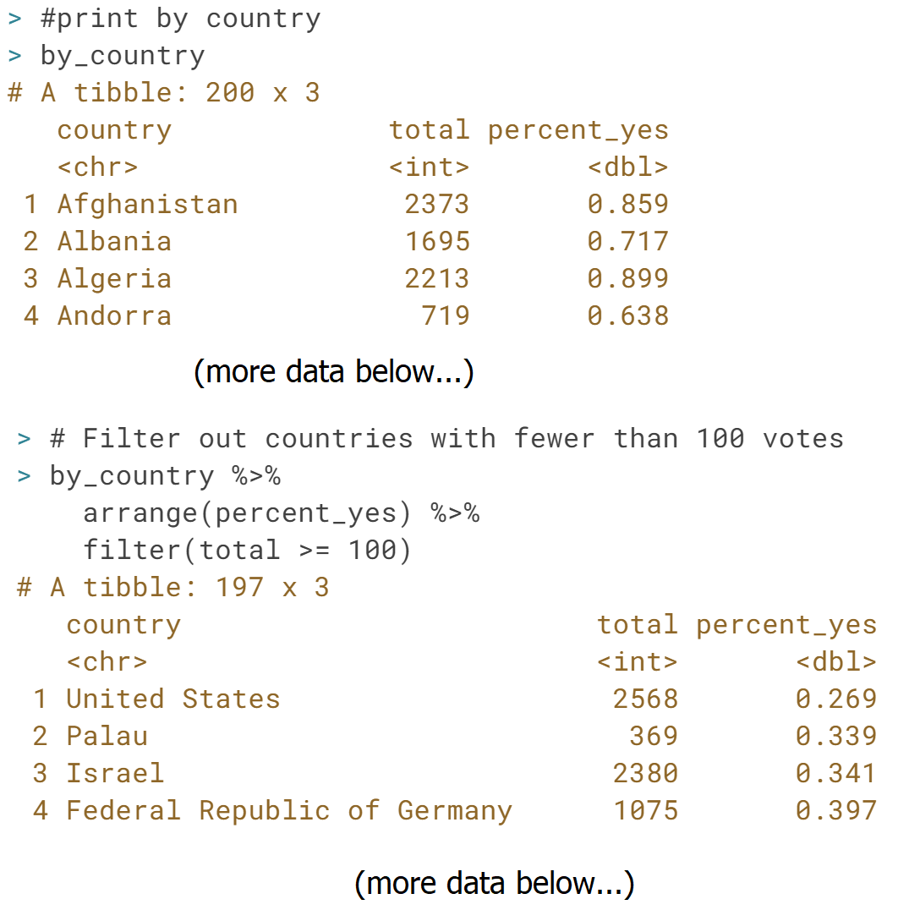

**Data visualization with ggplot2**

Once you've cleaned and summarized data, you'll want to visualize them to understand trends and extract insights. Here you'll use the ggplot2 package to explore trends in United Nations voting within each country over time.



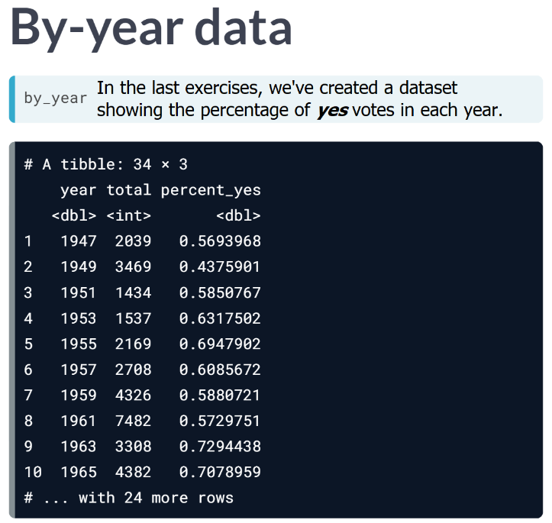

While this isn't a "large" dataset by typical standards, it's still difficult to read through it and get a sense of a trend over time, or to communicate that trend to others. Instead, we want to visualize this data, into a line plot like below:

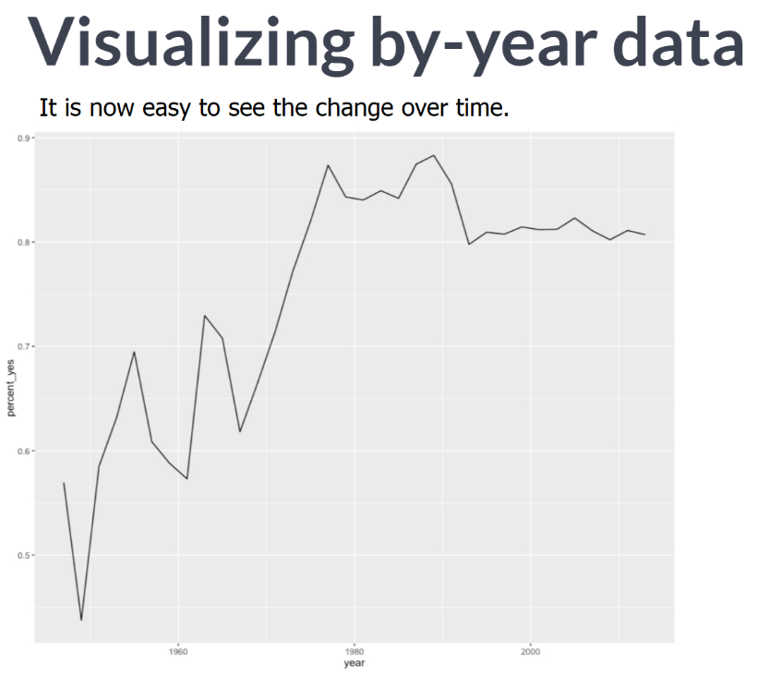  
Data visualization thus makes up the next essential part of our exploratory data analysis.

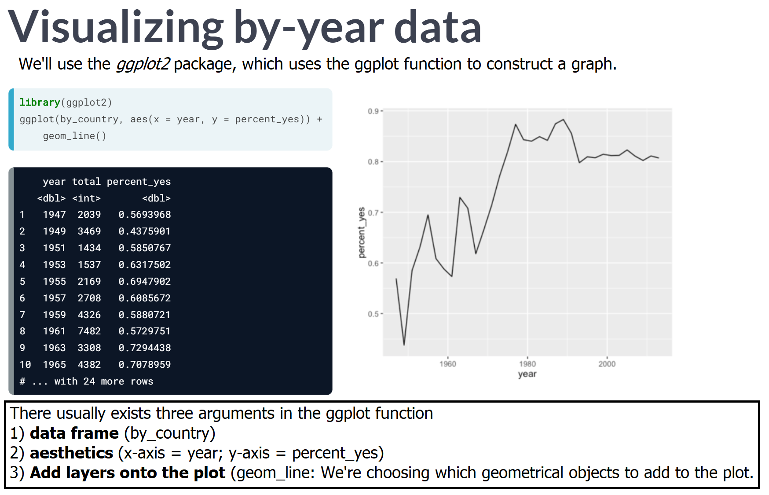

# Choosing an aesthetic

You're going to create a line graph to show the trend over time of how many votes are "yes".

Which of the following aesthetics should you map the year variable to?

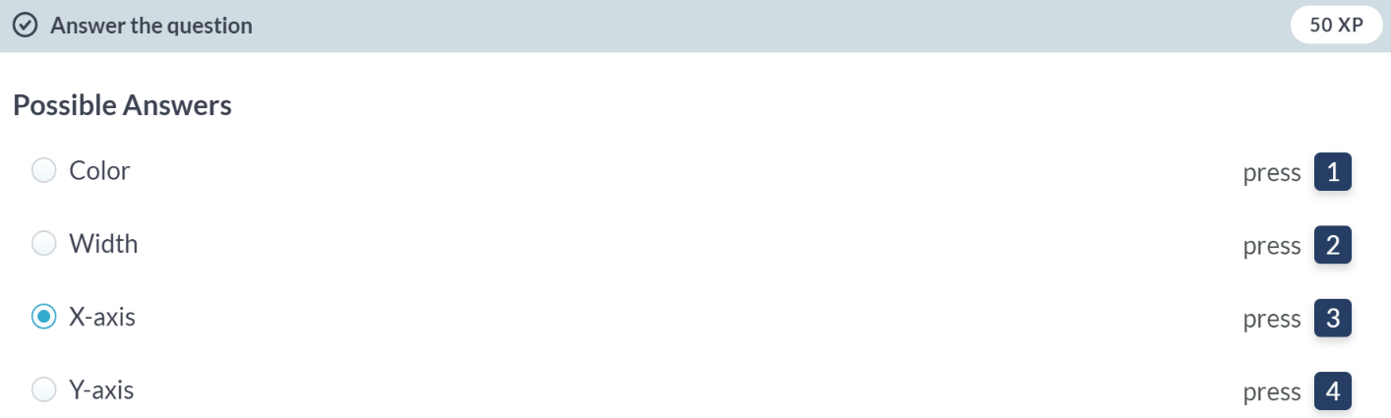  
Right! To plot a line graph to show the trend over time, the year variable should be on the x-axis.

# Plotting a line over time

In the last chapter, you learned how to summarize() the votes dataset by year, particularly the percentage of votes in each year that were "yes".

You'll now use the ggplot2 package to turn your results into a visualization of the percentage of "yes" votes over time.

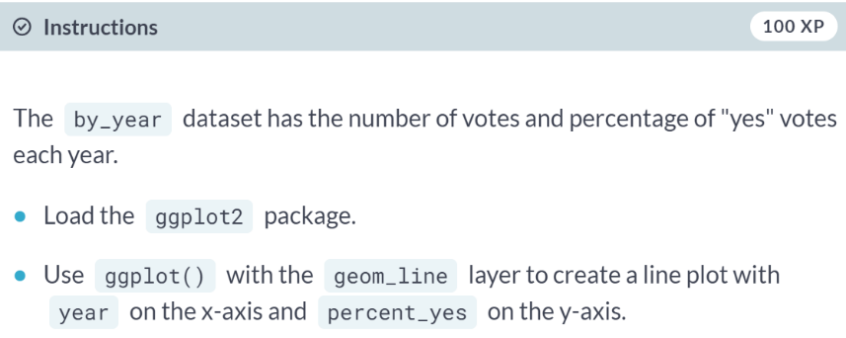

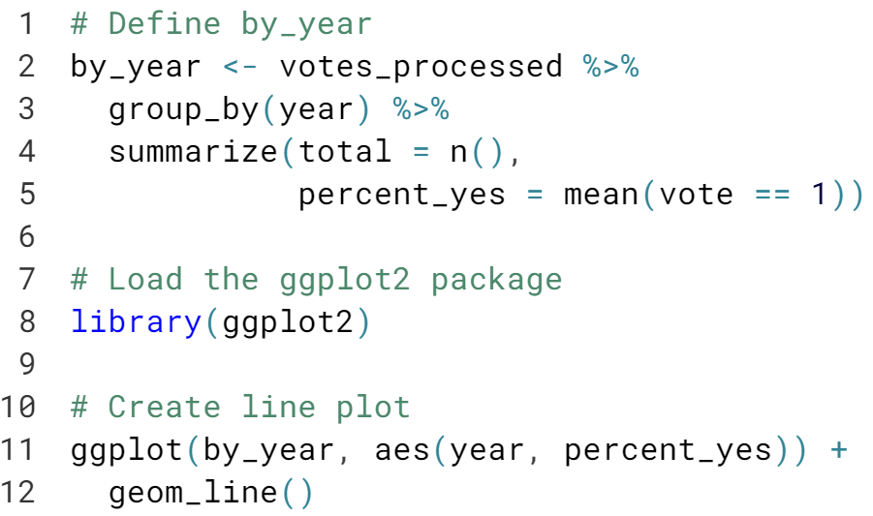

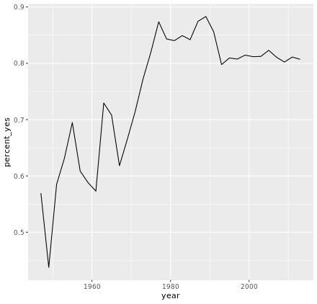

# Other ggplot2 layers

A line plot is one way to display this data. You could also choose to display it as a scatter plot, with each year represented as a single point. This requires changing the layer (i.e. geom\_line() to geom\_point()).

You can also add additional layers to your graph, such as a smoothing curve with geom\_smooth().



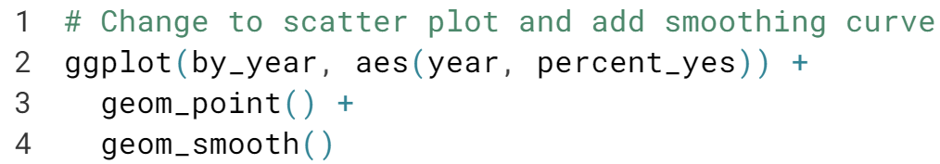

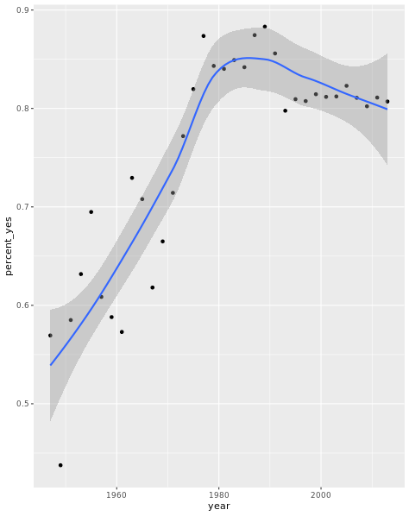



What if we wanted to plot the trend only for one country, such as the United States, to find out how its relationship with the United Nations has changed over time?

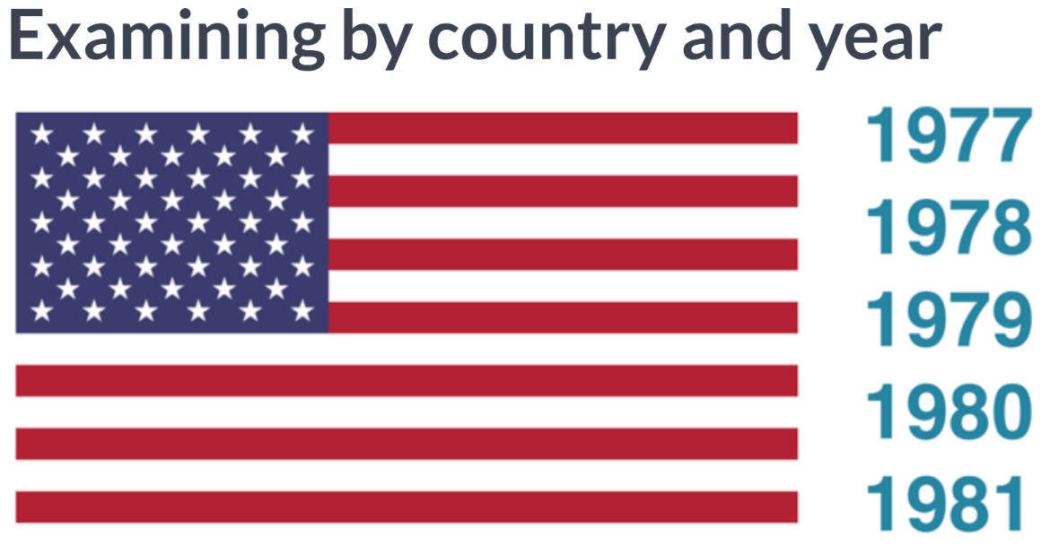

First we'll have to change our summary operation to structure our data appropriately.

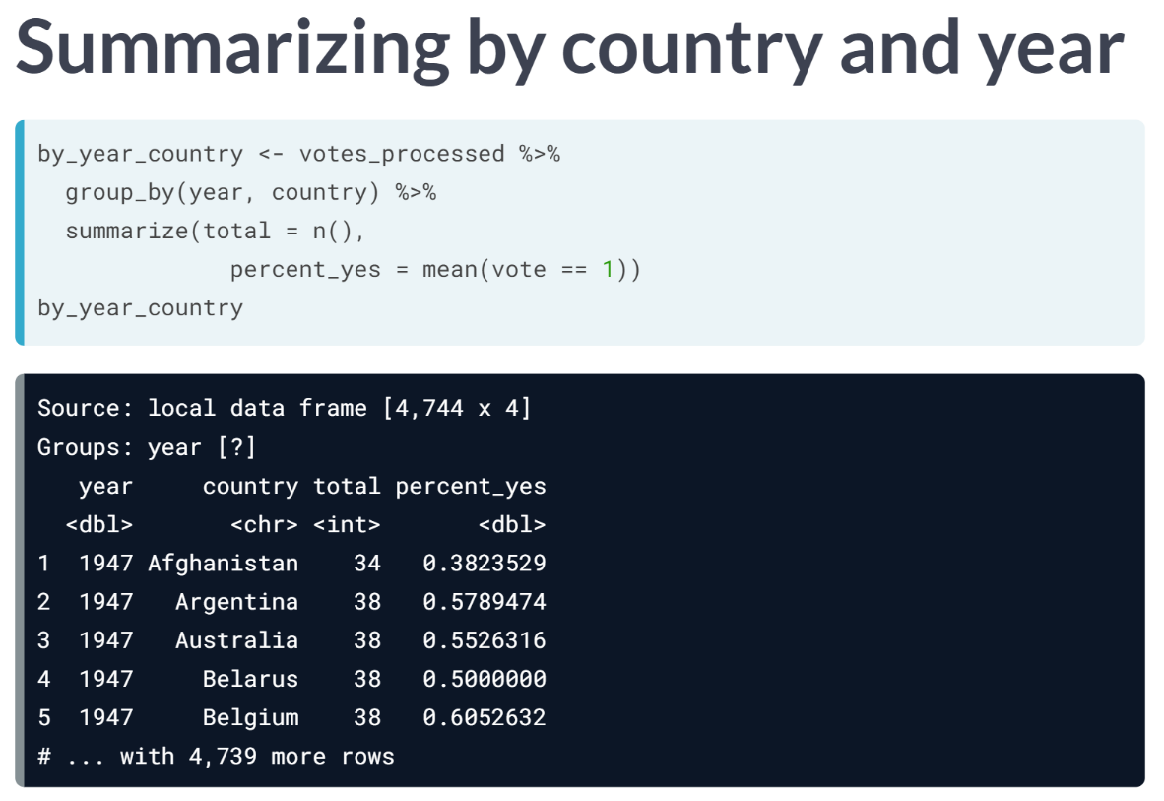

We've summarized by year before, and by country. Now, we're going to summarize by both, by adding year and country to the ***group\_by*** operation.

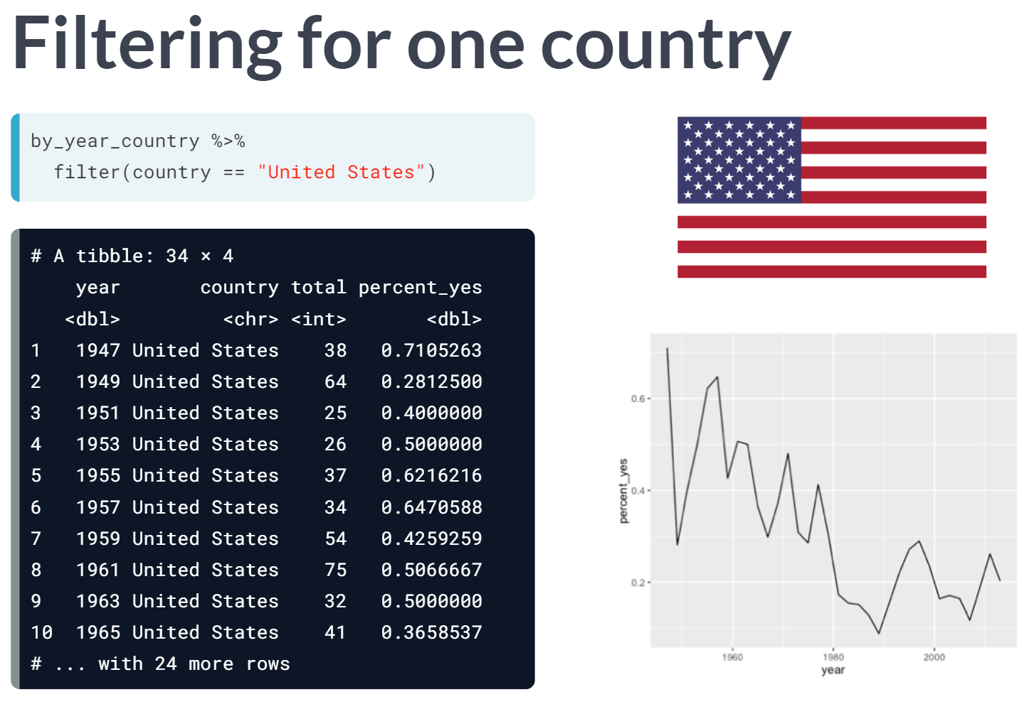

Once we have this data, we can extract the votes for just one country - such as the United States - with a filter operation.

This data is then easy to visualize the same way we visualized overall trends in the last exercises.

This ***by\_year\_country*** data gives us even more options: instead of plotting one country at a time, we can plot multiple by using additional %in% operator.

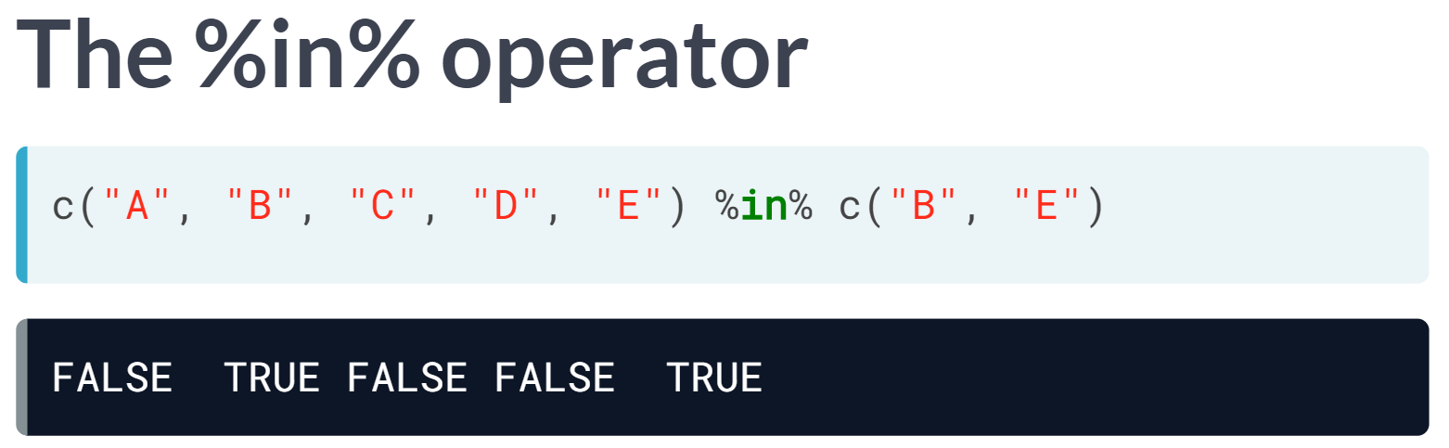

This ***%in%*** operator lets us take one vector and determine which of its items are in another vector. For example, here it would determine that the second and fifth elements, B and E, are in the second vector.

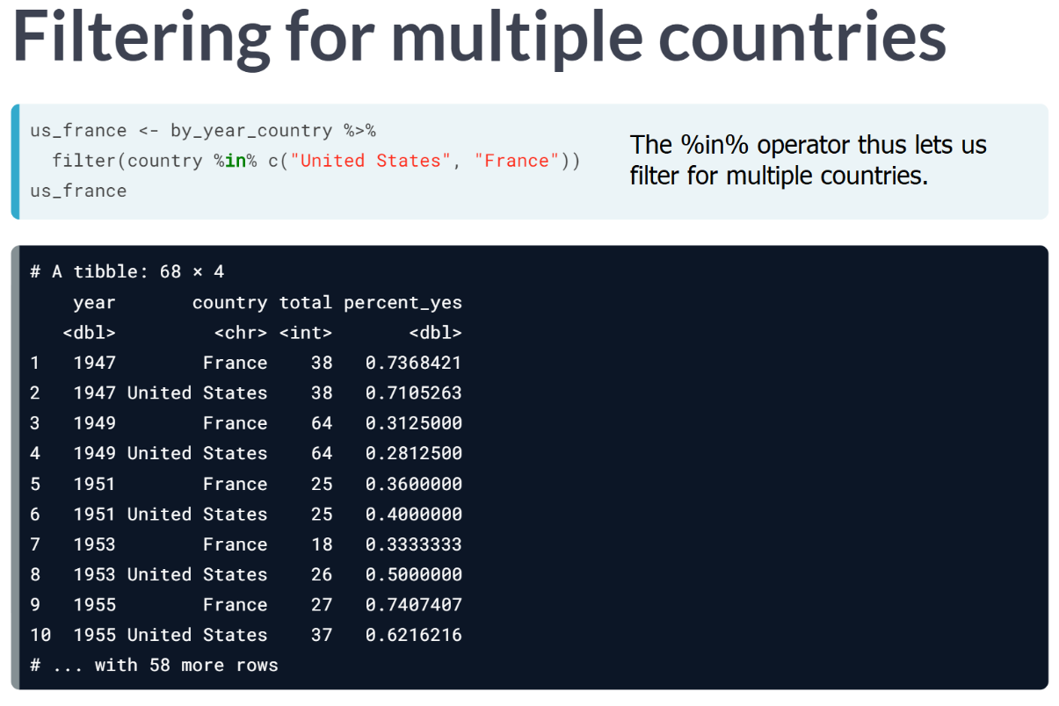

Here we are only filtering for the United States and France, which end up as the only rows in our data frame.

Don't forget "c" in our designation of United States and France as that's just the R way of defining a vector.

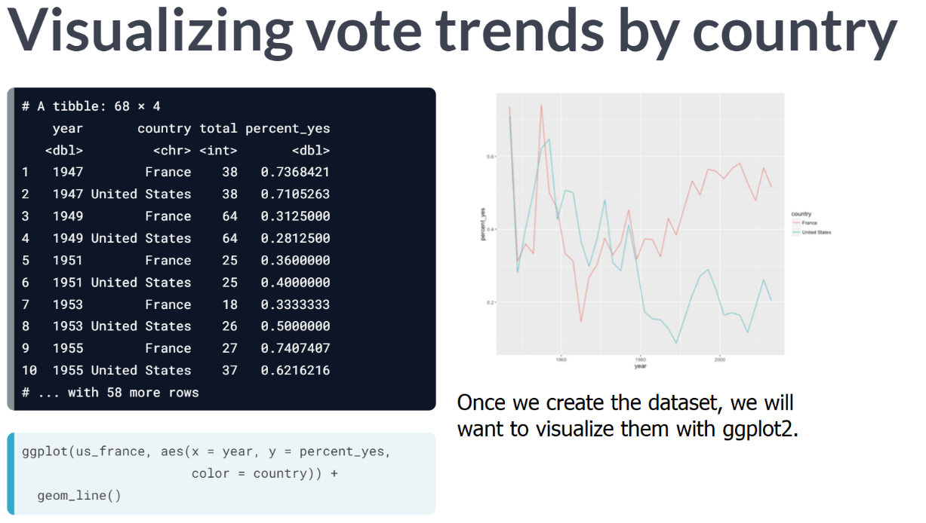  
To show both countries on the same plot while distinguishing them, we will need to add another aesthetic besides x and y to our aes call.   
  
In this case, a good choice is color. By adding "***color = country***" to our aesthetics, we can plot both lines on one graph, with a legend distinguishing the two.

# Summarizing by year and country

You're more interested in trends of voting within specific countries than you are in the overall trend. So instead of summarizing just by year, summarize by both year and country, constructing a dataset that shows what fraction of the time each country votes "yes" in each year.

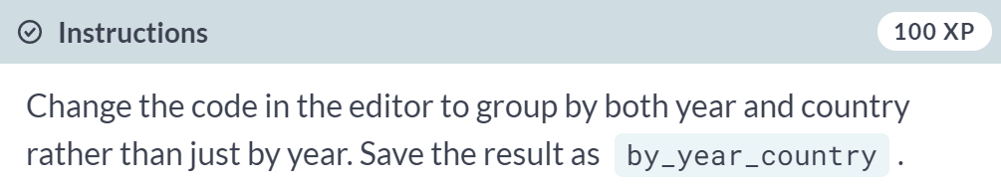

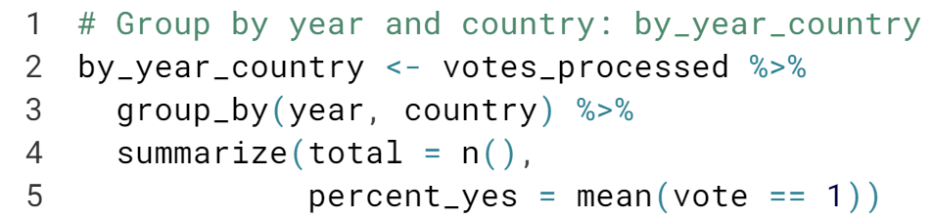

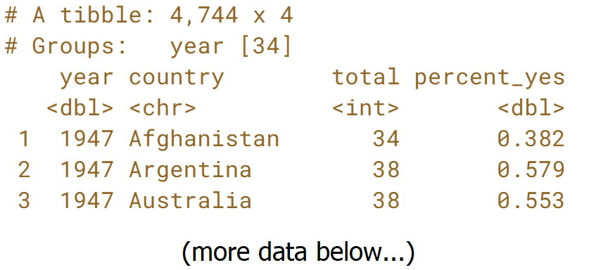

Awesome! Let's make some plots using this new dataset in the next exercise.

# Plotting just the UK over time

Now that you have the percentage of time that each country voted "yes" within each year, you can plot the trend for a particular country. In this case, you'll look at the trend for just the United Kingdom.

This will involve using filter() on your data before giving it to ggplot2.

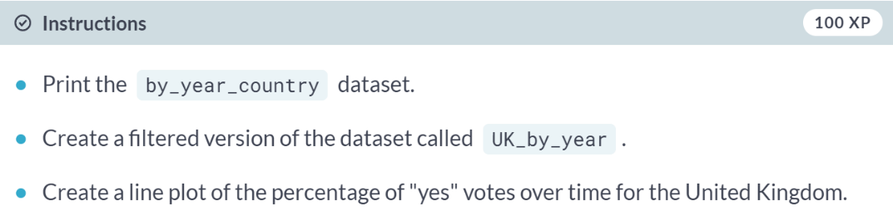

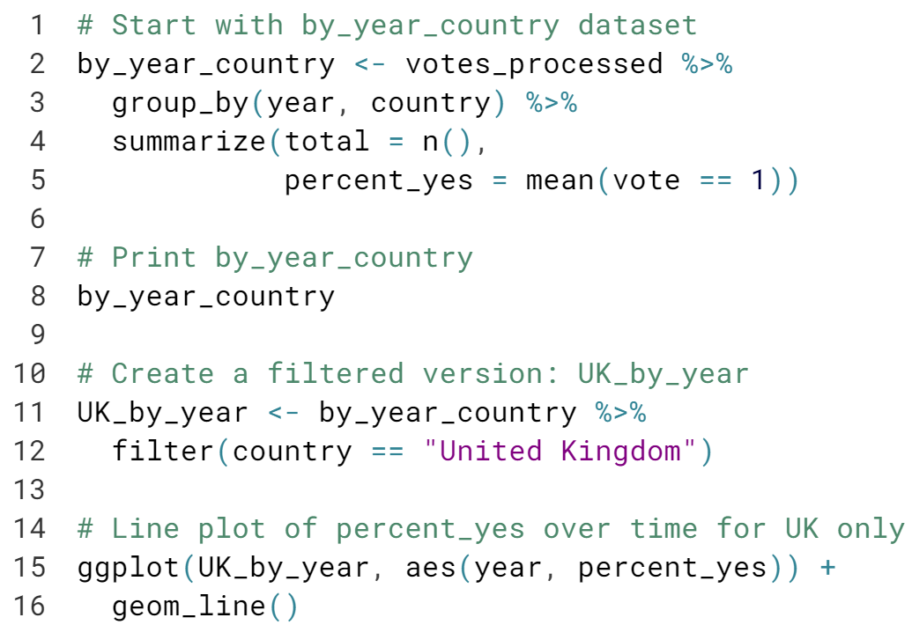

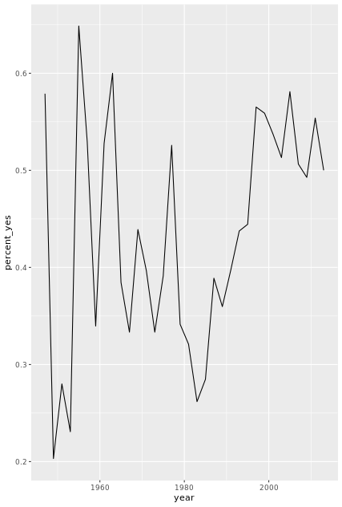

# Plotting multiple countries

Plotting just one country at a time is interesting, but you really want to compare trends between countries. For example, suppose you want to compare voting trends for the United States, the UK, France, and India.

You'll have to filter to include all four of these countries and use another aesthetic (not just x- and y-axes) to distinguish the countries on the resulting visualization. Instead, you'll use the color aesthetic to represent different countries.

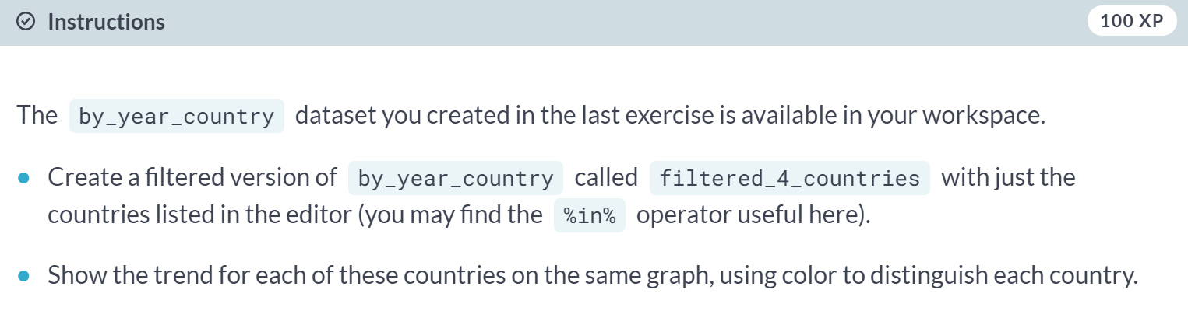

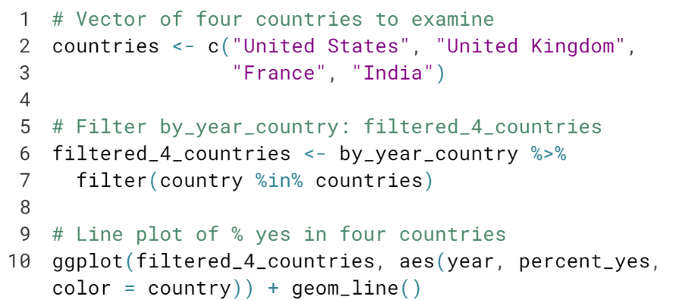  
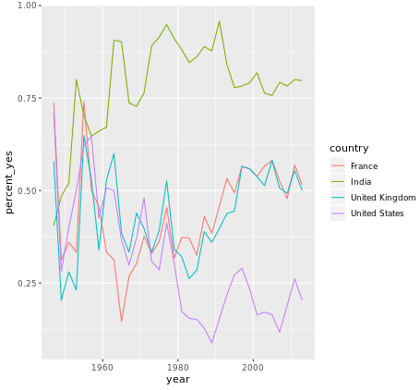



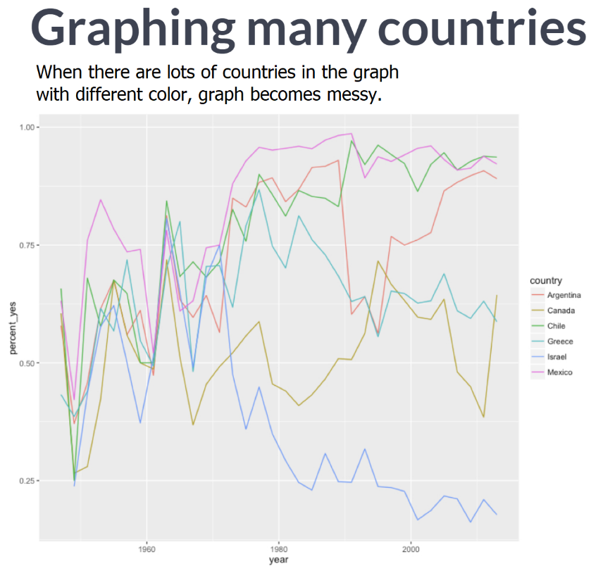  
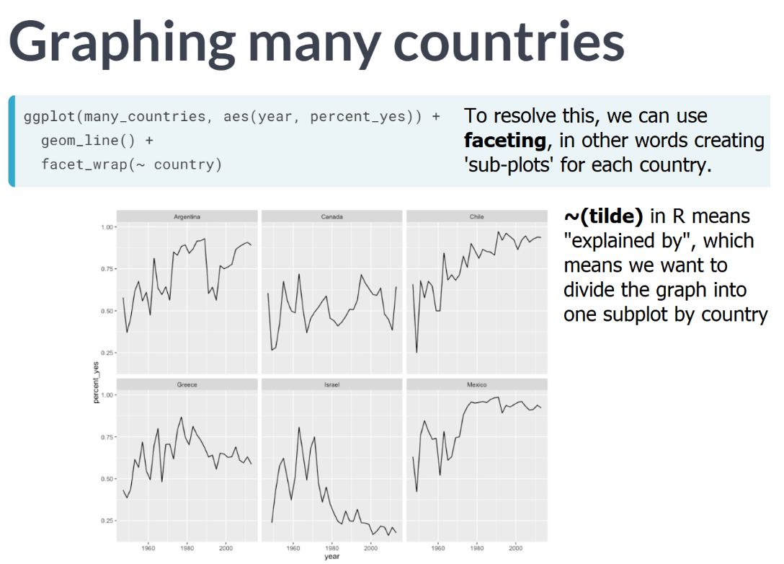

When six countries are divided onto separate subplots, it becomes a lot easier to understand each country's trend. You also might notice that all six graphs have the same y-axis, even though they cover different ranges, leading to "wasted space" within each graph, where the trend in particular countries is compressed because of the patterns in other countries.

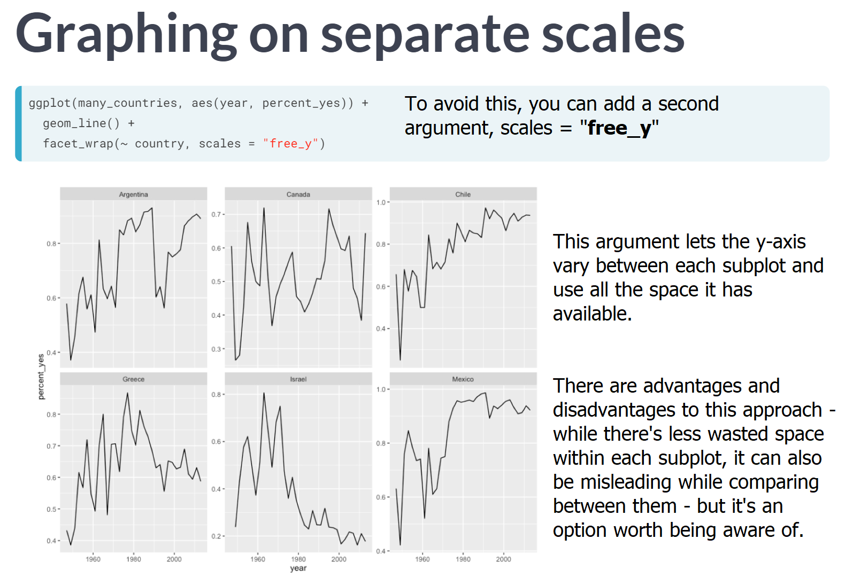

# Faceting the time series

Now you'll take a look at six countries. While in the previous exercise you used color to represent distinct countries, this gets a little too crowded with six.

Instead, you will facet, giving each country its own sub-plot. To do so, you add a facet\_wrap() step after all of your layers.

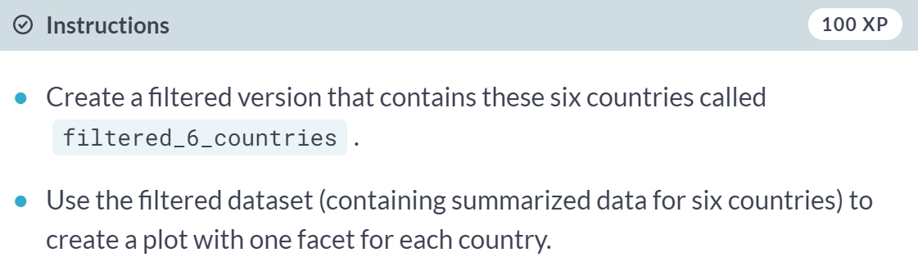

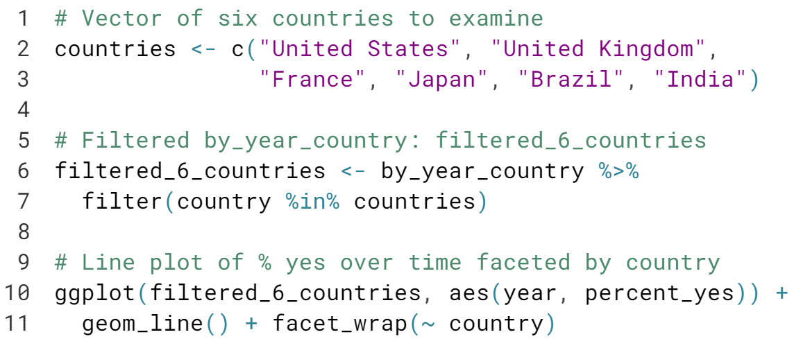

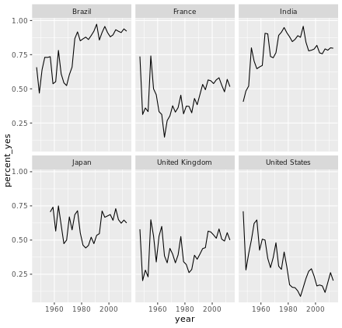

# Faceting with free y-axis

In the previous plot, all six graphs had the same axis limits. This made the changes over time hard to examine for plots with relatively little change.

Instead, you may want to let the plot choose a different y-axis for each facet.



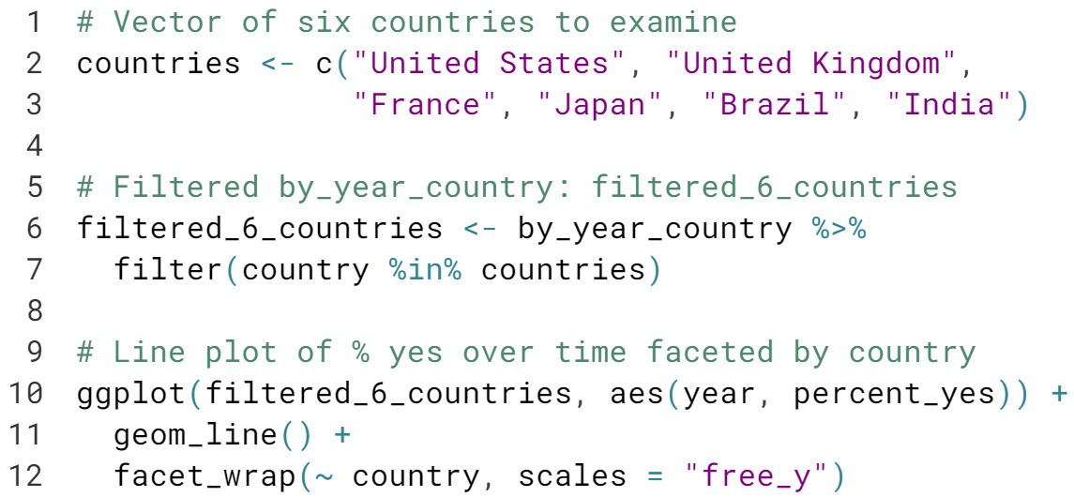

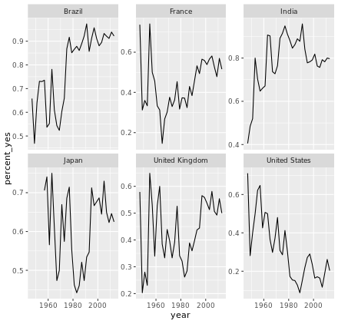

# Choose your own countries

The purpose of an exploratory data analysis is to ask questions and answer them with data. Now it's your turn to ask the questions.

You'll choose some countries whose history you are interested in and add them to the graph. If you want to look up the full list of countries, enter by\_country$country in the console.

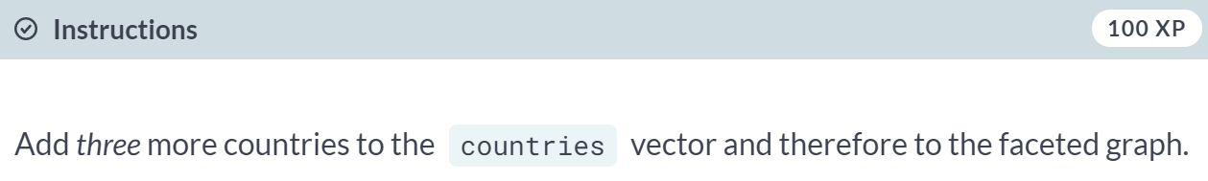

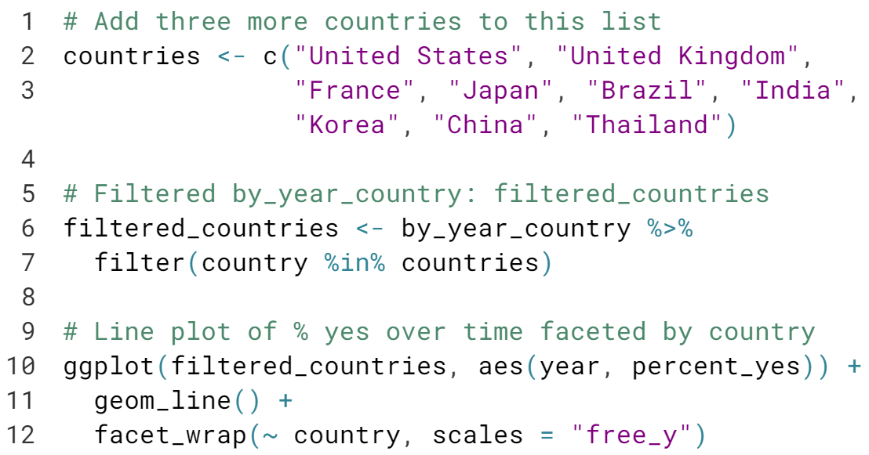

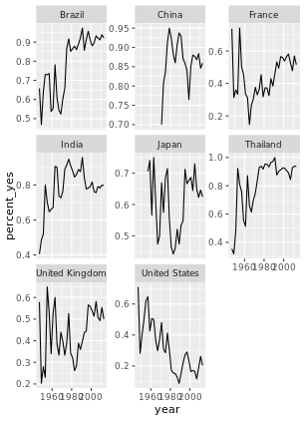

#### Tidy modeling with broom

While visualization helps you understand one country at a time, statistical modeling lets you quantify trends across many countries and interpret them together. Here you'll learn to use the tidyr, purrr, and broom packages to fit linear models to each country, and understand and compare their outputs.



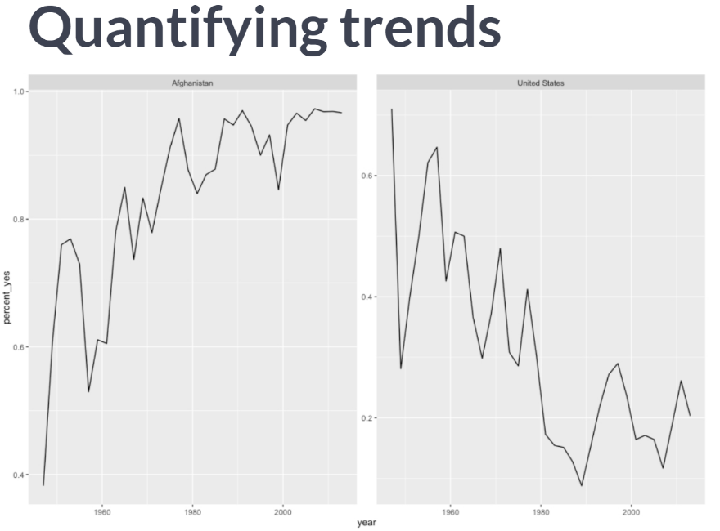

last chapter, we learned to visualize the trend of the "% yes" metric over time for individual counties and observed that Afghanistan's agreement has been generally going up while the United States has been going down. While it's easy to recognize this trend visually, we haven't yet quantified it.

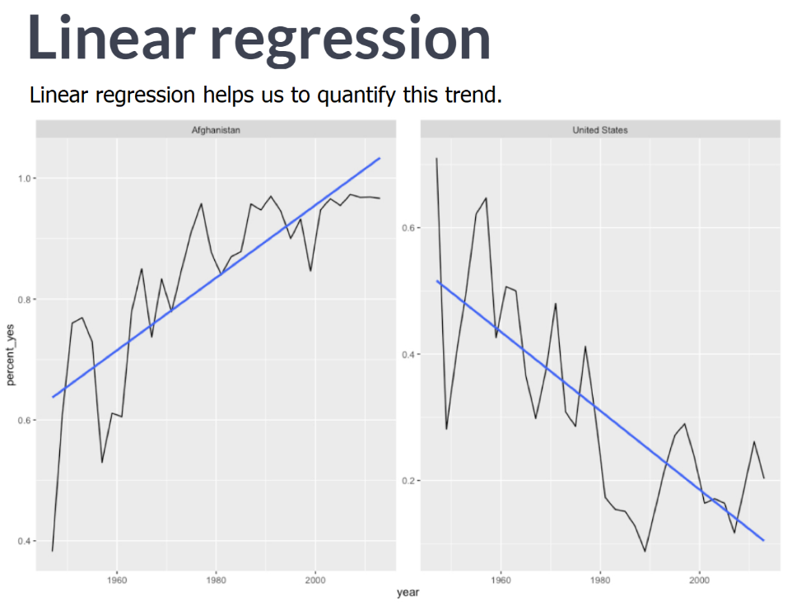

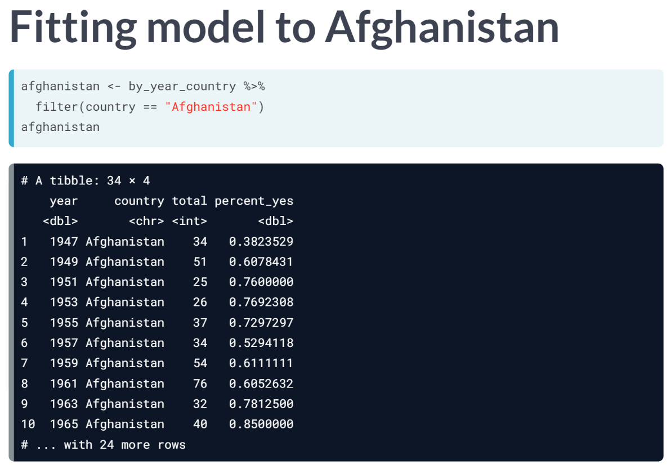

First, you can use filter to extract the per-year-data for one country, in this case Afghanistan, into its own data frame.

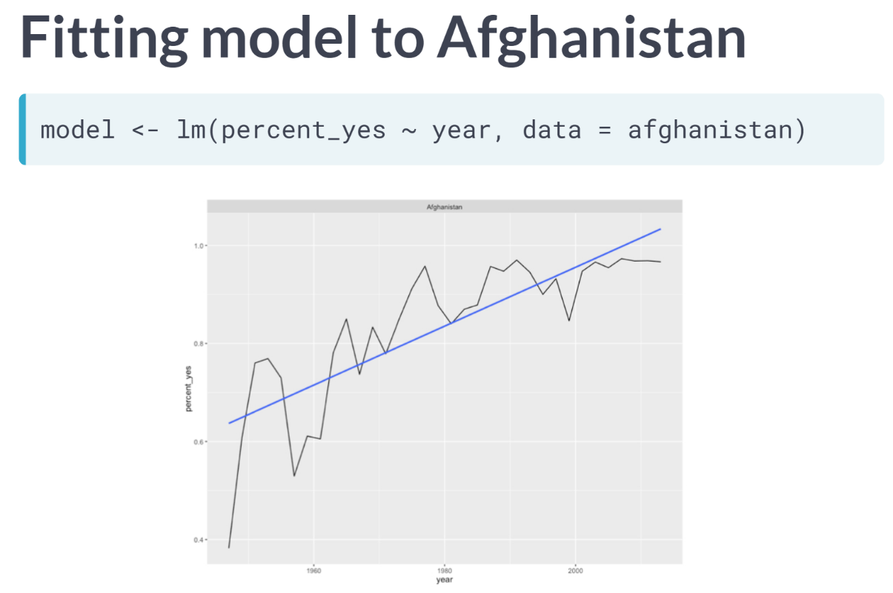

We can then use the *lm* function, short for "*linear model*", to fit the line. We describe the model as "*percent\_yes ~ year*".

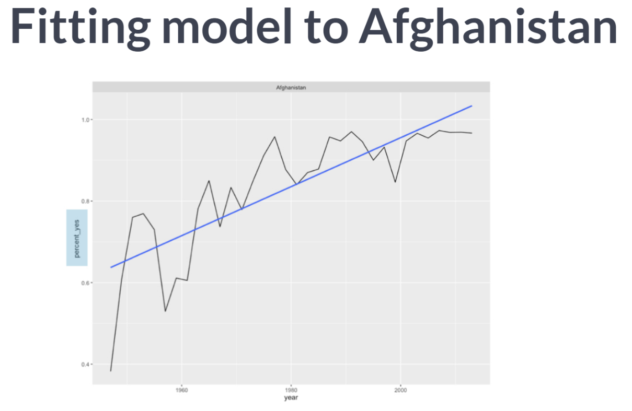

*Percent\_yes* is our dependent variable on the y-axis. Next is the *~(tilde)* - as described earlier it means "explained by". Then we have a *year*, the independent variable , on the x-axis. This says we are modeling "**percent yes explained by year**".

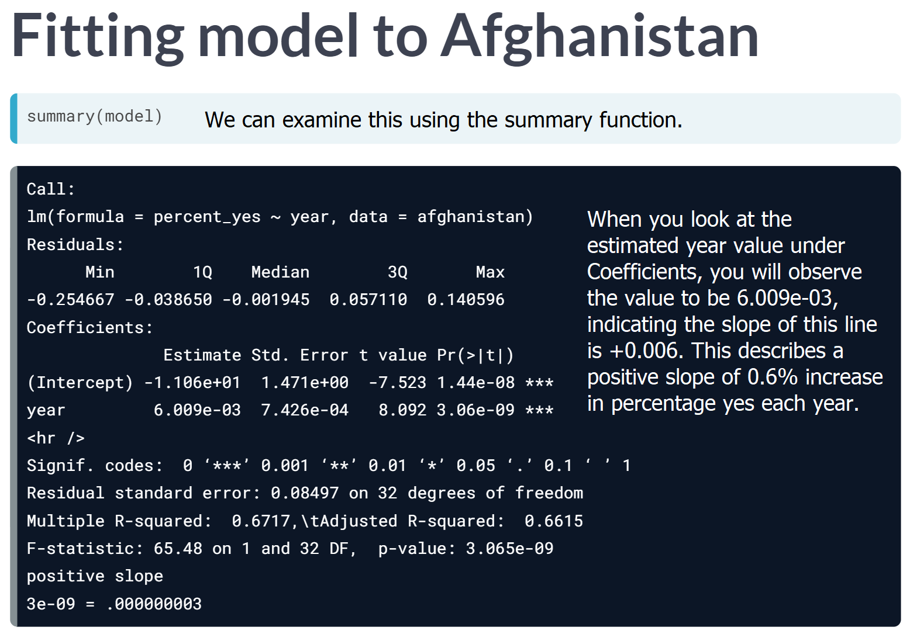



# Linear regression on the United States

A linear regression is a model that lets us examine how one variable changes with respect to another by fitting a best fit line. It is done with the lm() function in R.

Here, you'll fit a linear regression to just the percentage of "yes" votes from the United States.

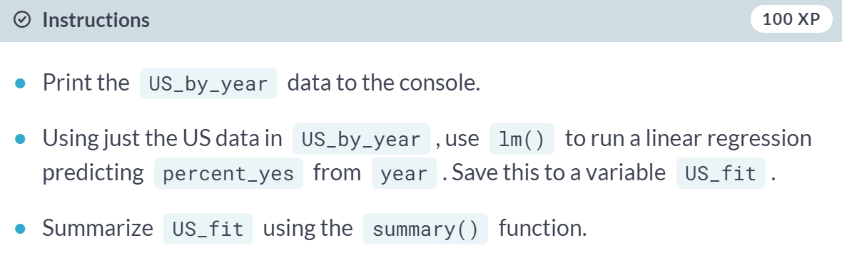

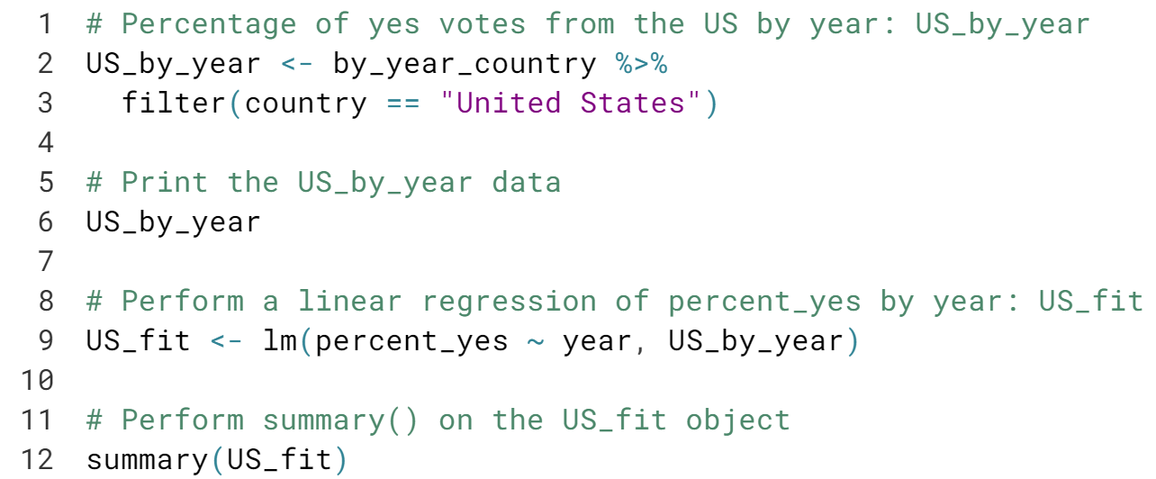

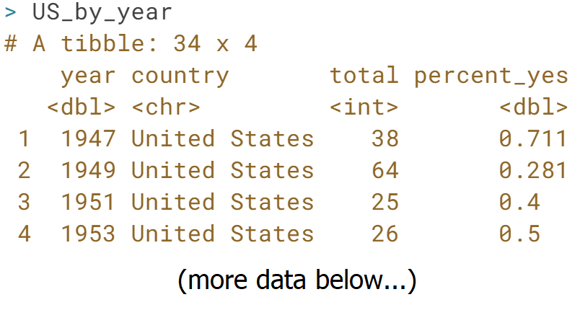

# Finding the slope of a linear regression

The US\_fit object you created in the previous exercise is available in your workspace. Calling summary() on this gives you lots of useful information about the linear model.

What is the estimated slope of this relationship? Said differently, what's the estimated change each year of the probability of the US voting "yes"?

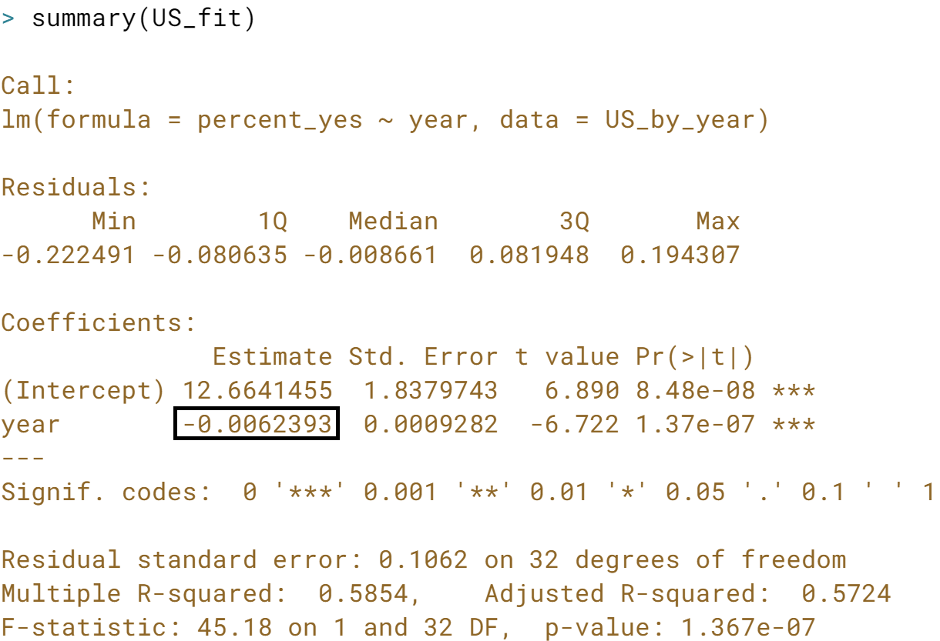

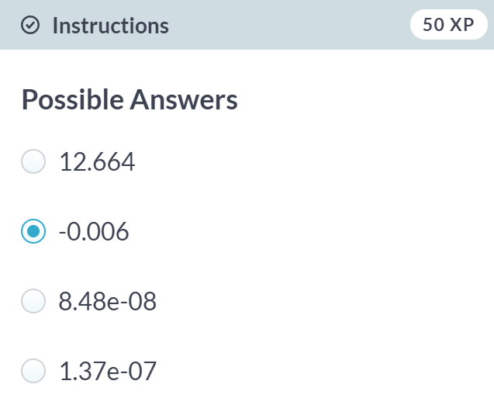

# Finding the p-value of a linear regression

Not all positive or negative slopes are necessarily real. A p-value is a way of assessing whether a trend could be due to chance. Generally, data scientists set a threshold by declaring that, for example, p-values below .05 are significant.

US\_fit is still available in your workspace. In this linear model, what is the p-value of the relationship between year and percent\_yes?

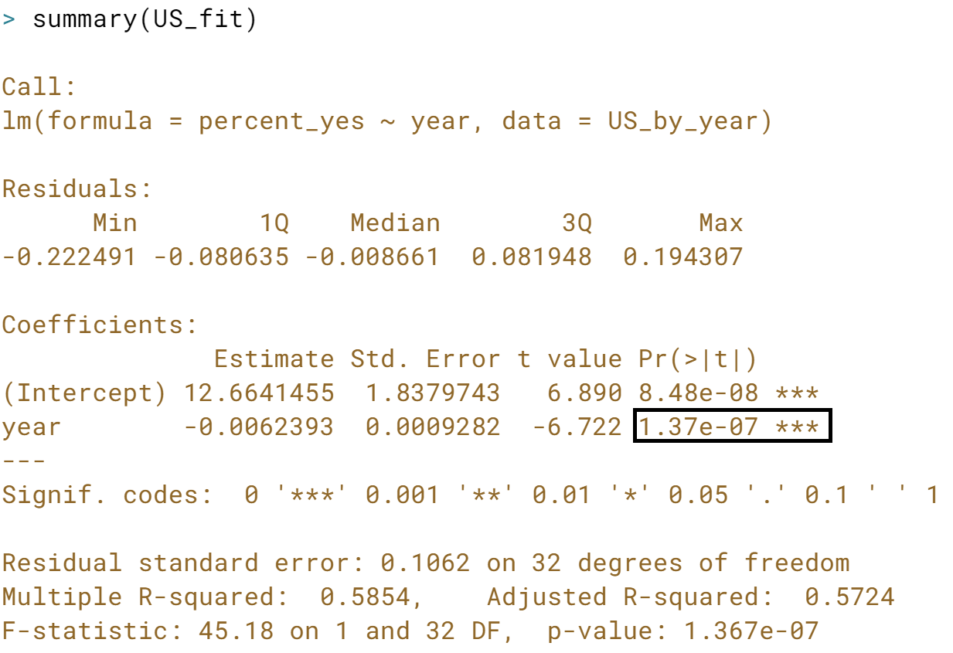

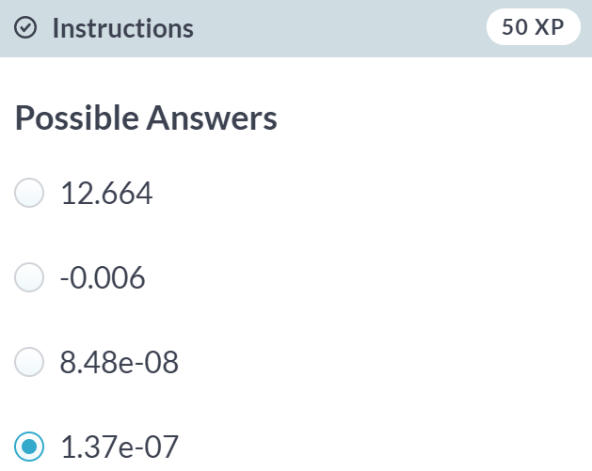  
Correct! It seems year is very significant when modeling percent\_yes.



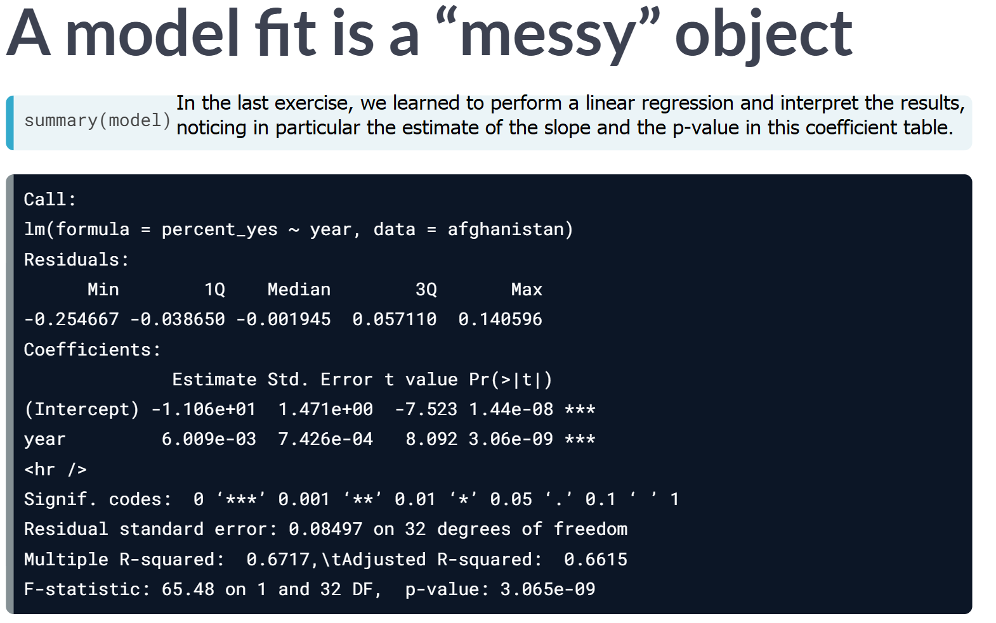However, while we were able to see these values in the printed output, we didn't discuss how to extract them out within R. This is particularly important when combining multiple models.

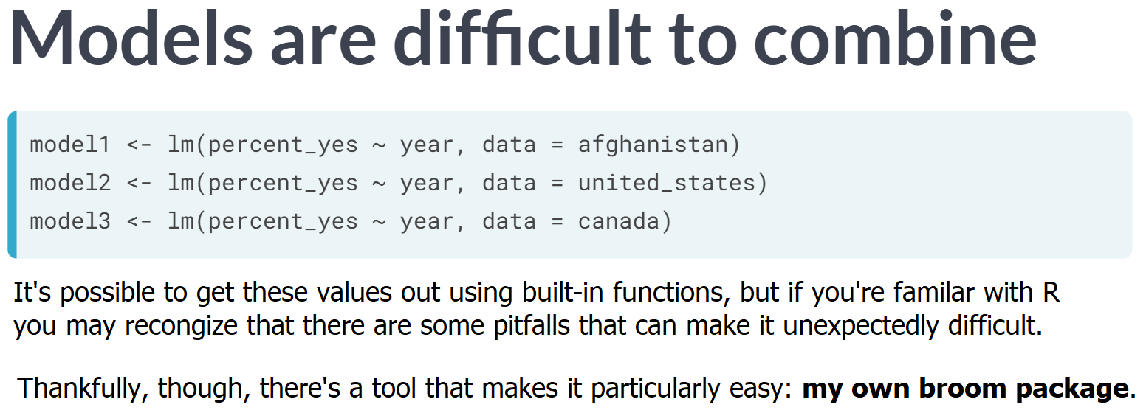

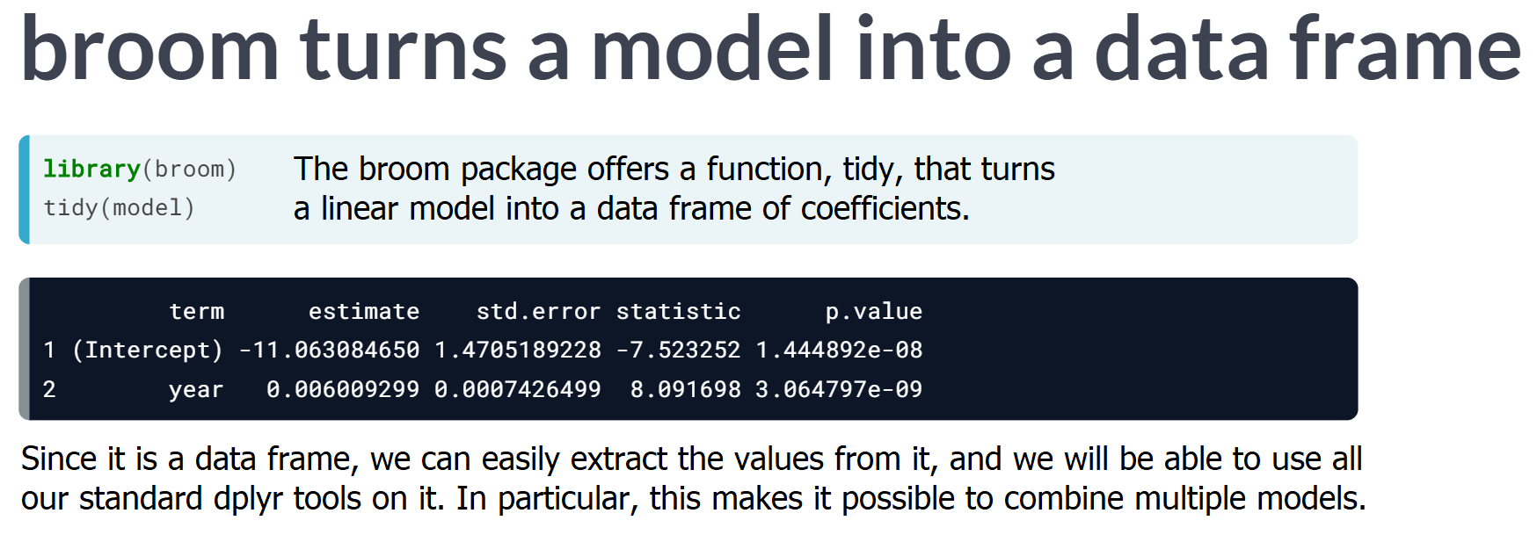

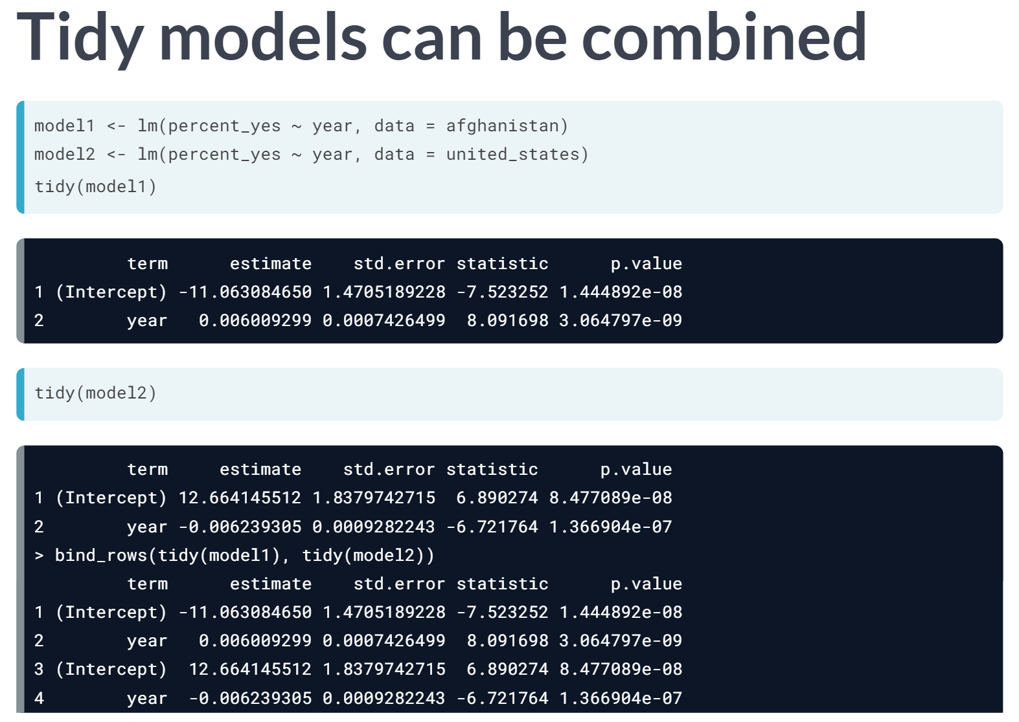

Since the tidied models are the same shape, they can be combined with dplyr's ***bind\_rows*** function. In the following sections, we will build one model for each country and combine all of them.

# Tidying a linear regression model

In the last section, you fit a linear model. Now, you'll use the tidy() function in the broom package to turn that model into a tidy data frame.

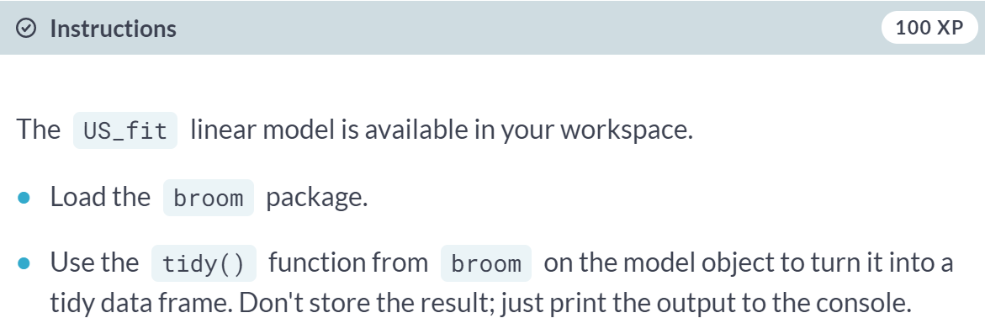

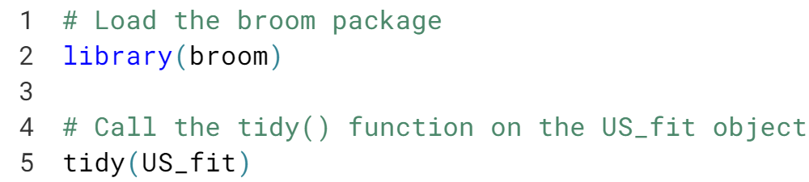

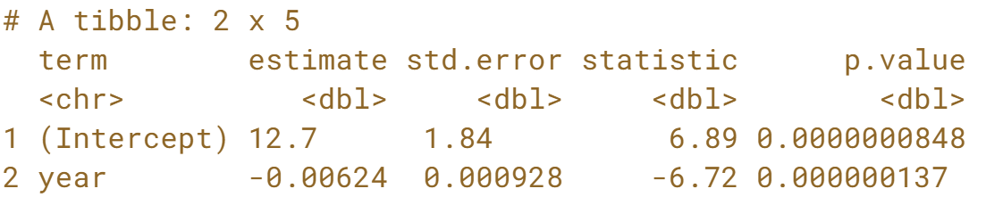

# Combining models for multiple countries

One important advantage of changing models to tidied data frames is that they can be combined.

In an earlier section, you fit a linear model to the percentage of "yes" votes for each year in the United States. Now you'll fit the same model for the United Kingdom and combine the results from both countries.

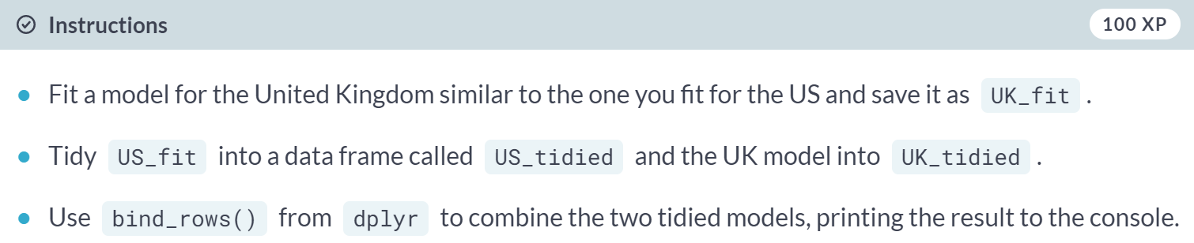

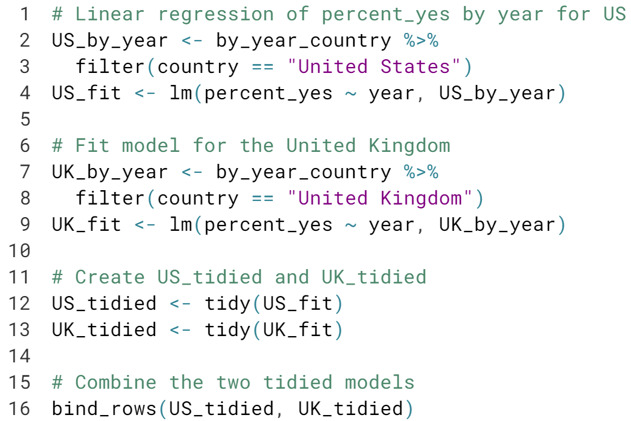

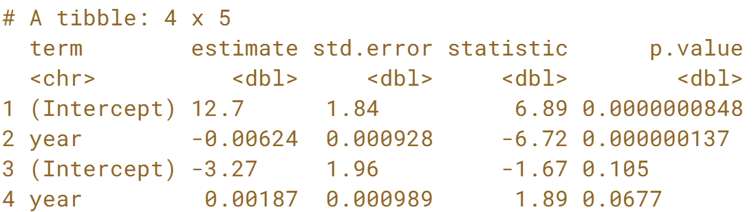



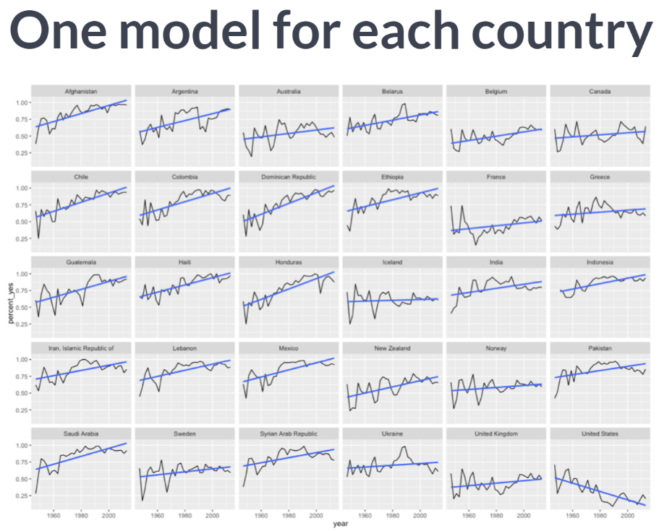

Fitting one model for each country allows us to find the counties whose level of agreement with the rest of the UN is increasing or decreasing most dramatically. Fitting multiple models requires several steps.

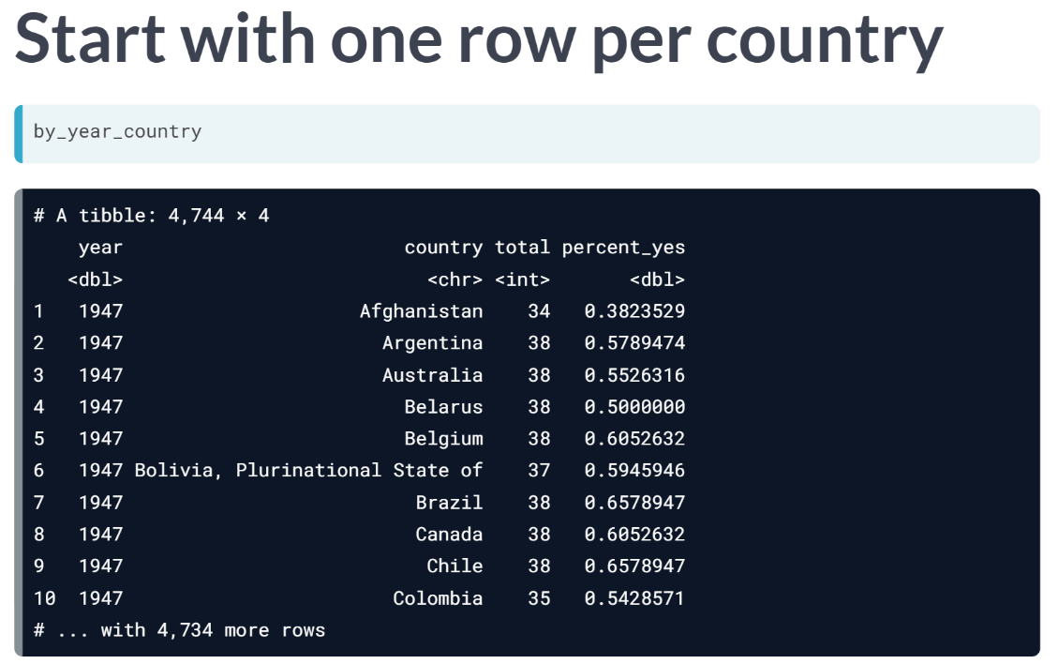

First, we start with the *by\_year\_country* dataset, containing one row for each combination of year and country. We need to separate this data out by country so we can model them individually. But instead of just pulling out one, as we've done before, we're going to split it into many small datasets, one for each country.

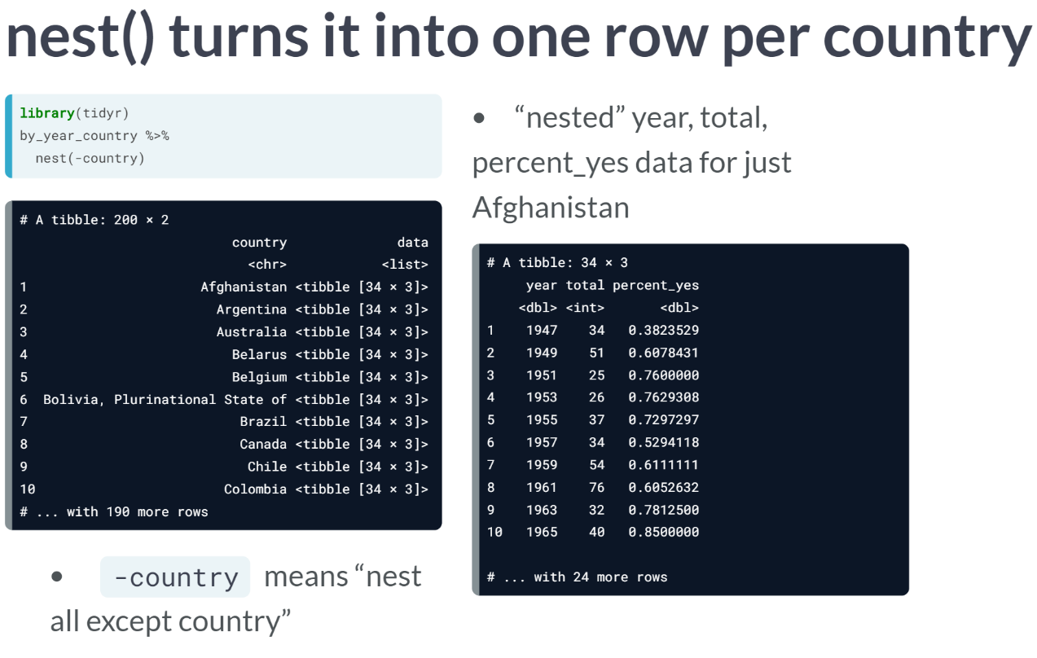  
As a result, we end up with a data frame with one row for each country. All the other columns - *year*, *total*, and *percent\_yes* - have been nested into a column called 'data'.

This is a list column, which we haven't seen before. It allows each item in the column to itself be a data frame (specifically a tibble, dplyr's version of a data frame) - containing the other columns. This means we now have a filtered version for Afghanistan, a filtered version for Argentina and so on.

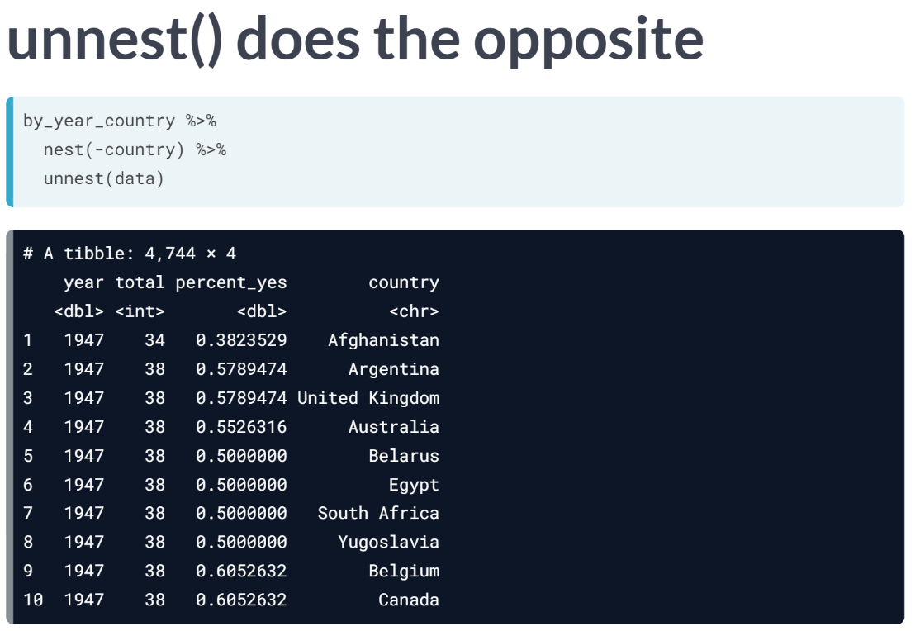  
Later we'll want to take a nested list column and bring the rows from each individual back into the "top level" of the data frame. This is done with function ***unnest()***.

# Nesting a data frame

Right now, the by\_year\_country data frame has one row per country-vote pair. So that you can model each country individually, you're going to "nest" all columns besides country, which will result in a data frame with one row per country. The data for each individual country will then be stored in a **list column** called data.

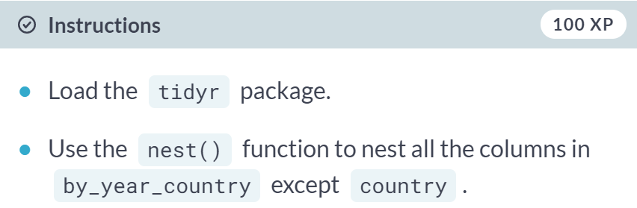

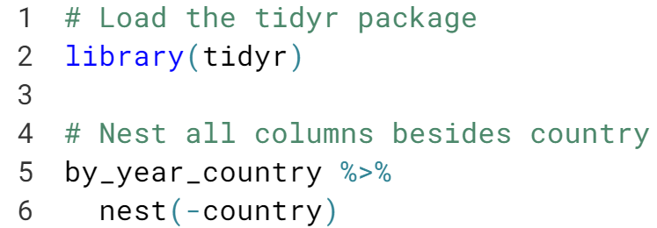

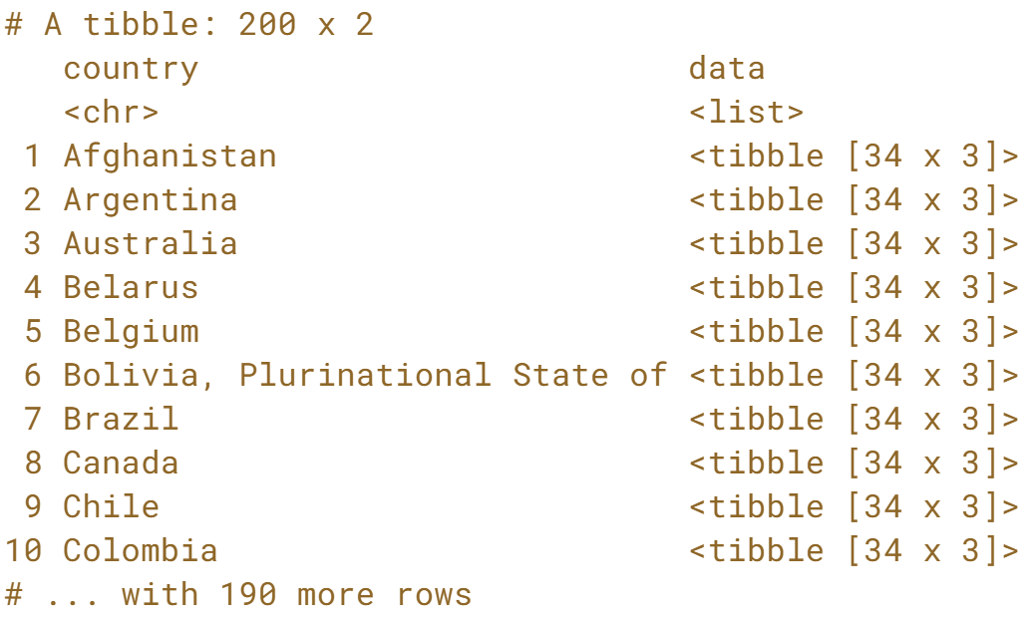

# List columns

This "nested" data has an interesting structure. The second column, data, is a **list**, a type of R object that hasn't yet come up in this course that allows complicated objects to be stored within each row. This is because each item of the data column is itself a data frame.

# A tibble: 200 × 2

country data

<chr> <list>

1 Afghanistan <tibble [34 × 3]>

2 Argentina <tibble [34 × 3]>

3 Australia <tibble [34 × 3]>

4 Belarus <tibble [34 × 3]>

5 Belgium <tibble [34 × 3]>

6 Bolivia, Plurinational State of <tibble [34 × 3]>

7 Brazil <tibble [34 × 3]>

8 Canada <tibble [34 × 3]>

9 Chile <tibble [34 × 3]>

10 Colombia <tibble [34 × 3]>

You can use nested$data to access this list column and double brackets to access a particular element. For example, nested$data[[1]] would give you the data frame with Afghanistan's voting history (the percent\_yes per year), since Afghanistan is the first row of the table.

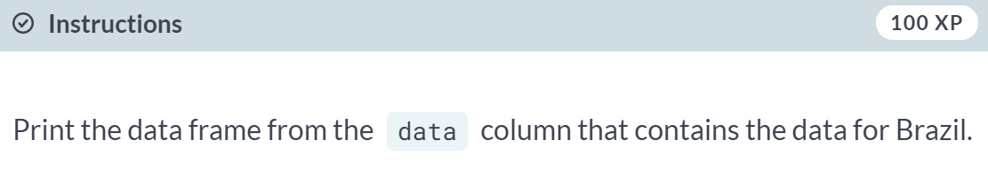  
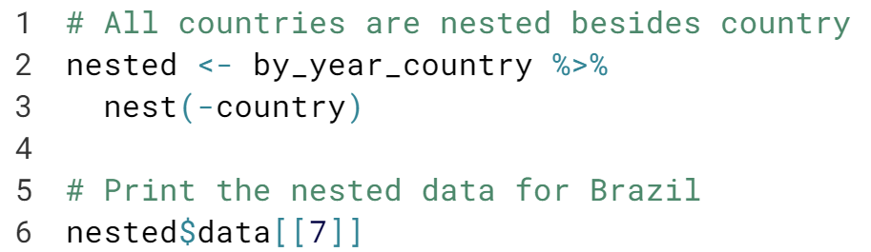  
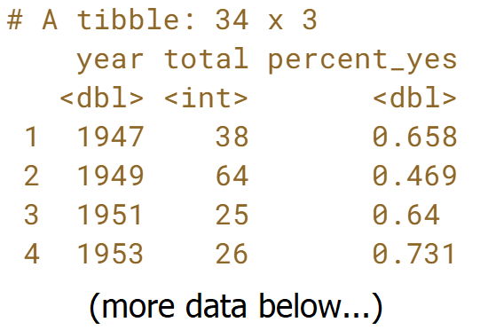

# Unnesting

The opposite of the nest() operation is the unnest() operation. This takes each of the data frames in the list column and brings those rows back to the main data frame.

In this exercise, you are just undoing the nest() operation. In the next section, you'll learn how to fit a model in between these nesting and unnesting steps that makes this process useful.

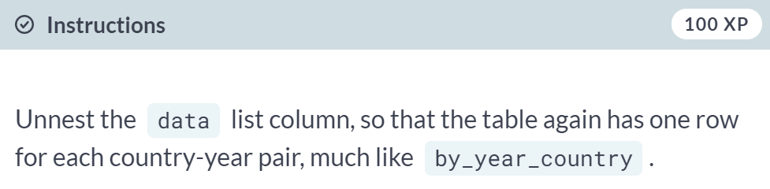

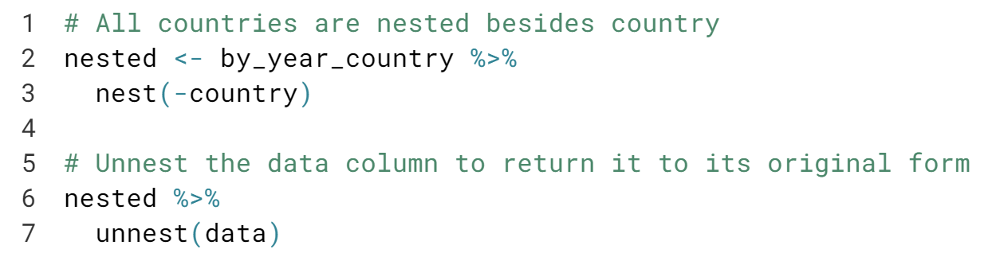

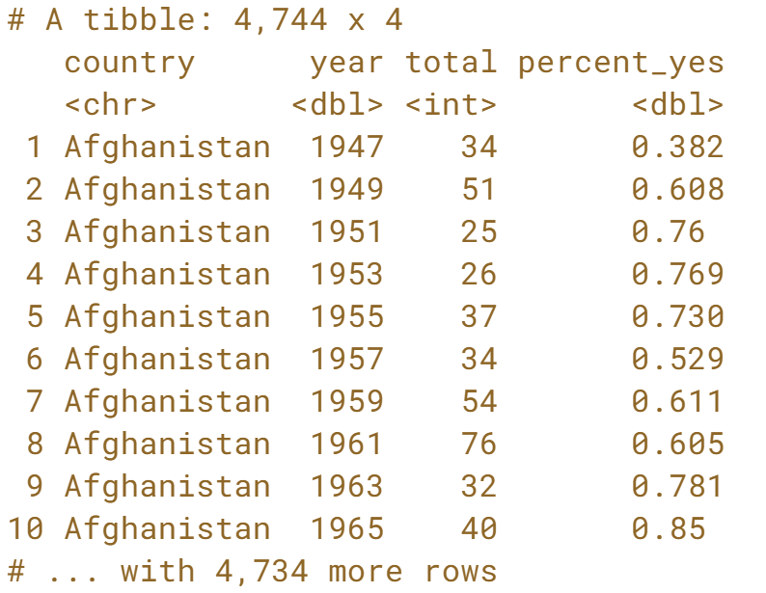

  
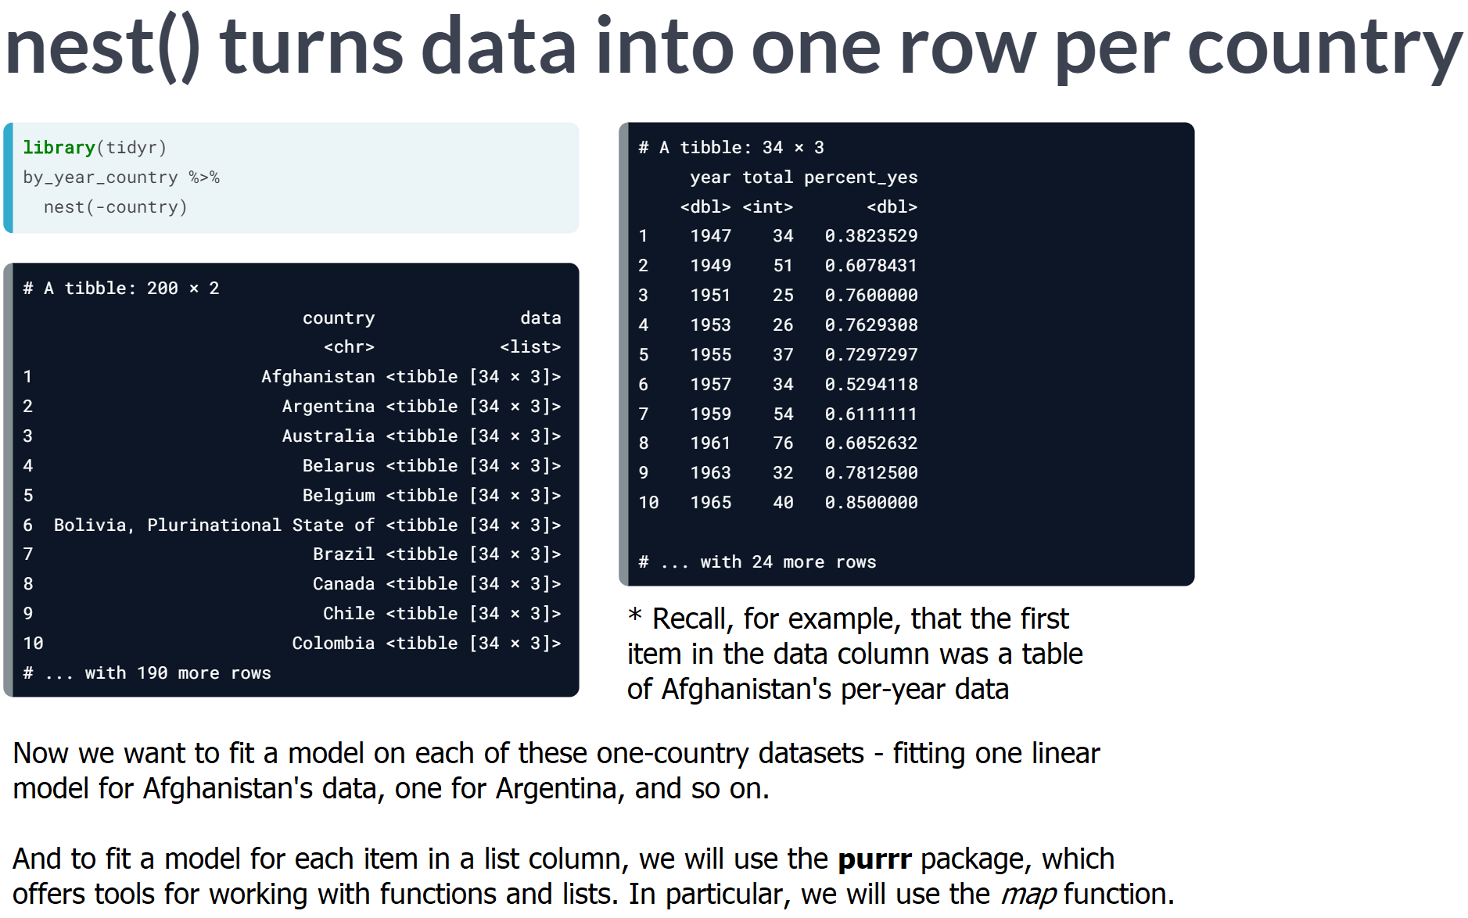

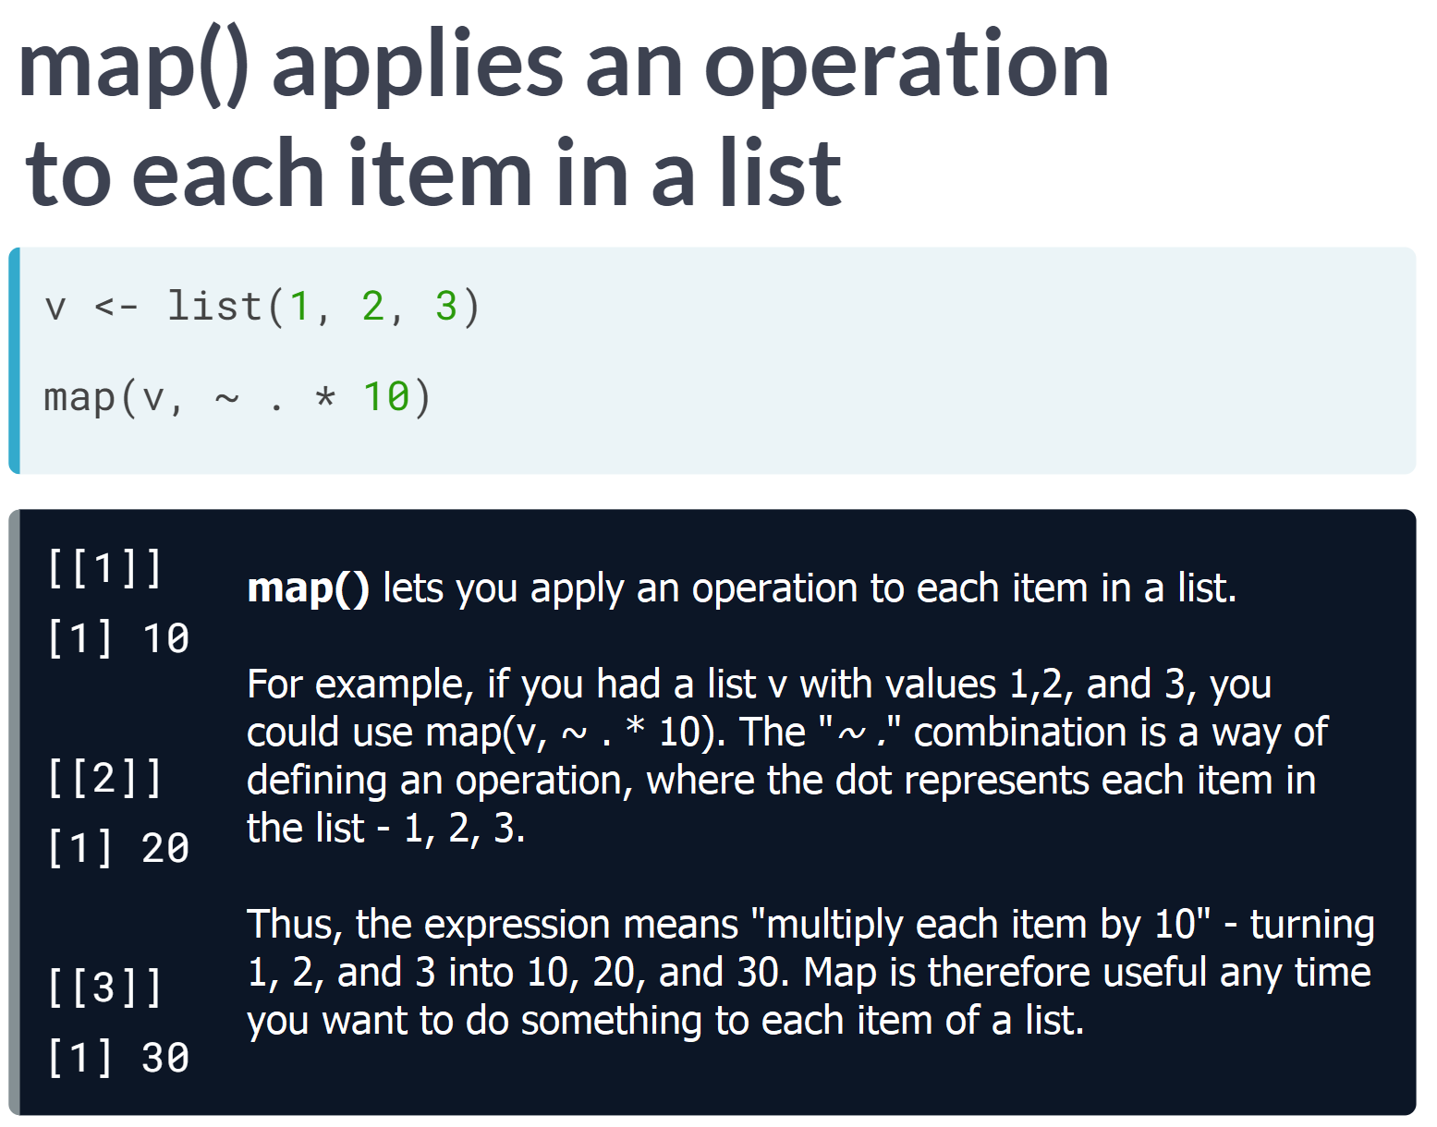

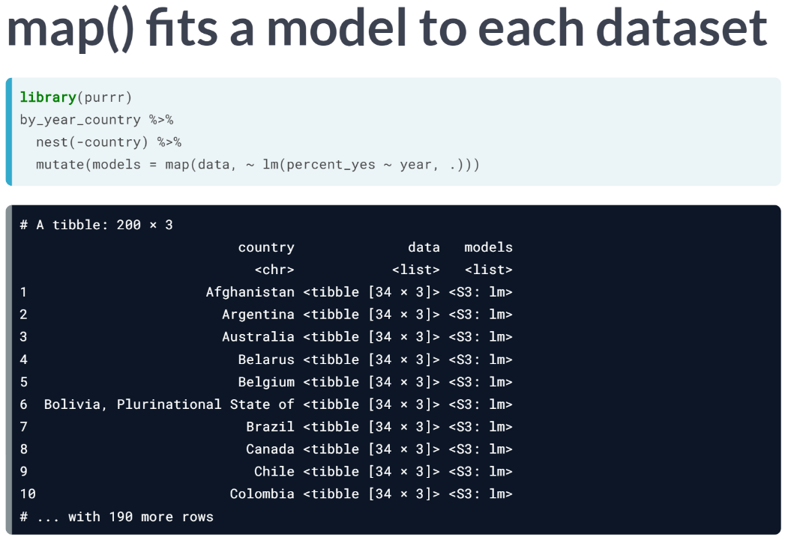  
Here we want to fit a linear model into a new column based on each sub-data frame. We use mutate to define the new column "model" and use map to apply a linear regression to each item of "data". We describe the linear regression with "*~ lm*", with dot as the data. This creates a new column of linear models - one for each sub-data frame. So, the first item would contain the slope just for Afghanistan. Unfortunately, we can't combine, manipulate, or visualize them, though. That's why we return to the broom package.

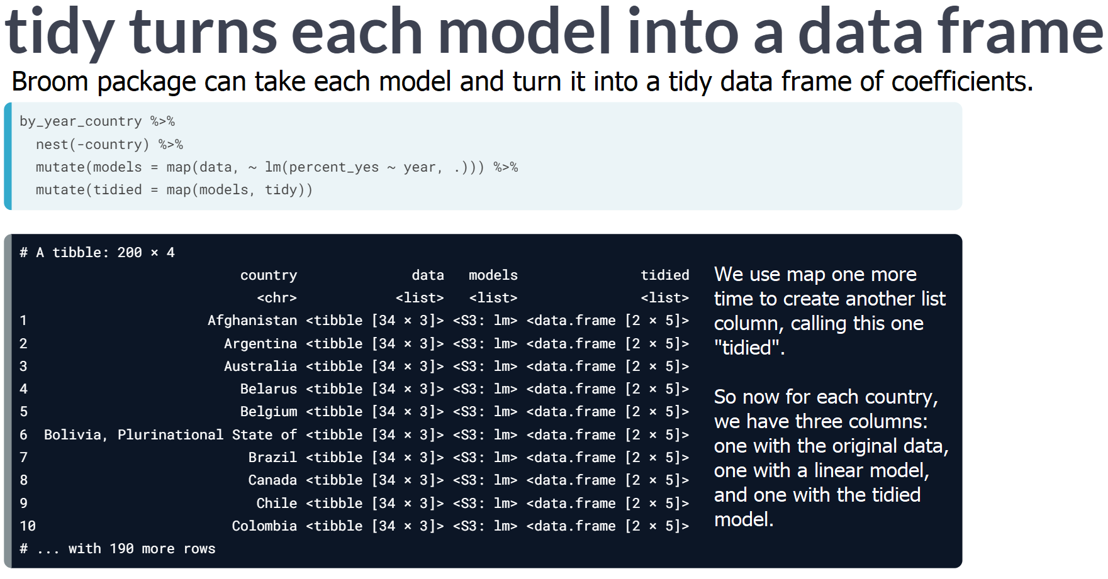  
Now we have a table of coefficients, where the first two rows represent the slope and intercept for Afghanistan, the next two rows for Argentina, the next two for Australia, and so one: all of the details of each model in one place.

This was four steps: **nest by country** -> **map to fit a model to each dataset** -> **map to tidy each model** -> **unnest to a table of coefficients**.

# Performing linear regression on each nested dataset

Now that you've divided the data for each country into a separate dataset in the data column, you need to fit a linear model to each of these datasets.

The map() function from purrr works by applying a formula to each item in a list, where . represents the individual item. For example, you could add one to each of a list of numbers:

map(numbers, ~ 1 + .)

This means that to fit a model to each dataset, you can do:

map(data, ~ lm(percent\_yes ~ year, data = .))

where . represents each individual item from the data column in by\_year\_country. Recall that each item in the data column is a dataset that pertains to a specific country.

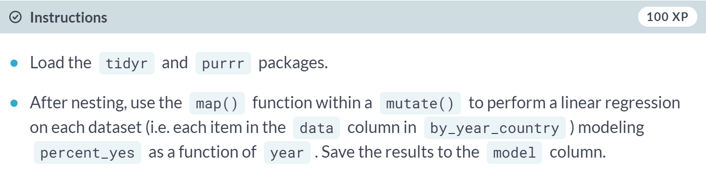  
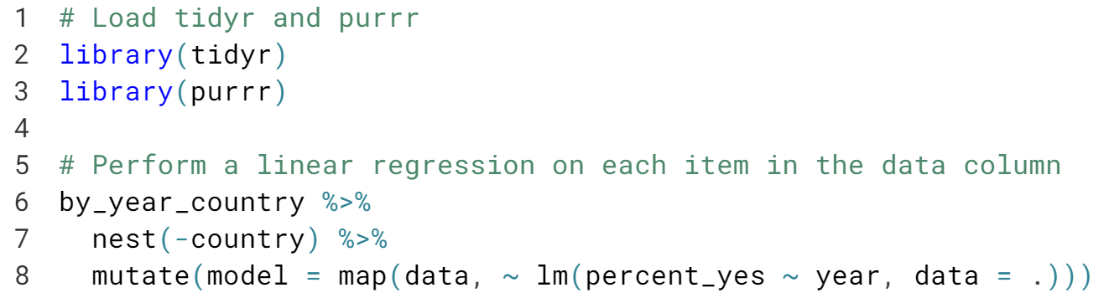

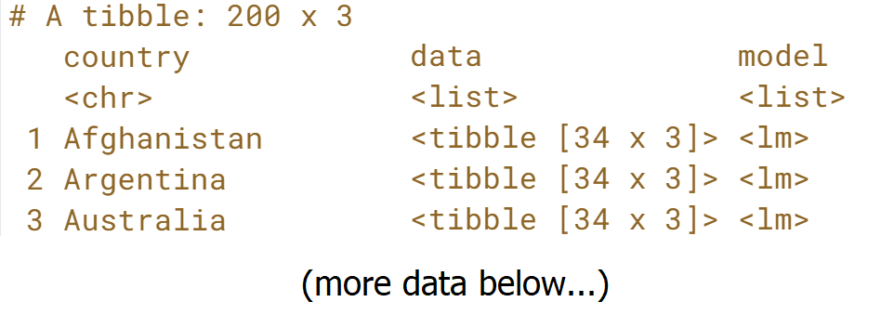

# Tidy each linear regression model

You've now performed a linear regression on each nested dataset and have a linear model stored in the list column model. But you can't recombine the models until you've tidied each into a table of coefficients. To do that, you'll need to use map() one more time and the tidy() function from the broom package.

Recall that you can simply give a function to map() (e.g. map(models, tidy)) in order to apply that function to each item of a list.

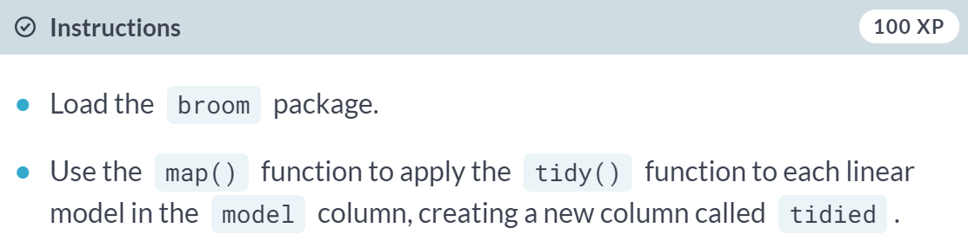

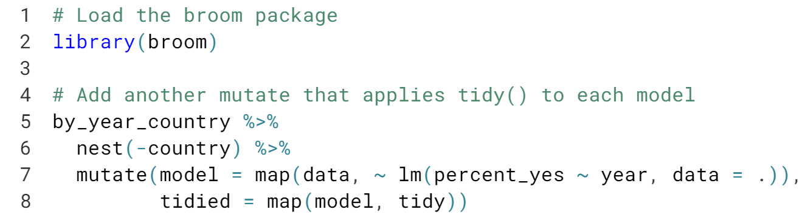

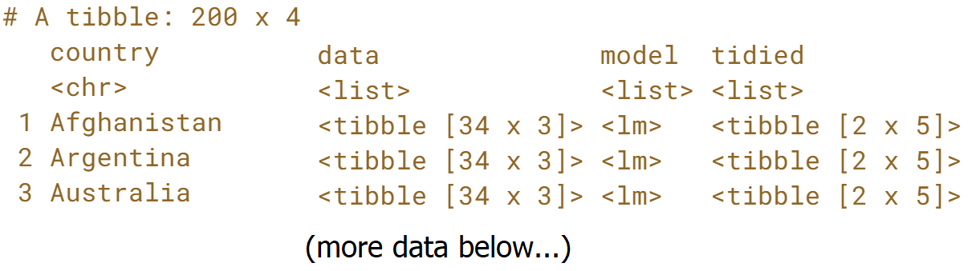

# Unnesting a data frame

You now have a tidied version of each model stored in the tidied column. You want to combine all of those into a large data frame, similar to how you combined the US and UK tidied models earlier. Recall that the unnest() function from tidyr achieves this.

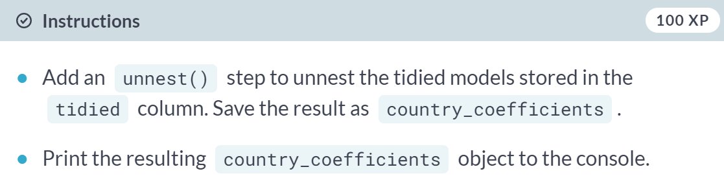

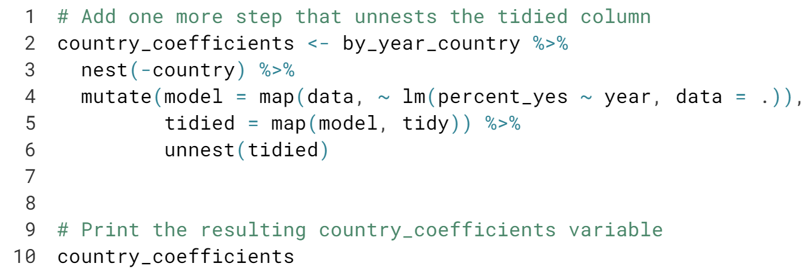

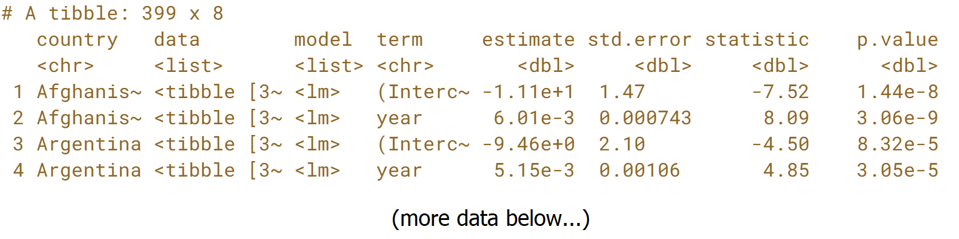



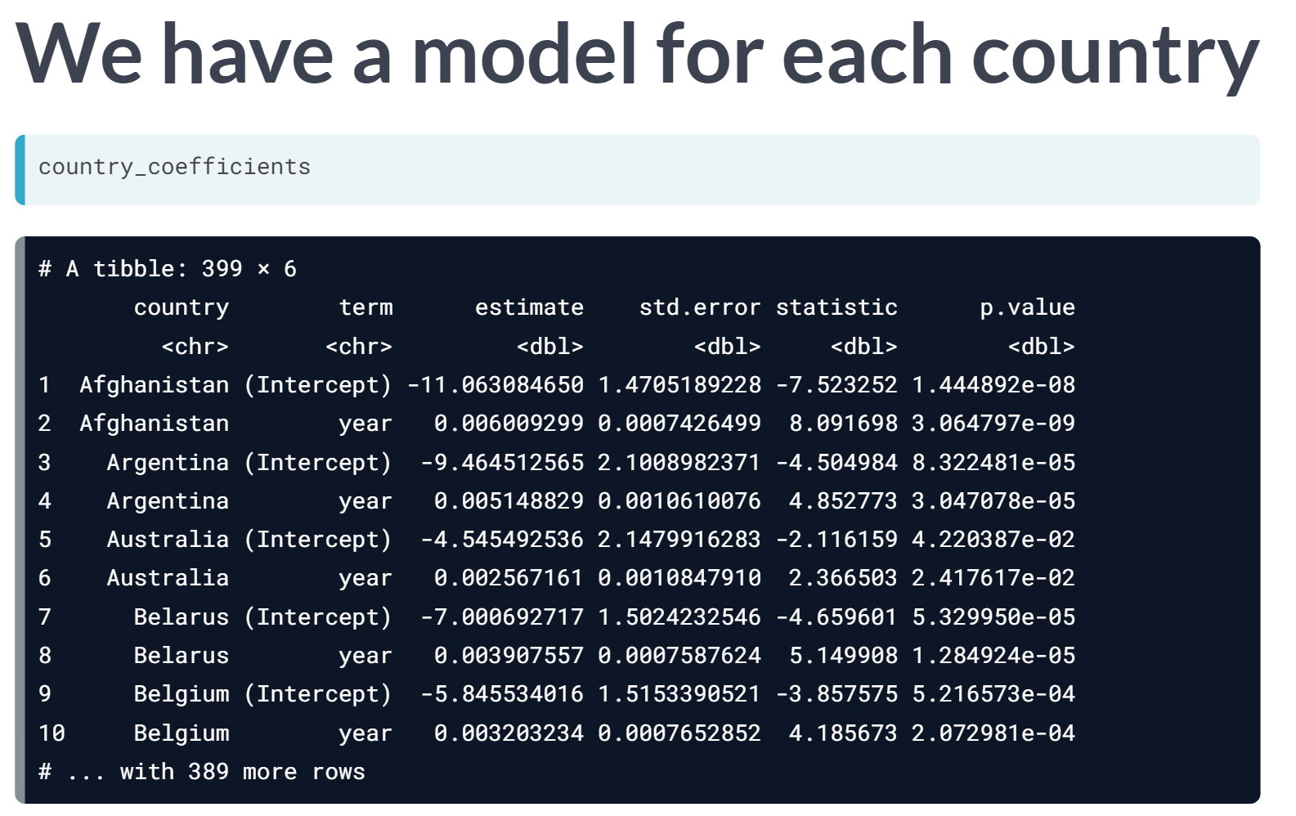  
In the last exercise, we created a table called *country\_coefficients*, with rows for the slope and intercept for each country. Since the data is tidy, we can manipulate these coefficients with dplyr operation just like we did the original voting data.

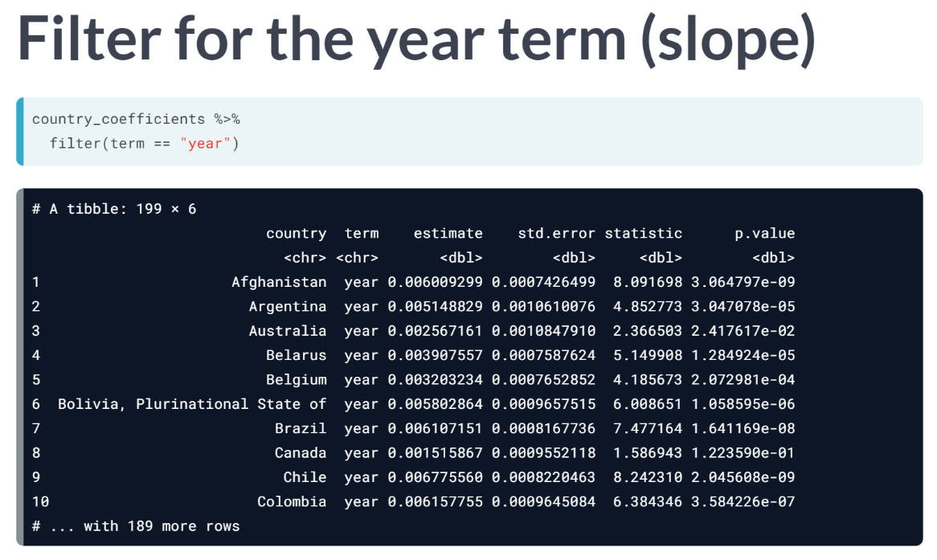  
For example, in this analysis we are interested in how countries change over time (the slope) not where they started (the intercept). So, we can use the dplyr's filter to get only the cases where term equals year.

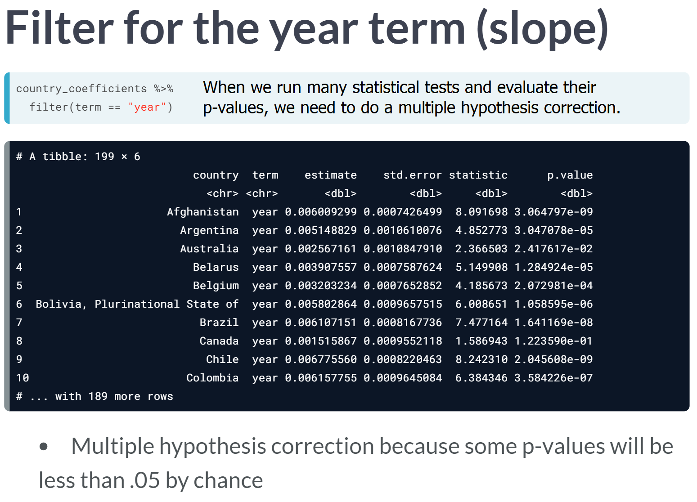

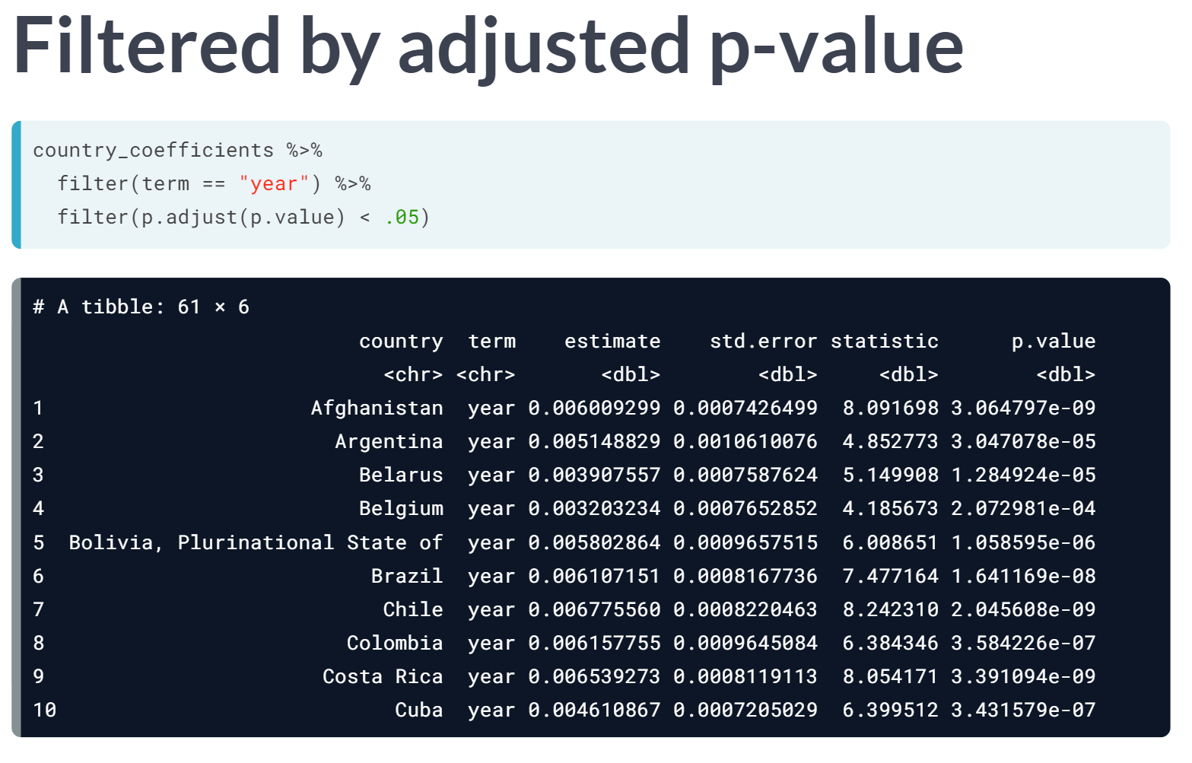  
R provides a useful built-in function for p-value correction, called ***p.adjust()***. By filtering for cases where the adjusted p-value is less than 0.05, we can feel safer in our assumptions and get a set of country trends that we believe are real. Using dplyr operations to work with many model outputs is a powerful way to draw conclusions out of a large dataset.

# Filtering model terms

You currently have both the intercept and slope terms for each by-country model. You're probably more interested in how each is changing over time, so you want to focus on the slope terms.

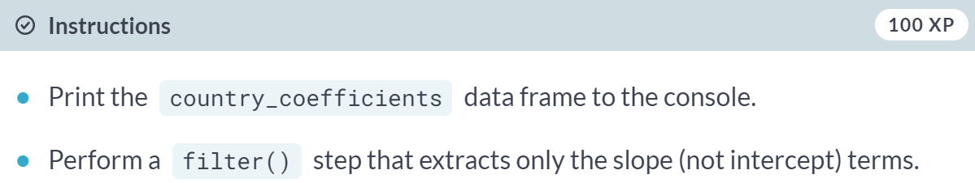

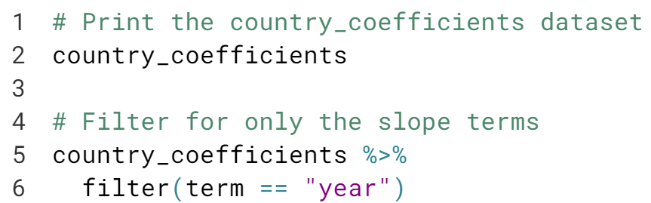

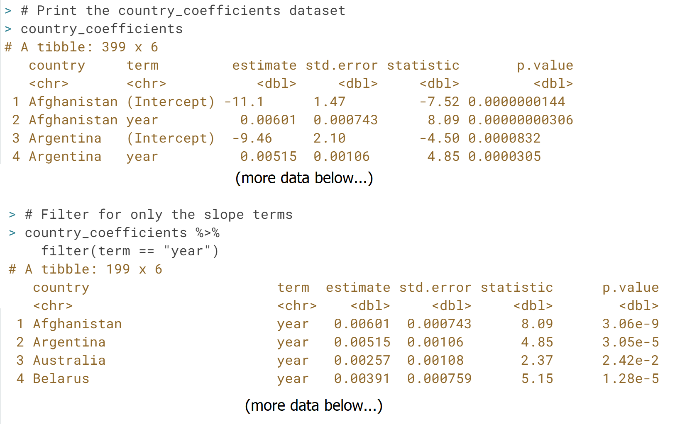

# Filtering for significant countries

Not all slopes are significant, and you can use the p-value to guess which are and which are not.

However, when you have lots of p-values, like one for each country, you run into the problem of multiple hypothesis testing, where you have to set a stricter threshold. The **[p.adjust()](https://www.rdocumentation.org/packages/stats/topics/p.adjust" \t "_blank)** function is a simple way to correct for this, where p.adjust(p.value) on a vector of p-values returns a set that you can trust.

Here you'll add two steps to process the slope\_terms dataset: use a mutate to create the new, adjusted p-value column, and filter to filter for those below a .05 threshold.

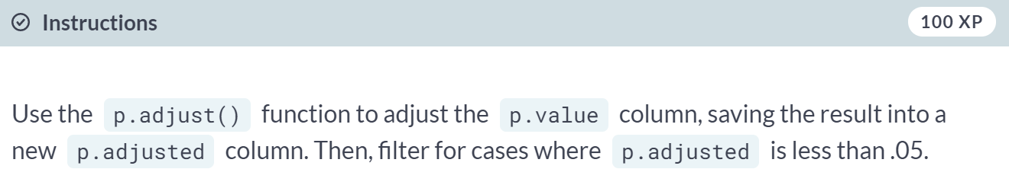

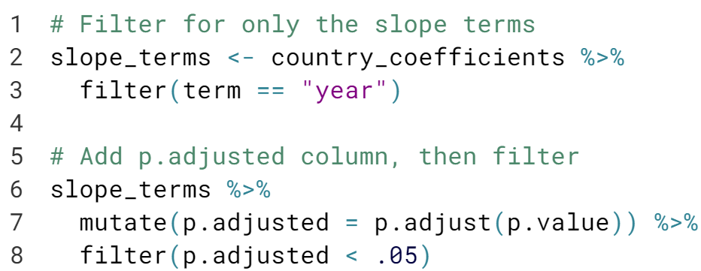

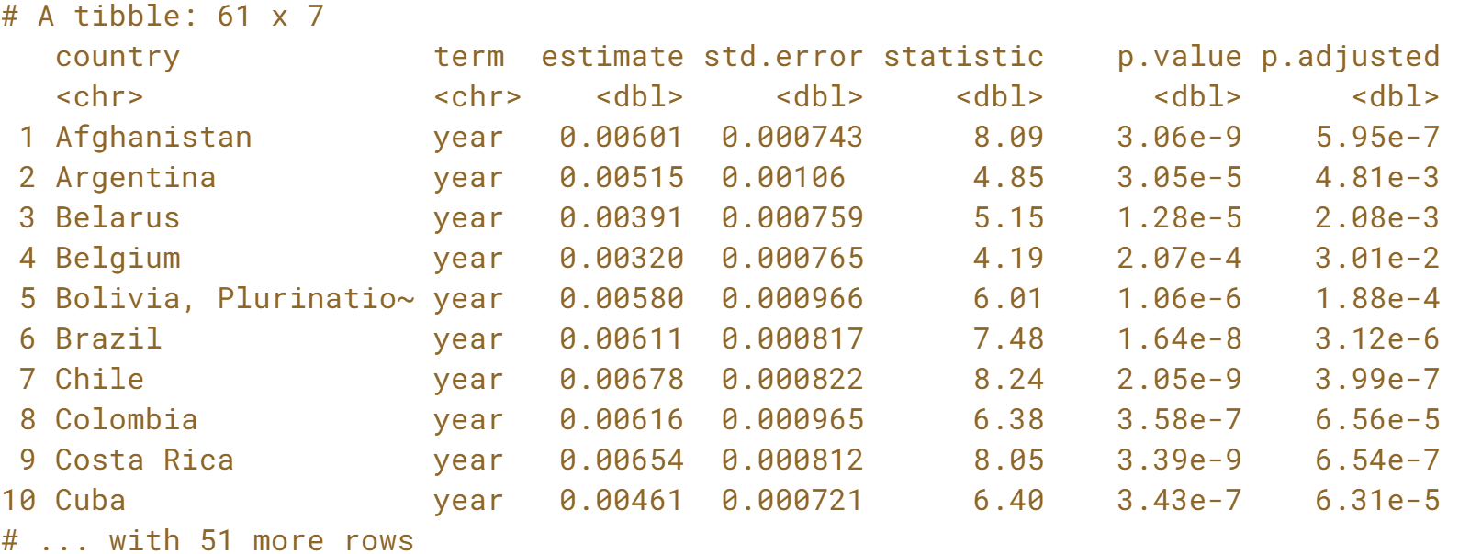  
Notice that there are now only 61 countries with significant trends.

# Sorting by slope

Now that you've filtered for countries where the trend is probably not due to chance, you may be interested in countries whose percentage of "yes" votes is changing most quickly over time. Thus, you want to find the countries with the highest and lowest slopes; that is, the estimate column.

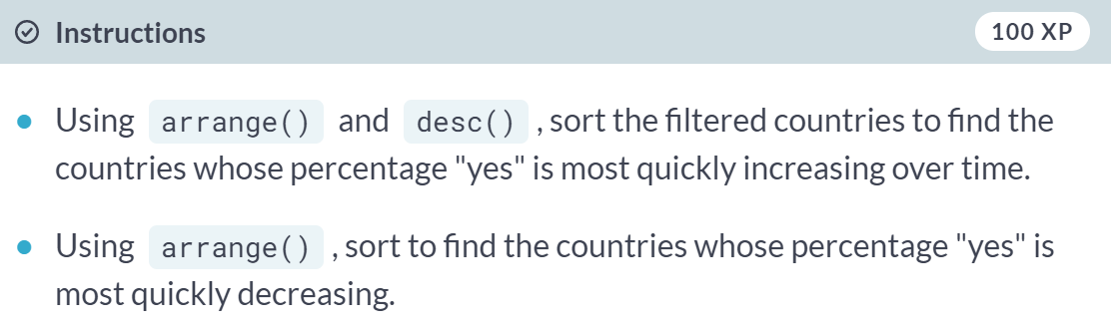

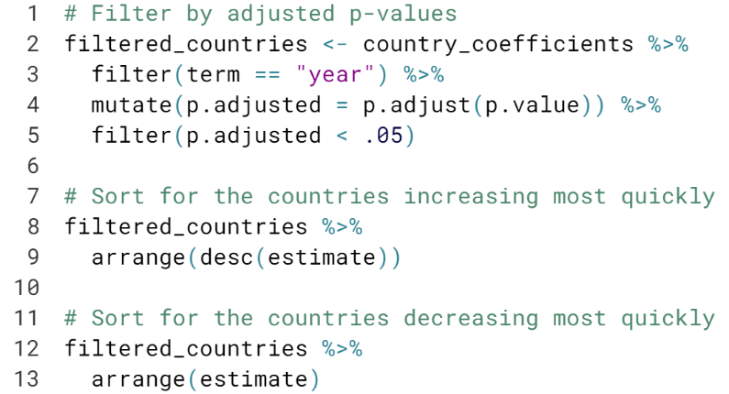  
  
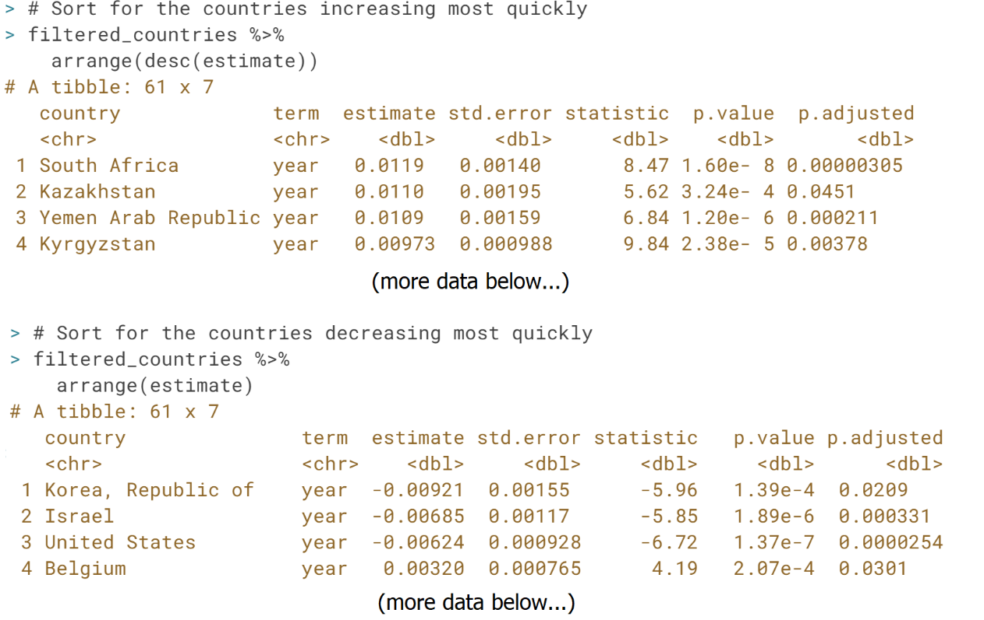

#### Joining and tidying

In this chapter, you'll learn to combine multiple related datasets, such as incorporating information about each resolution's topic into your vote analysis. You'll also learn how to turn untidy data into tidy data and see how tidy data can guide your exploration of topics and countries over time.



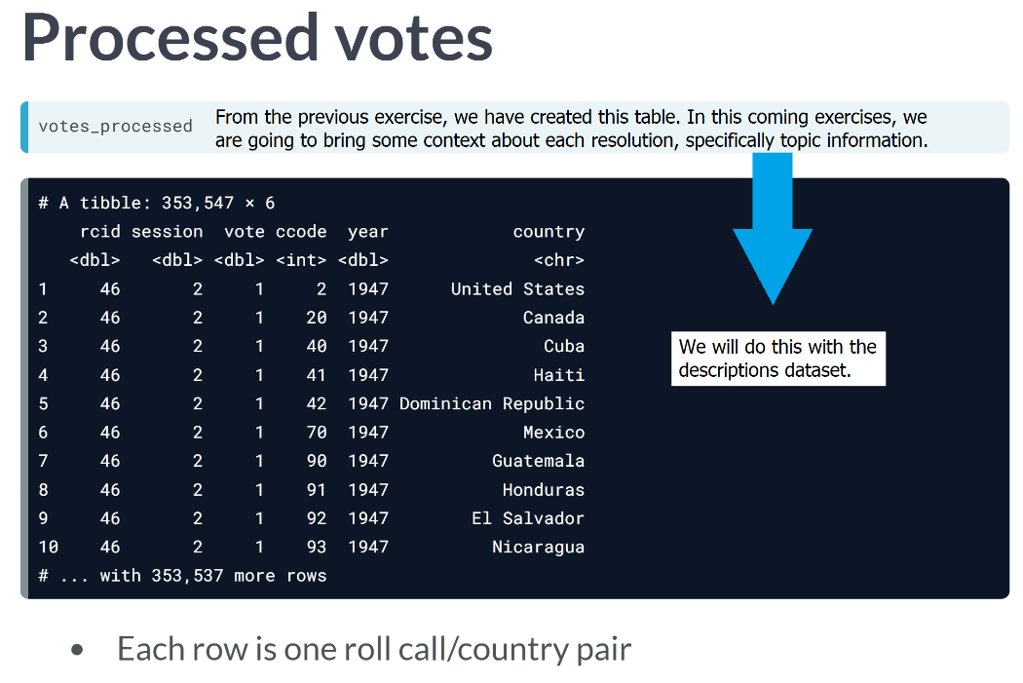  
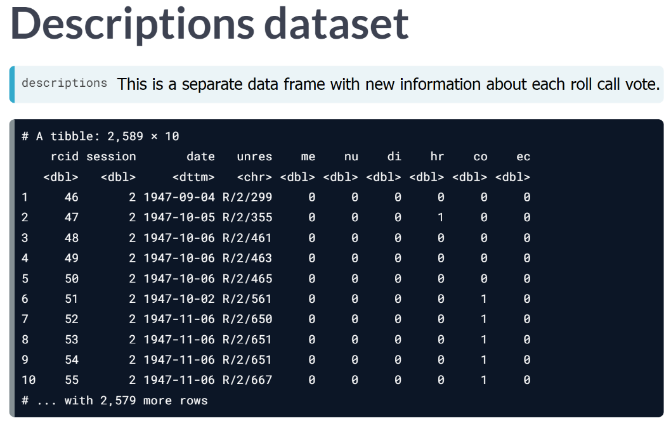  
For example, the second roll call vote has a 1 in the *hr* column, meaning it relates to human rights. this dataset, however, doesn't tell us anything about countries or their vote, so you want to combine it with the *votes\_processed* dataset.

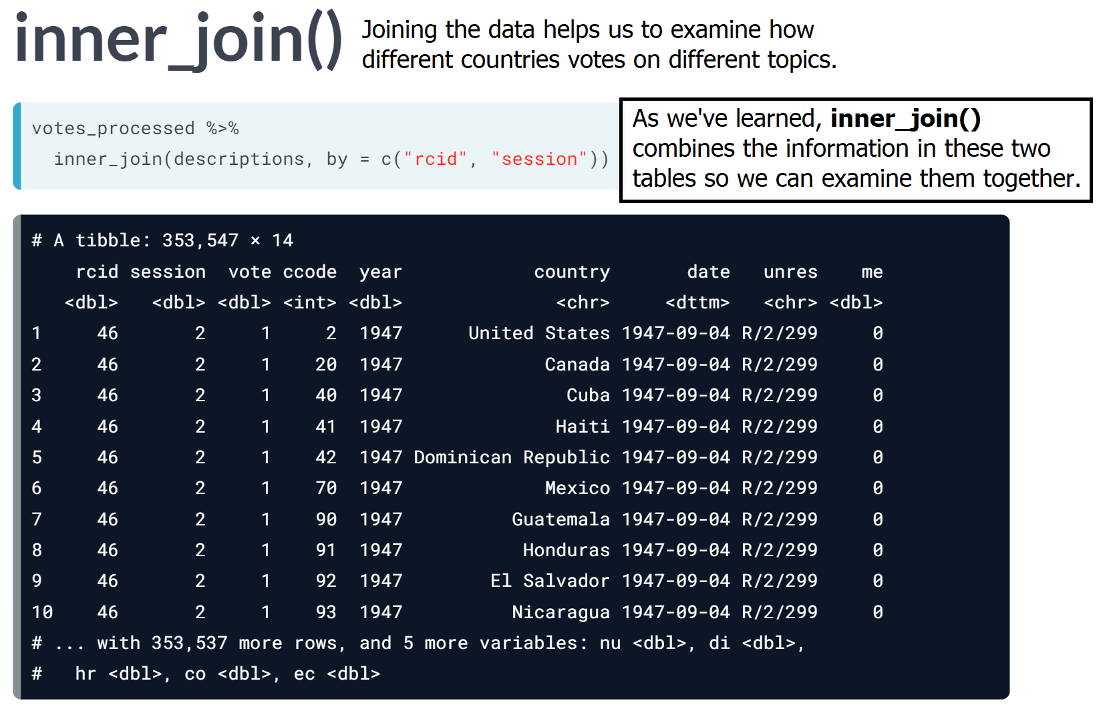

# Joining datasets with inner\_join

In the first chapter, you created the votes\_processed dataset, containing information about each country's votes. You'll now combine that with the new descriptions dataset, which includes topic information about each country, so that you can analyze votes within particular topics.

To do this, you'll make use of the inner\_join() function from dplyr.

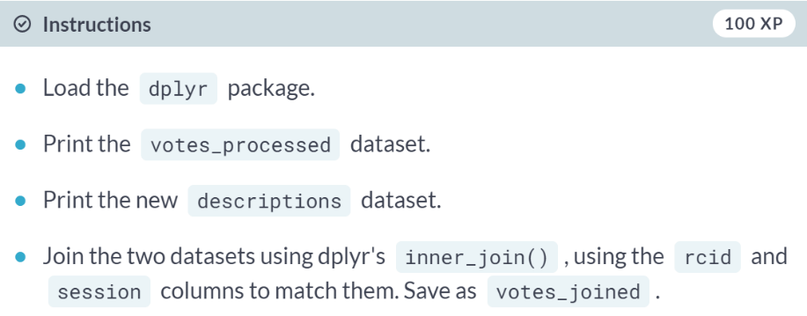

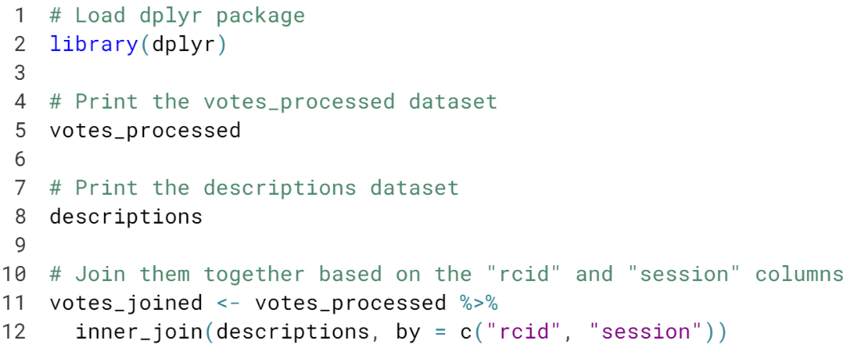

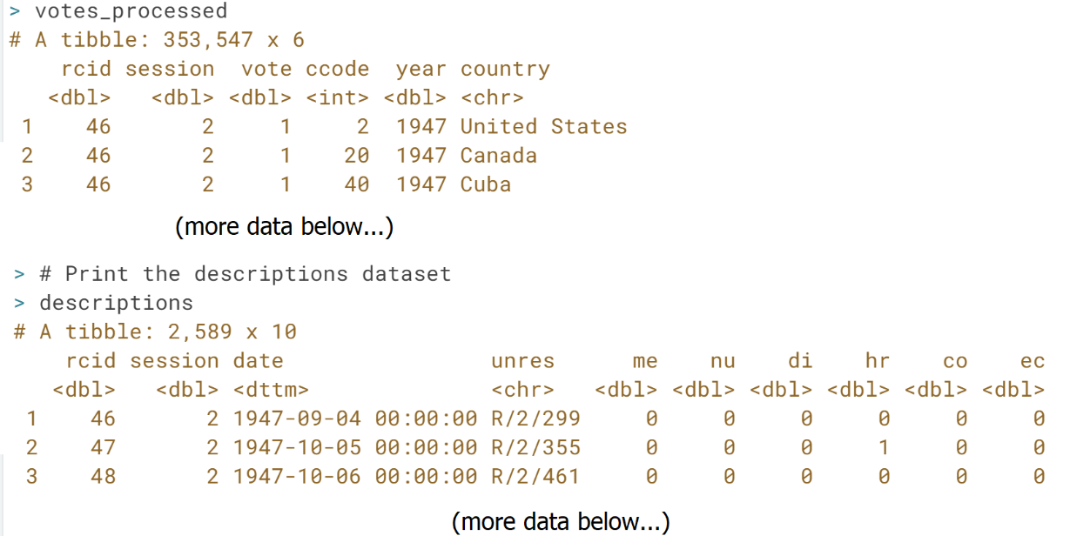

# Filtering the joined dataset

There are six columns in the descriptions dataset (and therefore in the new joined dataset) that describe the topic of a resolution:

1. **me**: Palestinian conflict
2. **nu**: Nuclear weapons and nuclear material
3. **di**: Arms control and disarmament
4. **hr**: Human rights
5. **co**: Colonialism
6. **ec**: Economic development

Each contains a 1 if the resolution is related to this topic and a 0 otherwise.



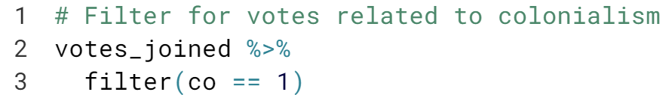

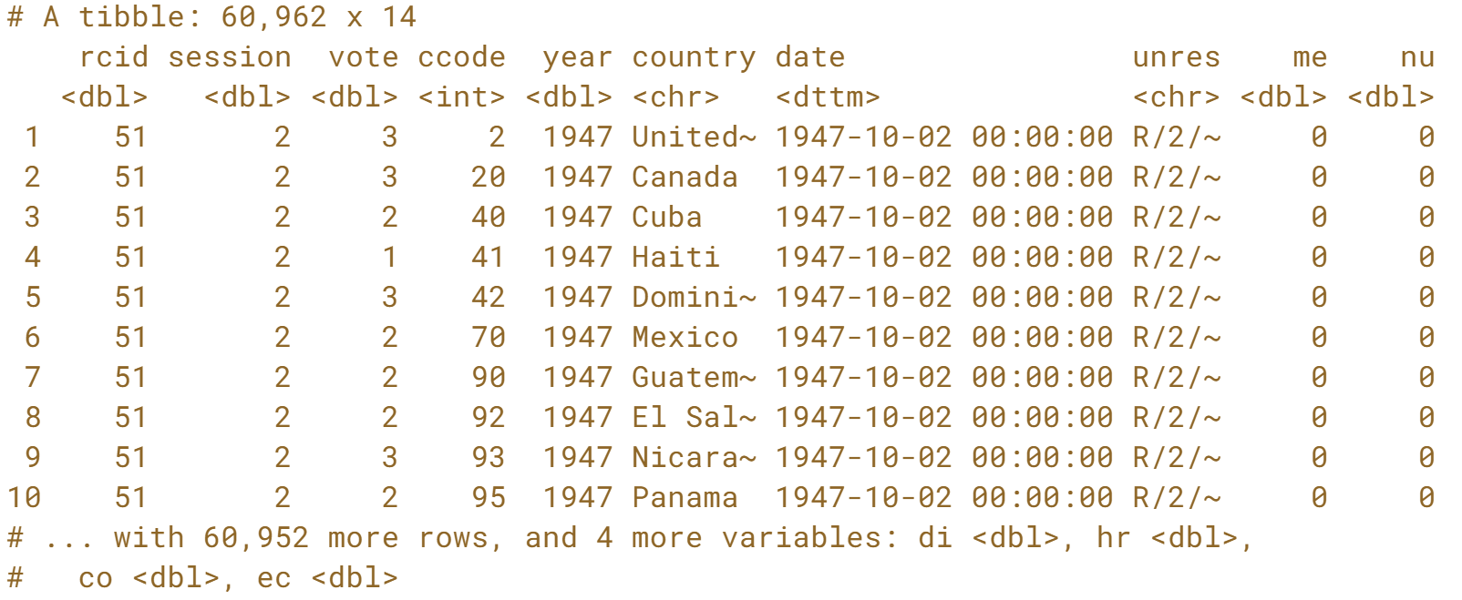

# Visualizing colonialism votes

In an earlier exercise, you graphed the percentage of votes each year where the US voted "yes". Now you'll create that same graph, but only for votes related to colonialism.

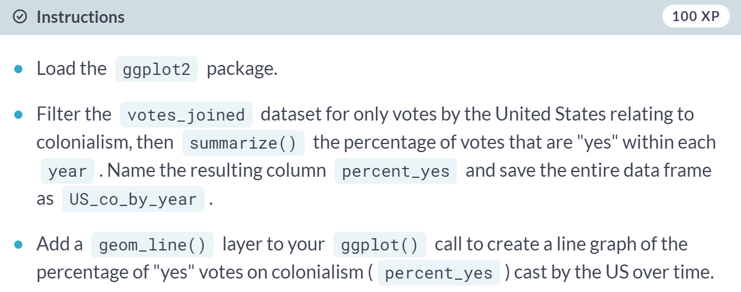  
  
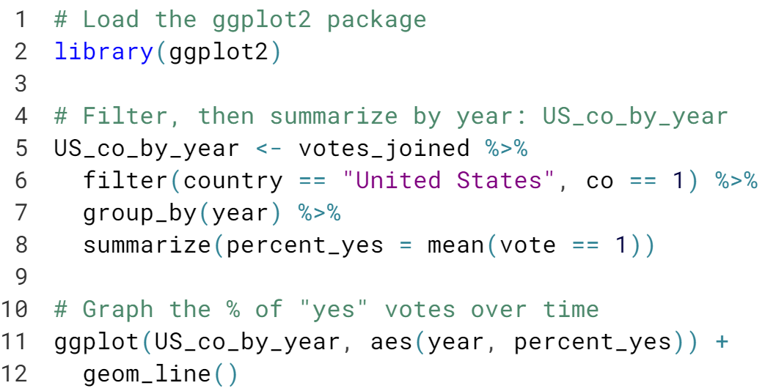  
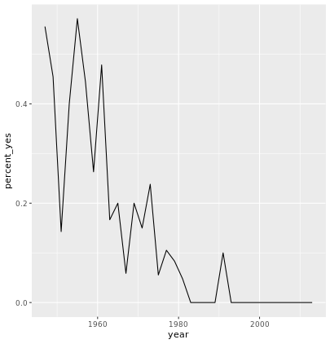



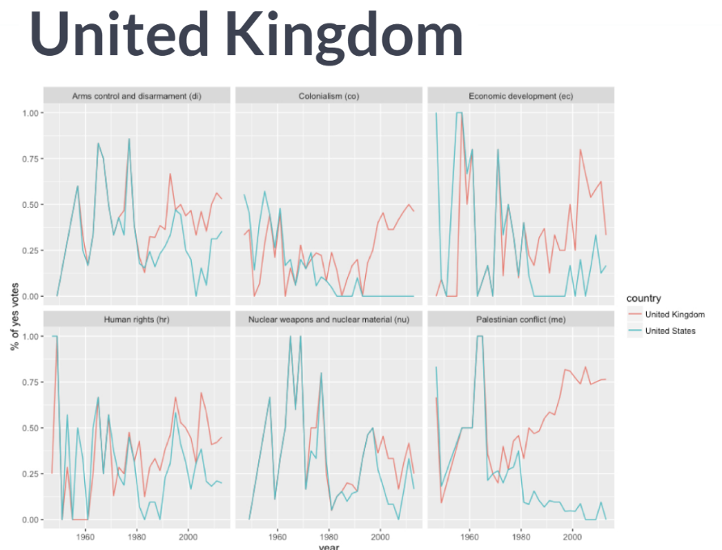  
Consider this graph of UN voting trends over time. Like other graphs you've made, it maps "year" to the x-axis, "percentage of yes votes" to the y-axis and "country" to color.

This graph is however faceted across the six topics, using one sub-graph for each topic. For instance, one single point on this graph represents votes of the United Kingdom on the topic of colonialism in 2001.

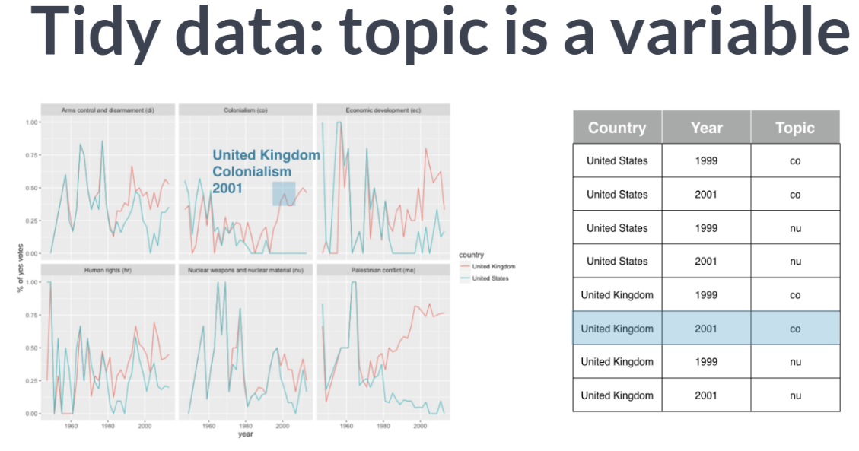  
This useful kind of analysis is possible only with a structure of data, where each observation, or row, represents a single combination of country, year, and topic. This allow every observation in the data to map to one point in your plot. Also notice that this data includes a variable called "topic", which specifies each observation whether it relates to colonialism, nuclear weapons, and so on. We call this arrangement "tidy".

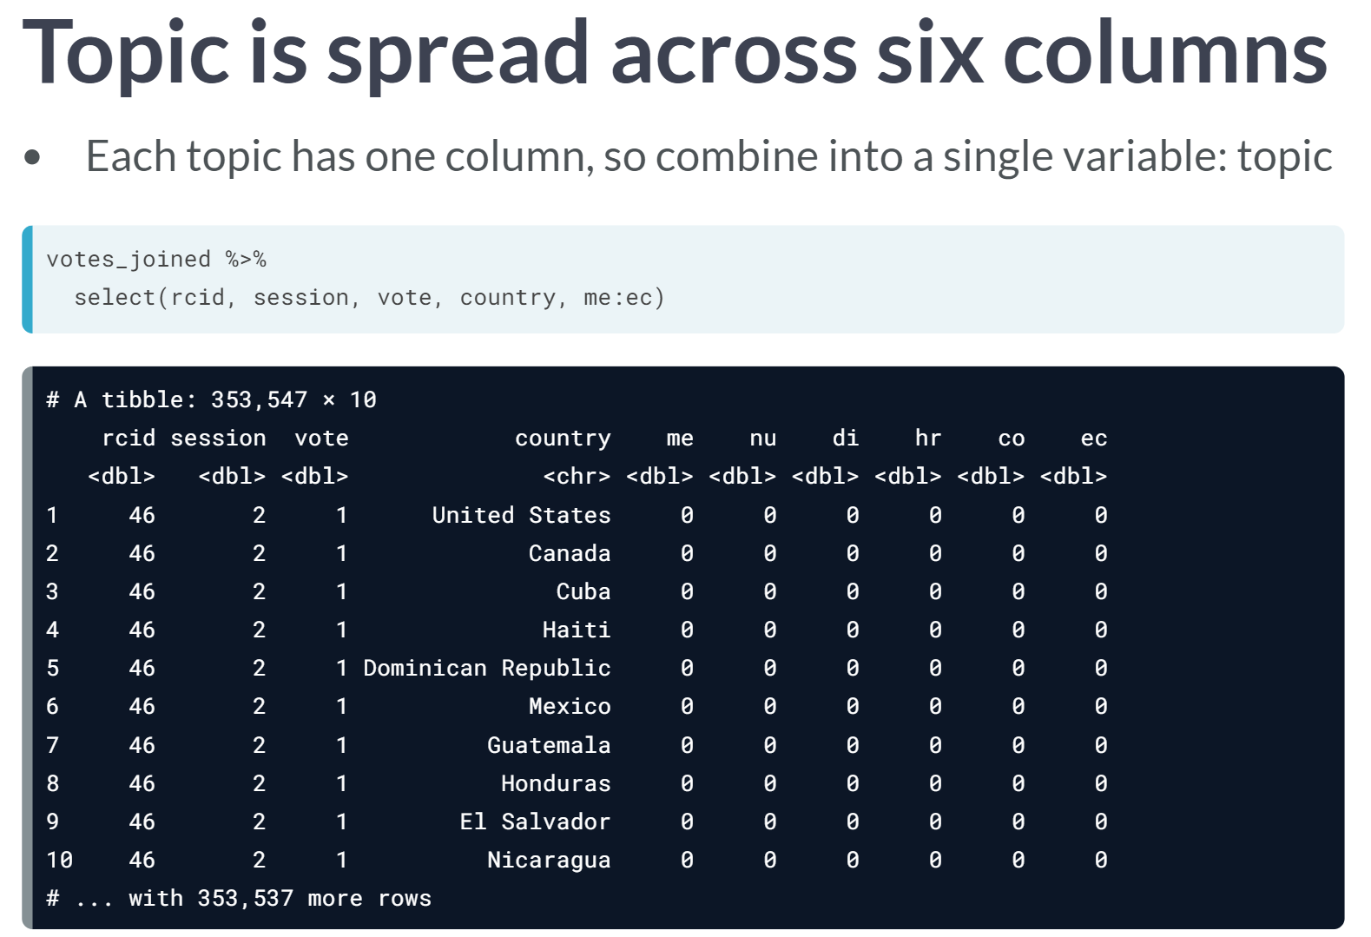

In the *vote\_joined* dataset we used in the previous exercise, we don't have a single topic variable but rather one column for each of the six topics containing a zero or a one. This means there's no easy way to use dplyr to summarize by topic, or to visualize the results for six topics on the same graph. In order to do that, we need to bring topic into a single variable. This can be done with the ***gather()*** function in the *tidyr* package.

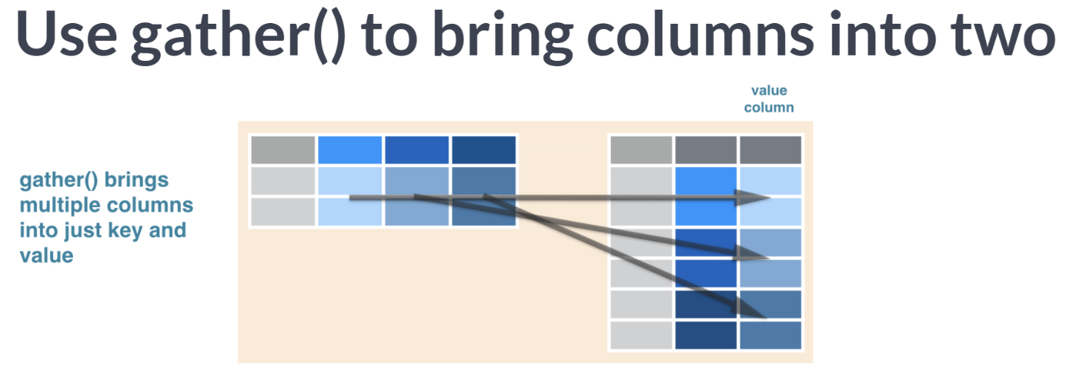  
***gather()*** is a reshaping operation that takes any number of columns and collects them into two: key, with original column names, and value, with the contents of those columns. Notice that this typically increases the number of rows in the data.

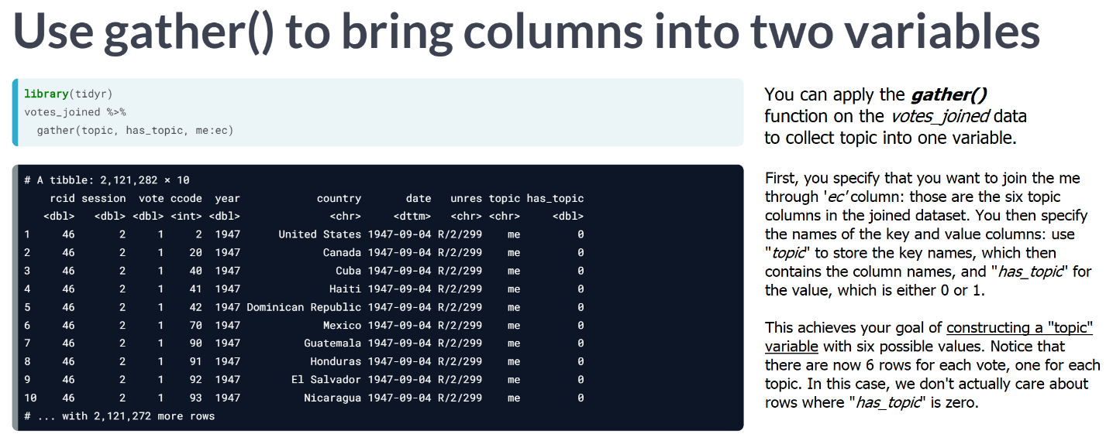

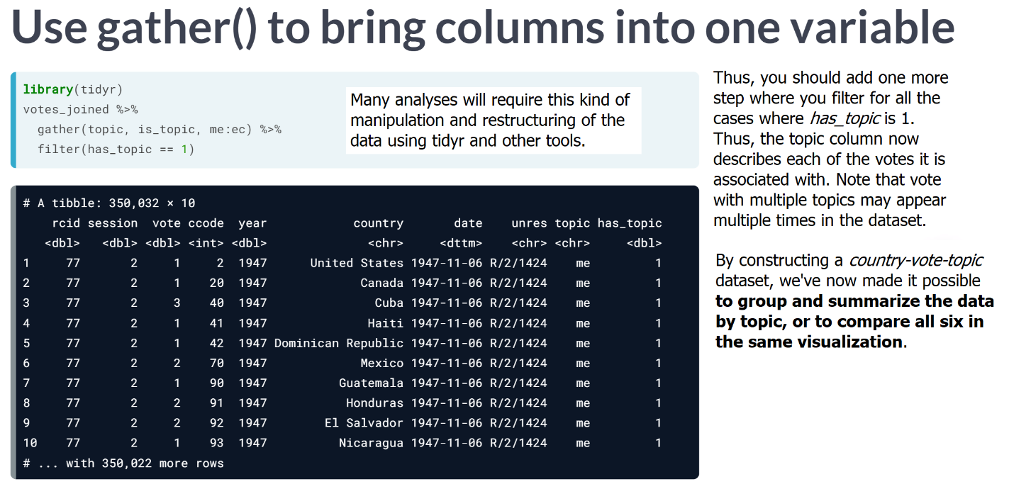

# Tidy data observations

According to the tidy data framework, which of the following counts as an observation in this graph?

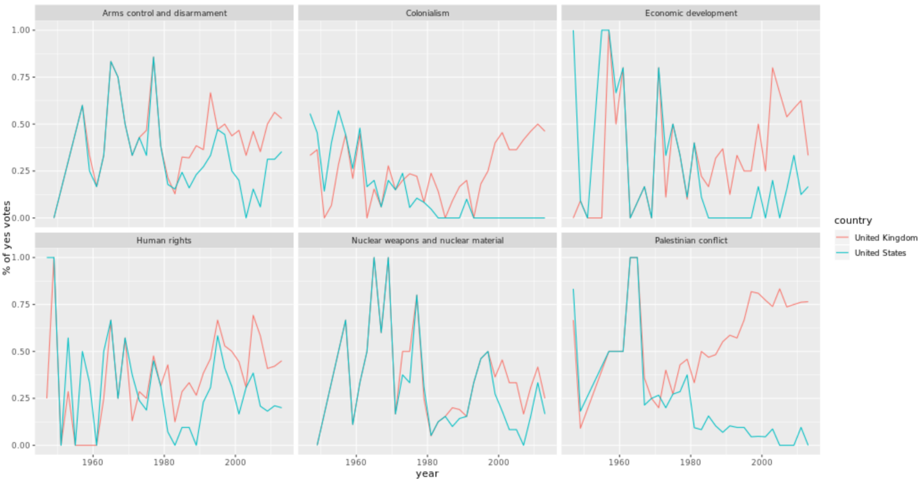

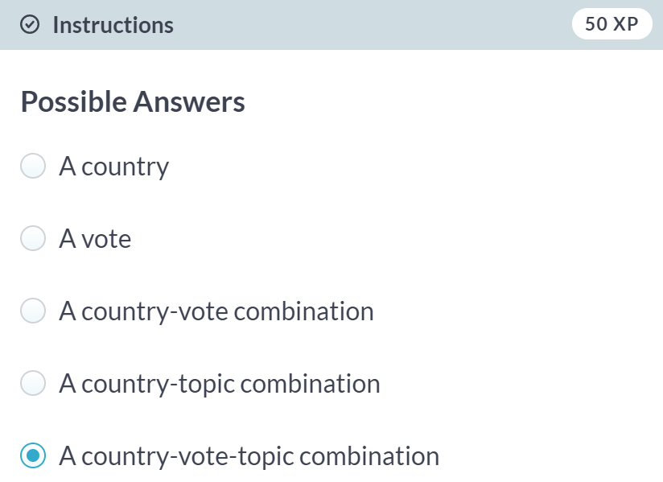

Correct! A single point in one of the lines on the graph uniquely represents a country-vote-topic combination.

# Using gather to tidy a dataset

In order to represent the joined vote-topic data in a tidy form so we can analyze and graph by topic, we need to transform the data so that each row has one combination of country-vote-topic. This will change the data from having six columns (me, nu, di, hr, co, ec) to having two columns (topic and has\_topic).

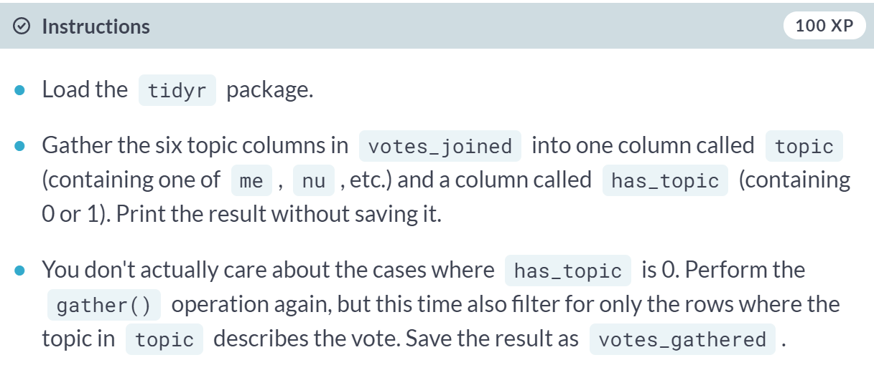

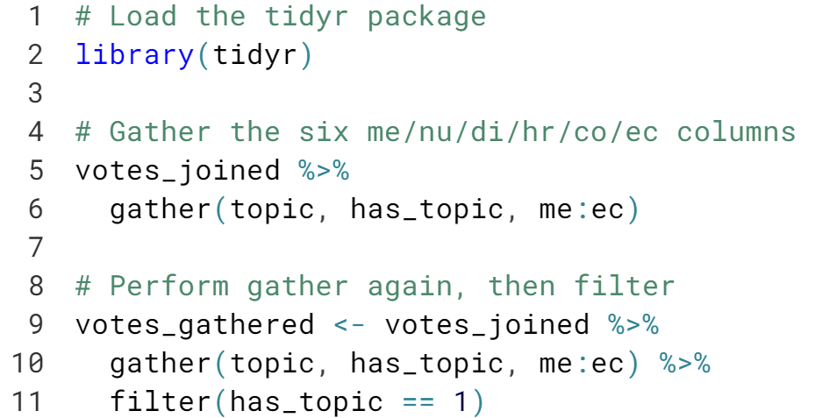

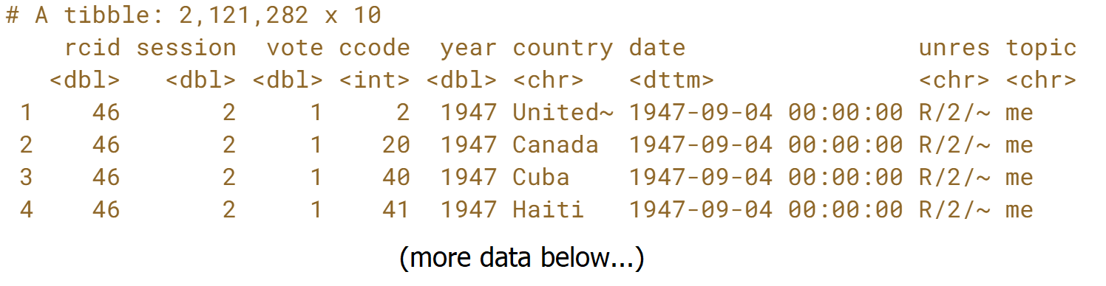

# Recoding the topics

There's one more step of data cleaning to make this more interpretable. Right now, topics are represented by two-letter codes:

1. **me**: Palestinian conflict
2. **nu**: Nuclear weapons and nuclear material
3. **di**: Arms control and disarmament
4. **hr**: Human rights
5. **co**: Colonialism
6. **ec**: Economic development

So that you can interpret the data more easily, recode the data to replace these codes with their full name. You can do that with dplyr's recode() function, which replaces values with ones you specify:

example <- c("apple", "banana", "apple", "orange")

recode(example,

apple = "plum",

banana = "grape")

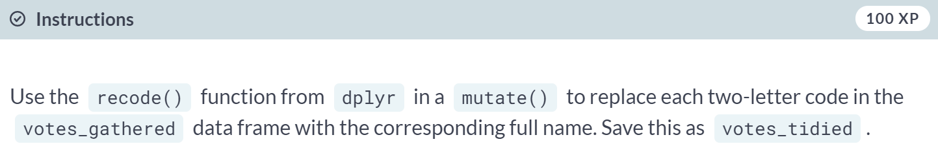

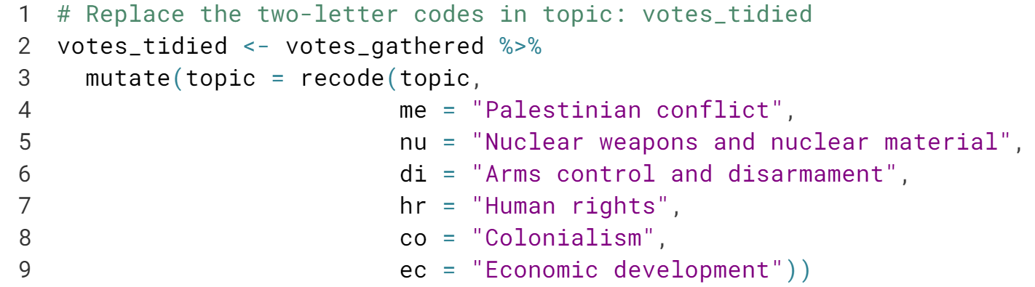

# Summarize by country, year, and topic

In previous exercises, you summarized the votes dataset by country, by year, and by country-year combination.

Now that you have topic as an additional variable, you can summarize the votes for each combination of country, year, and topic (e.g. for the United States in 2013 on the topic of nuclear weapons.)

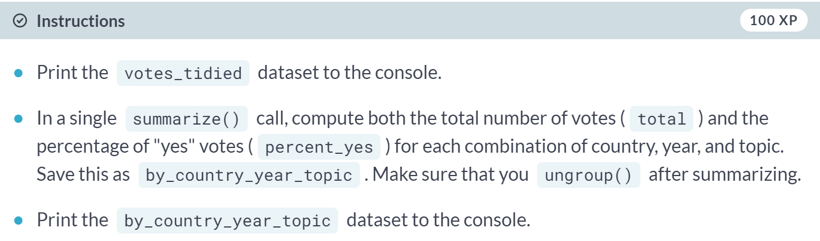  
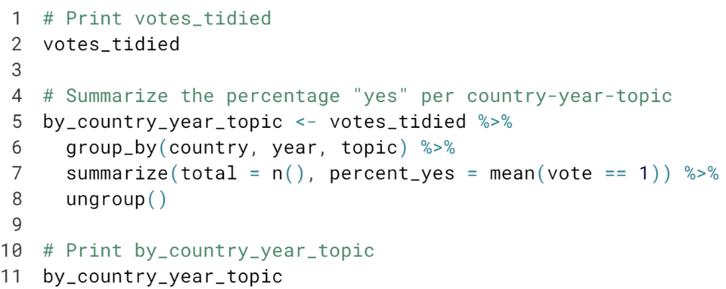  
  
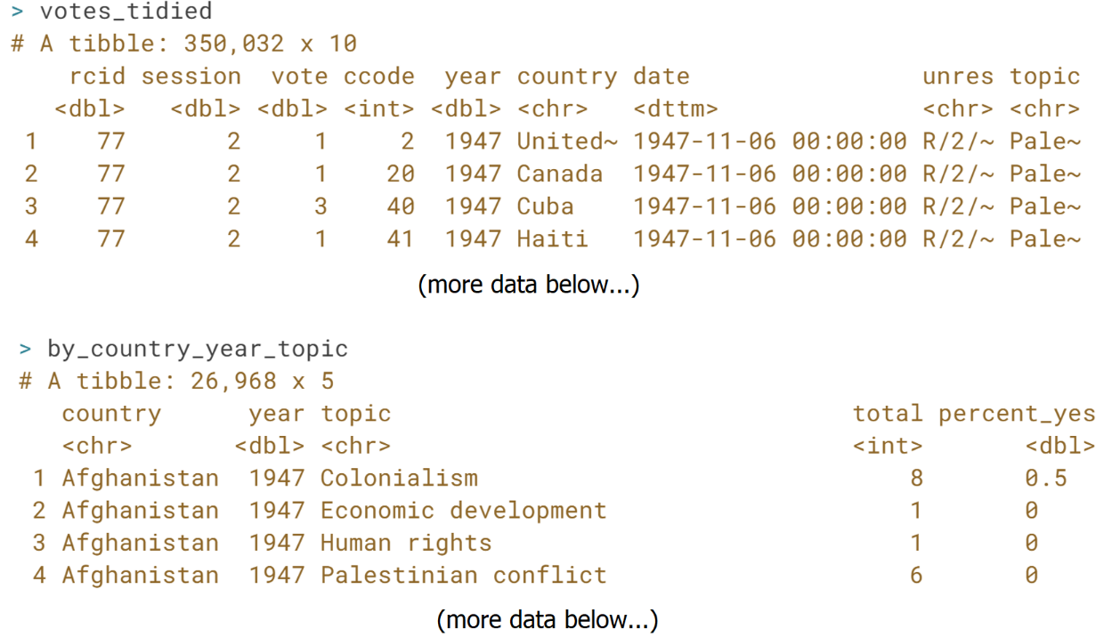

# Visualizing trends in topics for one country

You can now visualize the trends in percentage "yes" over time for all six topics side-by-side. Here, you'll visualize them just for the United States.

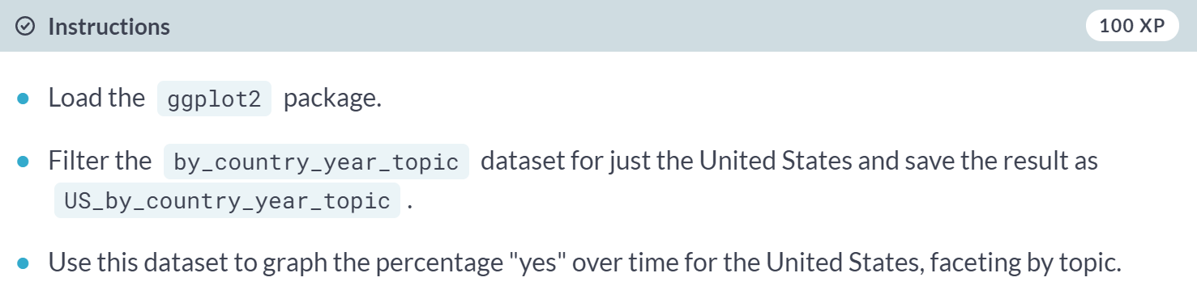  
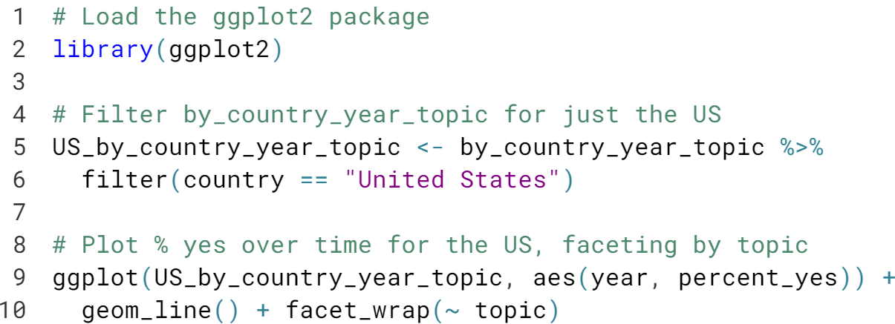  
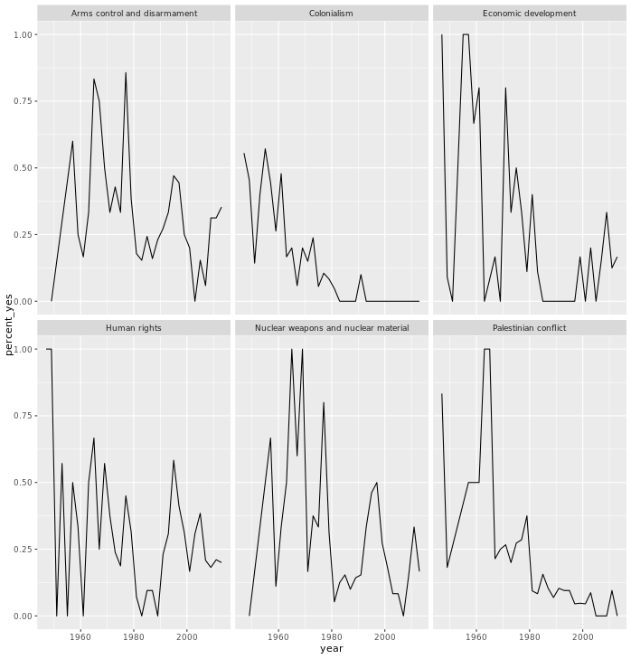



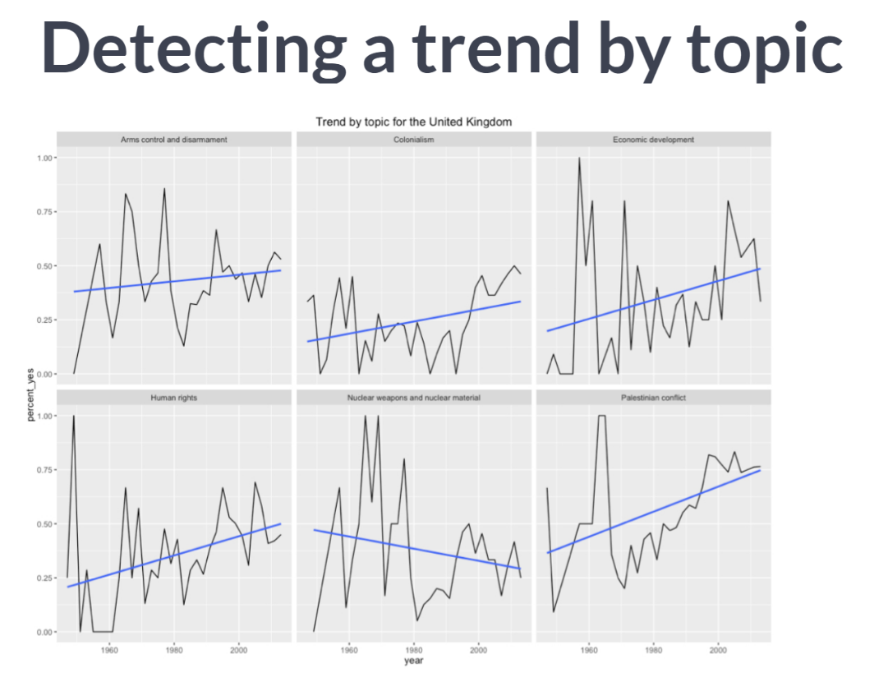  
With the new datasets we've built in this chapter, we can fit these trends within each country and within each topic. For example, we could fit trends for the UK's voting behavior within each of these six topics, as seen above.

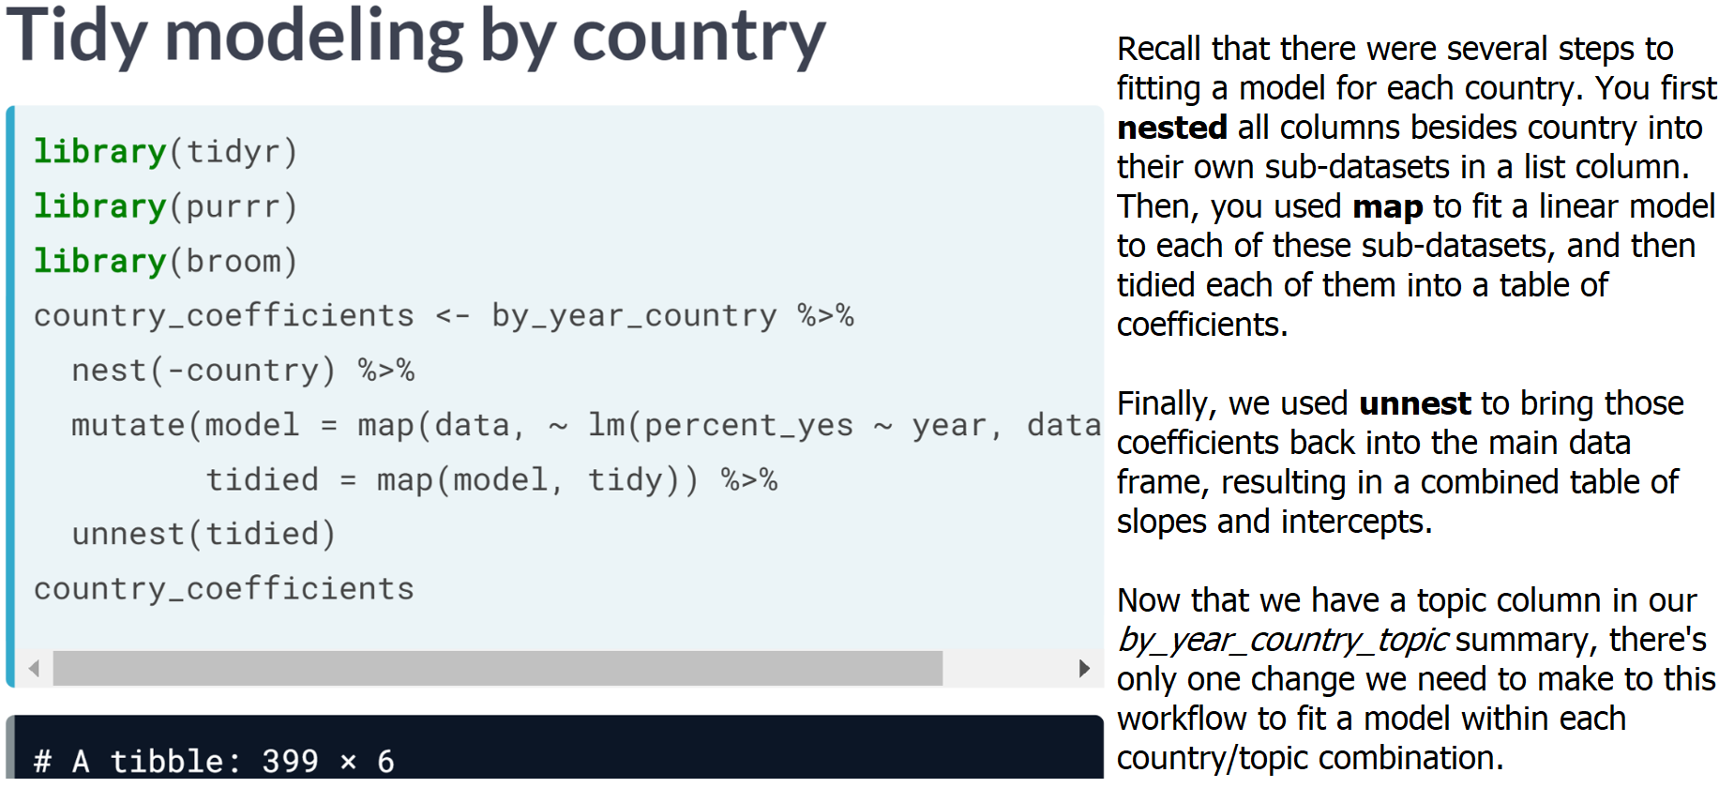

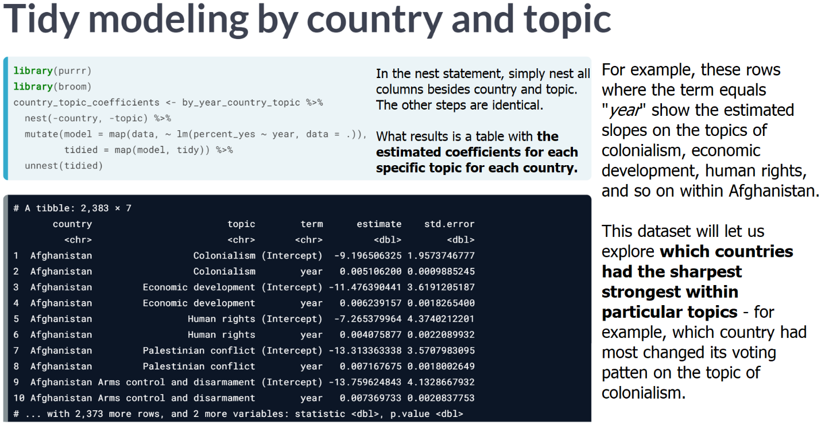  
This analysis demonstrates the flexibility of the nest, model, and unnest pattern in exploratory analysis. However, you could have chosen to slice your data in many other ways using alternative data sources such as tidyr, dplyr, and broom packages that will always give us the tools we need to answer the questions we're interested in.

# Nesting by topic and country

In the last chapter, you constructed a linear model for each country by nesting the data in each country, fitting a model to each dataset, then tidying each model with broom and unnesting the coefficients. The code looked something like this:

country\_coefficients <- by\_year\_country %>%

nest(-country) %>%

mutate(model = map(data, ~ lm(percent\_yes ~ year, data = .)),

tidied = map(model, tidy)) %>%

unnest(tidied)

Now, you'll again be modeling change in "percentage" yes over time, but instead of fitting one model for each country, you'll fit one for each combination of country and topic.

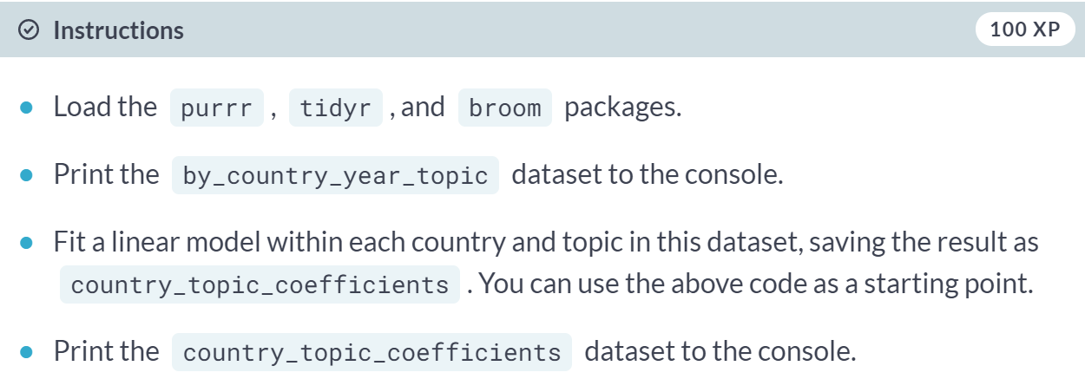

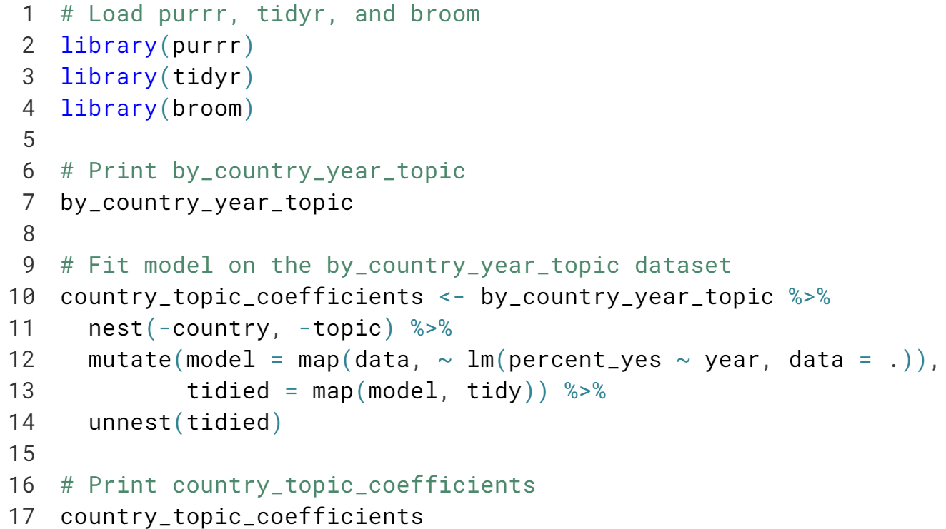

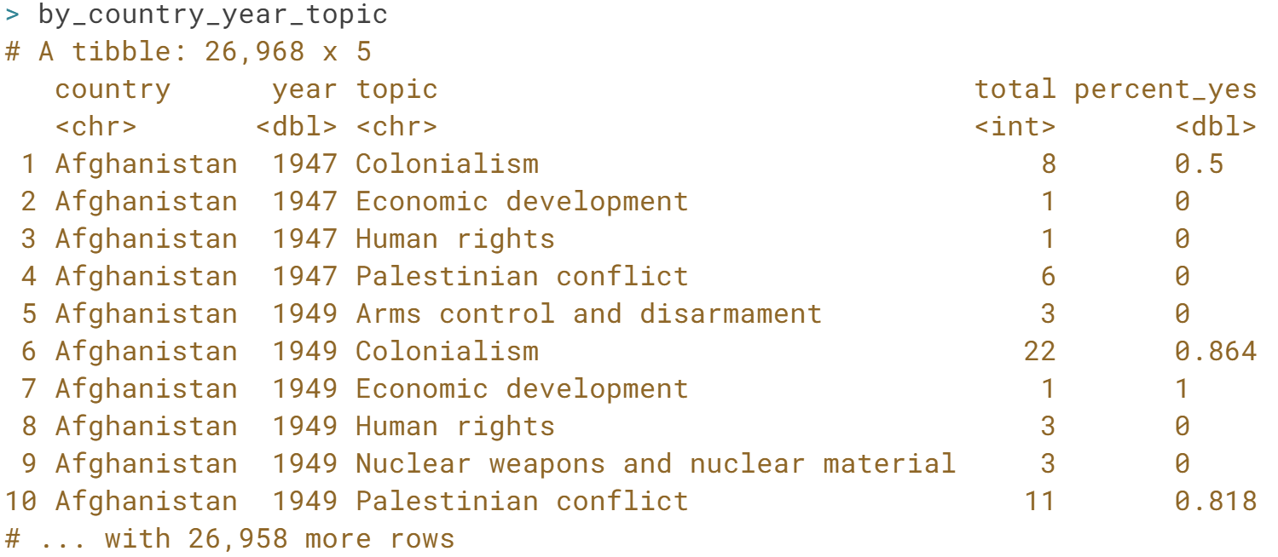

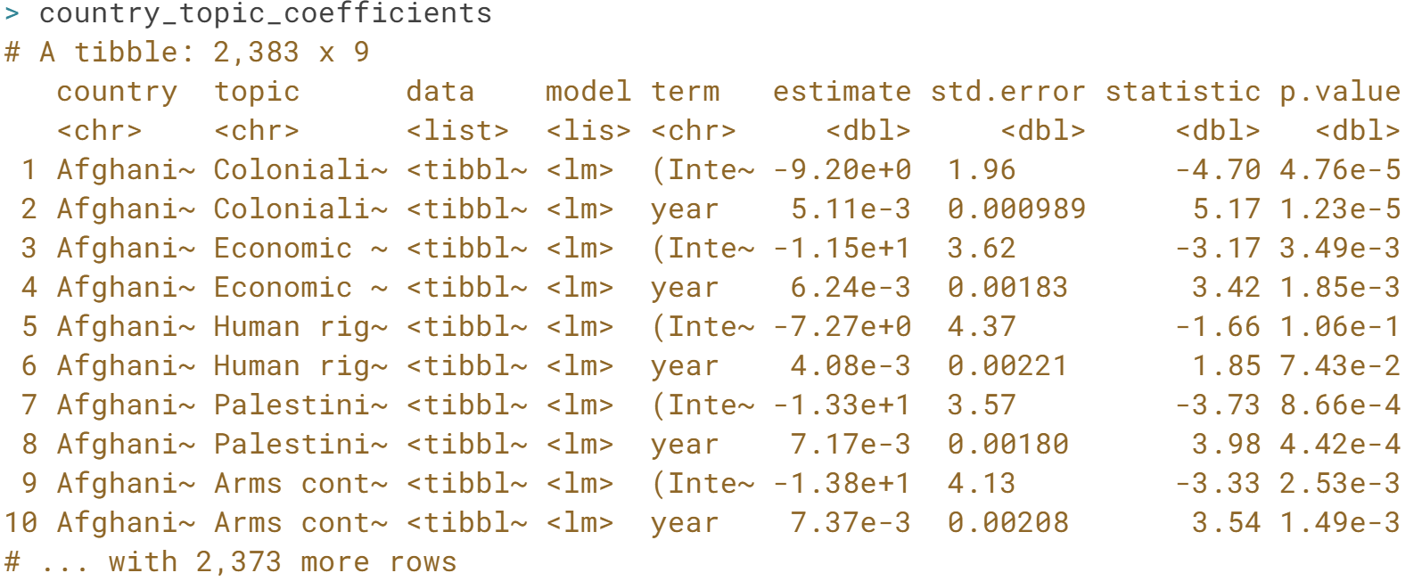

# Interpreting tidy models

Now you have both the slope and intercept terms for each model. Just as you did in the last chapter with the tidied coefficients, you'll need to filter for only the slope terms.

You'll also have to extract only cases that are statistically significant, which means adjusting the p-value for the number of models, and then filtering to include only significant changes.

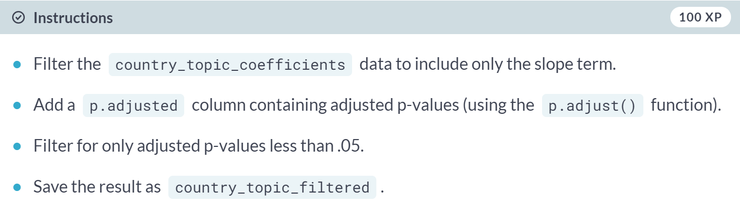

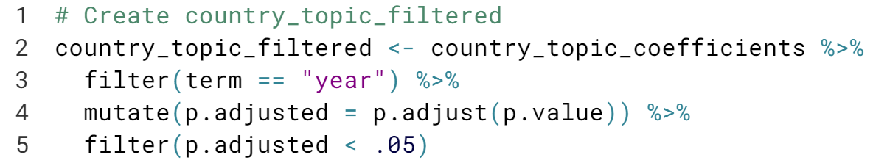

# Steepest trends by topic

country\_topic\_filtered from the previous exercise is available in your workspace. Which combination of country and topic has the steepest downward trend?

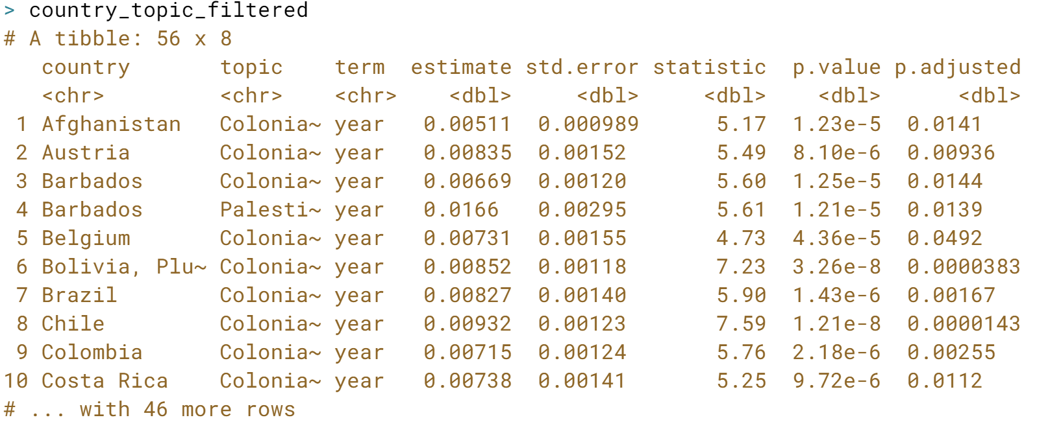

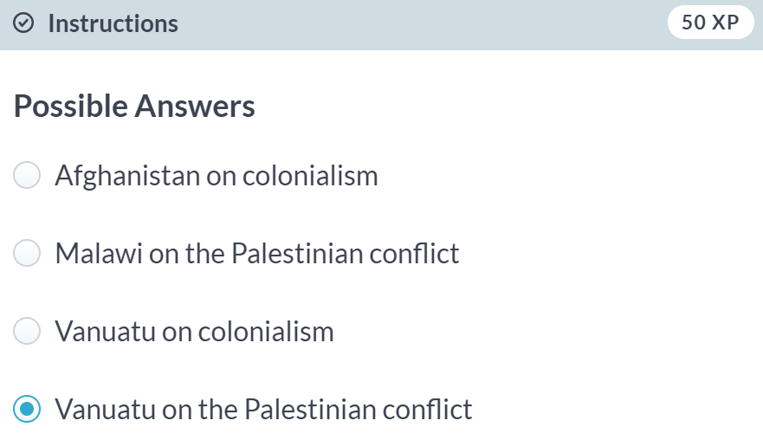

Can someone explain why?

# Checking models visually

In the last exercise, you found that over its history, Vanuatu (an island nation in the Pacific Ocean) sharply changed its pattern of voting on the topic of Palestinian conflict.

Let's examine this country's voting patterns more closely. Recall that the by\_country\_year\_topic dataset contained one row for each combination of country, year, and topic. You can use that to create a plot of Vanuatu's voting, faceted by topic.



